# **Lecture 1: Introduction to Concurrency**

| **Concurrency** | **Parallel** |
| --- | --- |
| Two or more tasks can start, run, and complete in overlapping time periods | Two or more tasks can run (execute) simultaneously, at the exact same time |
| They might not be running (executing on CPU) at the same instant | Tasks do not only make progress, they actually execute simultaneously |
| Two or more execution flows make progress at the same time by interleaving their executions or by executing instructions (on CPU) at exactly the same time |  |

* Hardware enables TRUE concurrency (parallelism)
  + Multicore processor
  + Multiple processors
* Hardware threads dictate the amount of TRUE concurrency
  + Multicore processor
  + A core can support multiple hardware threads

| **Exceptions** | **Interrupts** |
| --- | --- |
| Executing a machine level instruction can cause exception | External events can interrupt the execution of a program |
| e.g. Overflow, Underflow, Division by Zero, Illegal memory address, misaligned memory access | Usually hardware related: Timer, Mouse Movement, Keyboard Pressed etc |
| **Synchronous**: Occur due to program execution | **Asynchronous**: Occur independently of program execution |
| Have to execute an exception handler | Have to execute an interrupt handler |

| **Processes** | **Threads** |
| --- | --- |
| Safety   * each have their own memory context | Performance   * No copy of address space * Diff threads of a process can be assigned to run on diff cores (for multicore procesor) * Faster thread generation |
| Creating a new process is costly   * overhead of system calls * all data structures must be allocated initialized and copied | Extension of process model:   * A process may consist of multiple independent control flows called threads * Thread defines a sequential execution stream within a process (PC, SP, registers) |
| Costly communication between processes through OS | Share address space of the process (shared memory) |

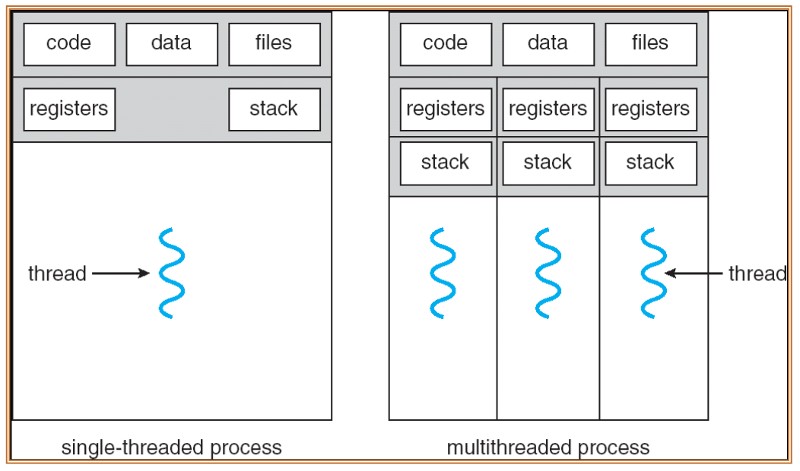

**Race Condition [More details in Lecture 2]**

1. Two concurrent threads (or processes) access a shared resource without any synchronization
2. At least one thread modifies the shared resource

* Necessary to synchronize access to any shared data structure e.g. buffers, queues, lists, hash tables, etc.

**Mutual exclusion**

* Synchronise access to shared resources → large atomic blocks
* Code sequence that uses mutual exclusion called is called critical section (one thread at a time)

**Critical Section requirements**

1. Mutual exclusion (mutex)
   * Only 1 thread can be is CS at any point in time
2. Progress
   * If some thread T is not in the CS, then T cannot prevent some other thread S from entering the CS
   * A thread in CS will eventually leave it
3. Bounded Waiting (no starvation)
   * If some thread T is waiting on the CS, then T will eventually enter the CS
4. Performance
   * The overhead of entering and exiting the CS is small with respect to the work being done within it

* Safety property (most impt): nothing bad happens
* Liveness property: something good happens → progress, bounded waiting
* Performance requirement

**Mechanisms**

| Locks | Primitive, minimal semantics, used to build others |
| --- | --- |
| Semaphores | Basic, easy to understand but hard to program with   * Dont belong to any thread so to make sure that resource will be acquired and released properly for multiple threads is hard |
| Monitors | * High-level * requires language support * Operations implicit * e.g. cond_var is used as an example |
| Messages | * Simple model of communication and synchronization based on atomic transfer of data across a channel * Direct application to distributed systems * Messages for synchronization are straightforward |

Deadlock

* Deadlock occurs when the waiting process is still holding on to another resource that the first needs before it can finish.
* Caused by
  + processes competing for access to limited resources
  + processes are incorrectly synchronized
* Conditions (must hold simultaneously)
  1. Mutual exclusion: >= 1 resource must be held in a non-sharable mode
  2. Hold and wait: There must be one process holding one resource and waiting for another resource
  3. No preemption – Resources cannot be preempted (critical sections cannot be aborted externally)
  4. Circular wait – There must exist a set of processes [P1, P2, P3,...,Pn] such that P1 is waiting for P2, P2 for P3, etc.

**Starvation**

* Situation where a process is prevented from making progress because some other process has the resource it requires
* Starvation is a side effect of the scheduling algorithm
  + OS: A high priority process always prevents a low priority process from running on the CPU
  + One thread always beat another when acquiring a lock

**Concurrency**

* Concurrency issues
* Maintenance difficulties
  + Complicated code
  + Debugging is challenging >.<
* Threading overhead
  + Stack
  + Context switching
* Increased memory usage
* Separation of concerns
* Performance
  + Take advantage of the hardware
  + Optimization strategy

**Types of Parallelism**

| Task | Do the same work faster |
| --- | --- |
| Data | Do more work in the same amount of time |

**Execution of a concurrent program (C/C++)**

* Compilation and linking: done by compiler
* Loading: loader is usually specific to the OS
* Execution
  + Coordinated by the OS
  + The program gets access to CPU, memories, devices, etc.

**Building flow in C/C++**

Transforming HLL written code to target machine code

* Preprocessor
  + Replaces preprocessor directives (#include and #define)
* Compiler
  + Parses pure C++ source code and converts it into assembly
* Assembler
  + Assembles that code into machine code
* Linker
  + Produces the final compilation output from the object files the compiler produced
  + Library codes are added

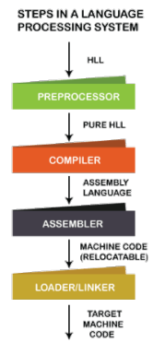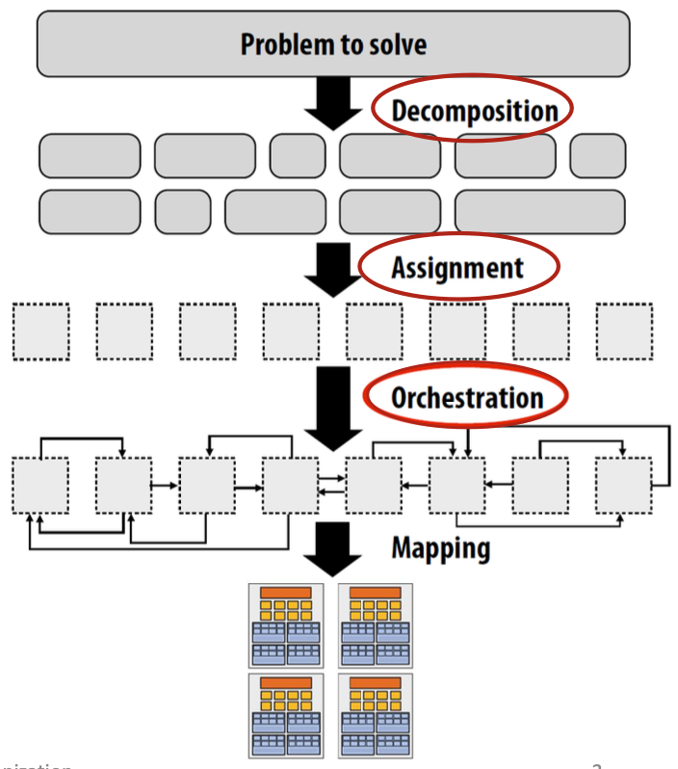

# **Lecture 2: Tasks, Threads and Synchronization (in Modern C++)**

Program execution

1. Decomposition of the computations
2. Assigning tasks to threads
3. Orchestration
   * Structuring communication
   * Adding synchronisation to preserve dependencies
   * Organising data structure in memory
   * Scheduling tasks
4. Mapping of threads to physical cores (done by the library)

**Task parallelism**

* Divide the work into tasks to make the threads specialists → separation of concerns
  + Same types of tasks assigned to the same thread (aka pipeline)
* Dividing a sequence of tasks among threads to achieve a complex solution
* Pipeline: each thread is responsible for a stage of a pipeline
* Use task pools and the number of threads to serve the task pool

**Data Parallelism**

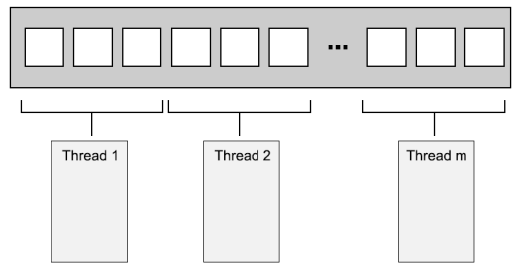

**Managing threads**

* Every program has at least one thread
  + Started by C++ runtime
  + Runs main()
* Use std::thread to add threads

**Creating a thread**

* Identifying a thread using get_id()

**Starting threads**

There are different ways to start threads and compiler may compile them in different ways:

* Using a function (like pthreads)

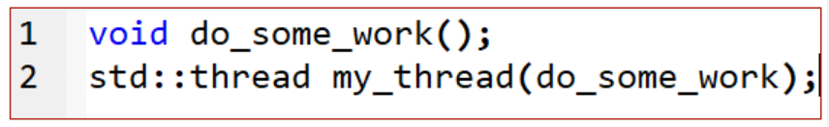

* Using a function object (callable type i.e. lambda functions)
  + Able to store state so that threads can access data not in the argument list
  + must use operator()()

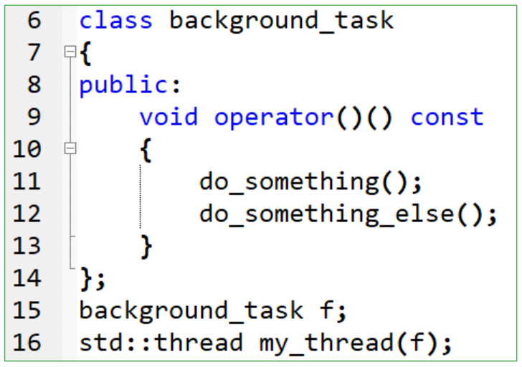



* Declares a function (my_thread) that takes in a single parameter and returns a thread object
* background_task() returns a pointer to the function
* ONLY declare, new thread not launched

From ChatGPT senseii

How pointer to a function is declared:

return_type (*function_pointer_name)(parameter_list);

So, background_task (*pointer_name)();

Can assign a function to this pointer type using the address-of operator &

background_task (*pointer_name)() = &function_name;

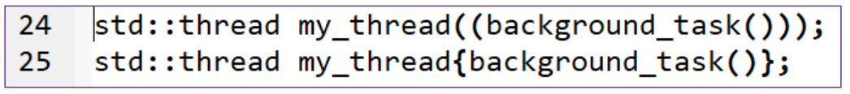

* Launches thread with a function object using {}

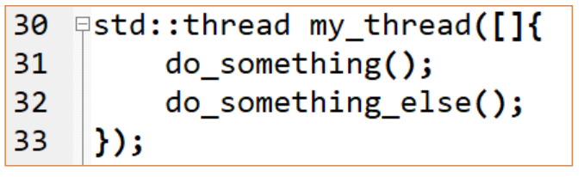

* Thread with a lambda expression (local function instead of a callable object)

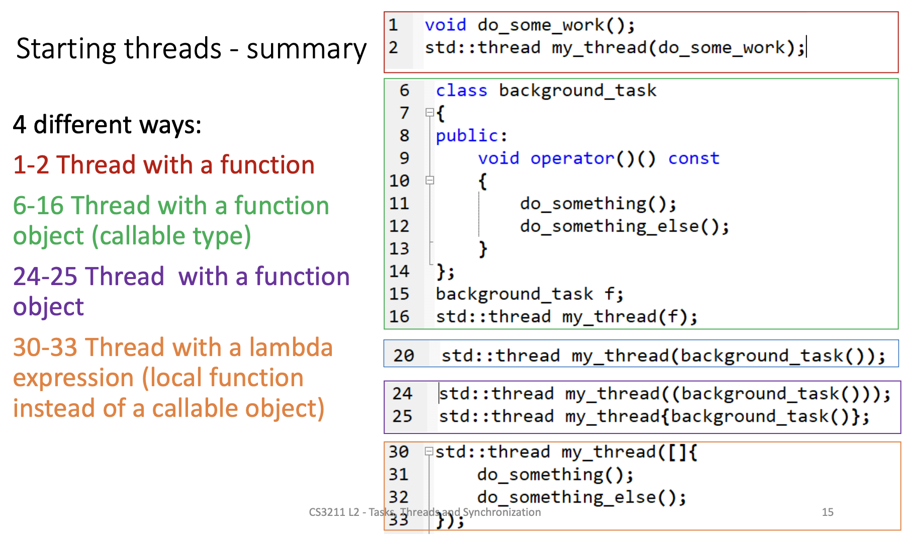

| **Wait** | **Detach** |
| --- | --- |
| * Use join() on thread instance, exactly once * Use joinable() to check * Rmb to join threads even when there is an exception   try {  …  } catch (...) {  t.join();  throw;  }  t.join(); | * Use detach() * Extra care is needed with local variables passed to the thread * Detached thread goes out of scope and can be destroyed * Local variables passed as parameters to the thread function might end their lifetime before the thread ends |

**Passing arguments to a thread function**

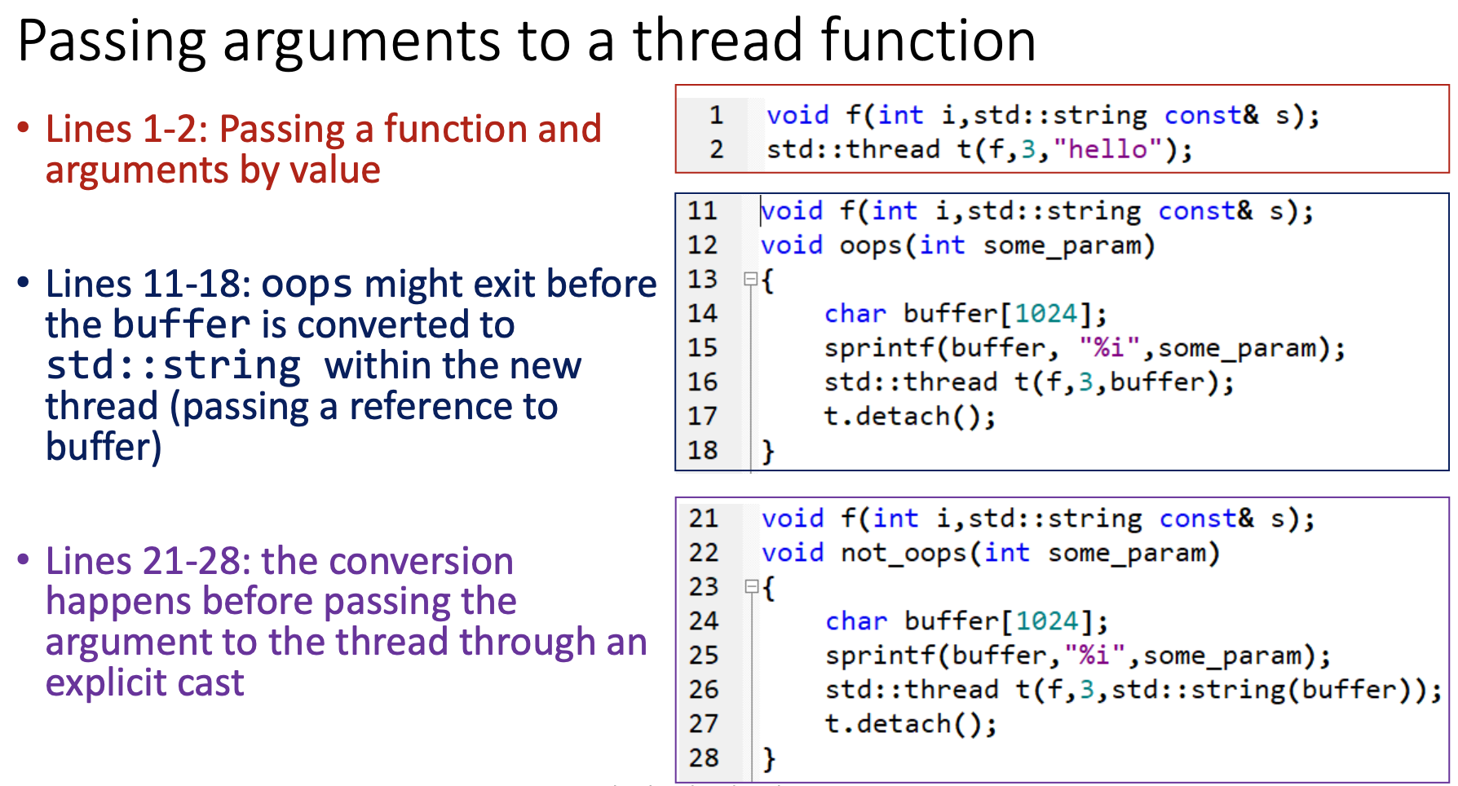

* explicit cast returns a new reference
* even if buffer is not accessible, it does not matter → new reference is used

Passing arguments by reference

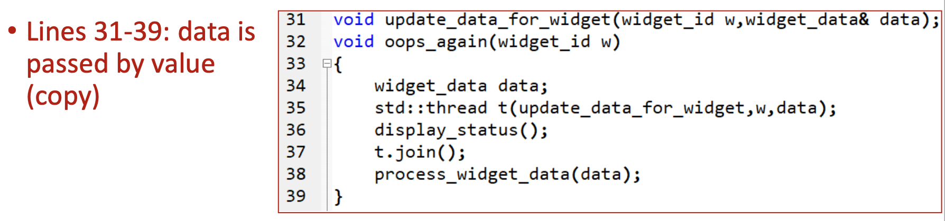

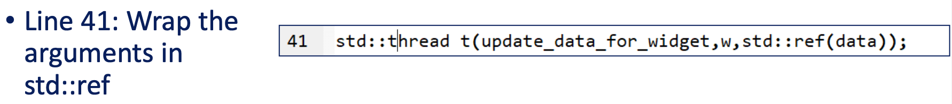

* Explicit cast to std::ref allows changes to be seen

**Ownership C++**

* An owner is an object containing a pointer to an object allocated by new for which a delete is required
* Every object on the free store (heap, dynamic store) must have exactly one owner
* C++’s model of resource management is based on the use of constructors and destructors
  + Scoped: destroyed is implicit at scope exit
  + Free Store: new and delete required

**RAII - Resource Acquisition is Initialization**

* A technique
* When an object is created, it acquires the resource it needs, and when the object goes out of scope, it releases the object automatically.
* Resources are guaranteed to be released, even in the presence of exceptions or other error conditions, without the need for manual intervention.
* Tie resources to the lifetime of the object.

**Lifetime of object**

* determined by the creation and destruction of the object itself
* begins when it is created
  + storage with the proper alignment and size for its type is obtained, and either
  + through direct construction using the object's constructor, or
  + through the use of a smart pointer, e.g. std::unique_ptr or std::shared_ptr.
* ends when it goes out of scope
  + the storage which the object occupies is released, or is reused by an object that is not nested within it, or
  + End of block, or
  + the object has been explicitly destroyed using delete or delete[], or destructor
* Lifetime of an object is equal to or is nested within the lifetime of its storage

**Lifetime of storage**

* the period of time during which a memory location has been reserved and can be used to store an object.
* begins when
  + the memory is dynamically allocated using new or
  + when it is automatically allocated on the stack, such as for variables declared in a function.
* ends when the memory is freed
  + explicitly using delete or
  + automatically when the storage goes out of scope.

**Lifetime of reference**

* Once a reference is initialized, it cannot be changed to refer to a different object
* starts when it is declared and initialized to refer to an object,
* ends when the object that it references goes out of scope or is destroyed.
* During its lifetime, the reference acts as an alternative name for the object, and any changes made to the object through the reference will be reflected in the object itself.

**Ownership of a thread**

* Instances of std::thread are
  + Movable
  + not copyable

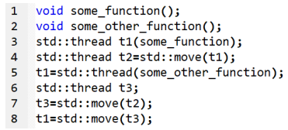

* line 8 will throw an error as t1 is already managing a thread and hence cannot be assigned another thread.
* Error can be avoided if t1.detach() is called before line 8.

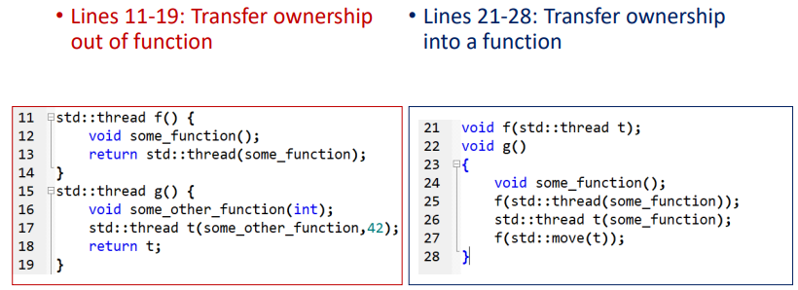

* Transferring ownership of a thread out of a function allows thread to continue executing after the function has completed. Ensures that the thread will not be destroyed when the function returns.
* Transferring ownership into a function passes the responsibility of managing the thread to that function. e.g. Pass a thread to a function for processing and you want the function to be responsible for joining the thread if it’s not necessary to wait for its completion
* Transferring ownership to a function can make the code more modular and decoupled

**Synchronizing threads in C++**

* Concurrent access to shared data → mutex
* Concurrent actions → cond var & monitor

Synchronising concurrent accesses (if there is potential race cond)

* Use invariant to reason about program correctness

Problems with sharing data among threads

* Must ensure changes to a chosen data structure are correctly synchronized among threads
  + Data structures are immutable, or
  + Protect data using some locking: external or internal
* Invariants are often broken during an update on the data structure
  + Other threads might work with data while the invariant is broken
* Race conditions

| **Race condition** | **Data race** |
| --- | --- |
| outcome/correctness depends on the relative ordering of execution of operations on >= 2 threads | 2 memory accesses where both:   * target the same location * are performed concurrently by 2 threads * are not reads * are not synchronization operations |
| Threads race to perform their respective operations |
| a flaw that occurs when the timing or ordering of events affects a program’s correctness. | Causes undefined behaviour |

**Avoiding race conditions**

* Chances of the problematic execution sequence occurring increases
  + high load in the system
  + the operation is performed more time
* Wrap data structure with a protection mechanism
  + Ensure that only the thread performing a modification can see the intermediate states while the invariants are broken
  + e.g. lock_guard for locking

**Mutex in C++**

* Not recommended usage: std::mutex
* Recommended usage: use std::lock_guard class template
  + Implements RAII idiom for a mutex
  + Locks the supplied mutex on construction and unlocks it on destruction
    - Groups the mutex and the protected data together in a class rather than use global variables

**Issues when passing references**

* The call to the user-supplied func function means that foo can pass in malicious_function to bypass the protection and then call do_something() without the mutex being locked
* Don’t pass pointers and references to protected data outside the scope of the lock, whether by returning them from a function, storing them in externally visible memory or passing them as arguments to user-supplied function

**Other types of lock**

* std::unique_lock instance doesn’t always own the mutex that it is associated with
  + Allows for locking the mutex later using std::defer_lock
* std::lock() function locks one or more mutexes at once without risk of deadlock
  + use std::adopt_lock to indicate to std::lock_guard objects that the mutexes are already locked
* std::scoped_lock instance accepts and locks a list of mutexes
  + locks in the same was as lock()
  + automatically locks the specified mutexes when it is constructed, and automatically unlocks them when it goes out of scope.
  + uses less memory than unique_lock()

**Condition Variable**

* One thread is waiting for a second thread to complete a task is wasteful
  + [Using while (flag == 1)] Keep checking a flag in shared data (protected by a mutex) and have the 2nd thread set the flag when it completes the task
  + Less wasteful: std::this_thread_sleep_for()
* A condition variable is associated with an event or other condition, and
  + >= 1 threads can wait for that condition to be satisfied
* void wait(std::unique_lock<std::mutex>& lock );
* How it works:
  + when the condition is satisfied, the thread can then notify one or more of the threads waiting on the condition variable
  + The notified threads wake up and continue processing

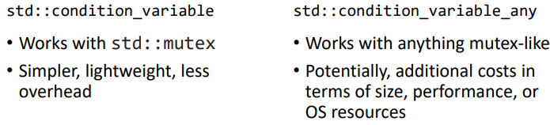

* During a call to wait(std::mutex m, Predicate stop_waiting) , a condition variable
  + May check the supplied condition any number of times
    - Do not use a function with side effects for the condition check
  + Checks the condition with the mutex locked
  + returns immediately if (and only if) the function provided to test the condition returns true
* Spurious wake
  + a situation in which a waiting thread is unexpectedly woken up from a wait operation, without being notified by another thread or the operating system.
  + woken up without the condition being met
  + The waiting thread reacquires the mutex and checks the condition, but not in direct response from a notification
  + Due to factors, such as system delays or thread scheduling issues
  + recommended to use cond var in conjunction with a predicate, or a condition that must be met before a wait operation can complete.

# **Lecture 3: Atomics & Memory Model (in Modern C++)**

Compiler

Correctly synchronized program should behave as if

* memory ops are executed in an order that appears equivalent to some sequentially consistent interleaved execution of the memory ops of each thread
* each write appears to be atomic and globally visible simultaneously to all processors

**Memory model**

* provides a contract to programmers about how their memory operations will be reordered by the compiler

Structure

* Every variable is an object, incl those that are members of other objects
* Every object occupies >= 1 mem location
* Primitive types occupy exactly 1 mem location (regardless of size), even if they are adjacent or part of an array
* Adjacent bit fields are part of the same memory location

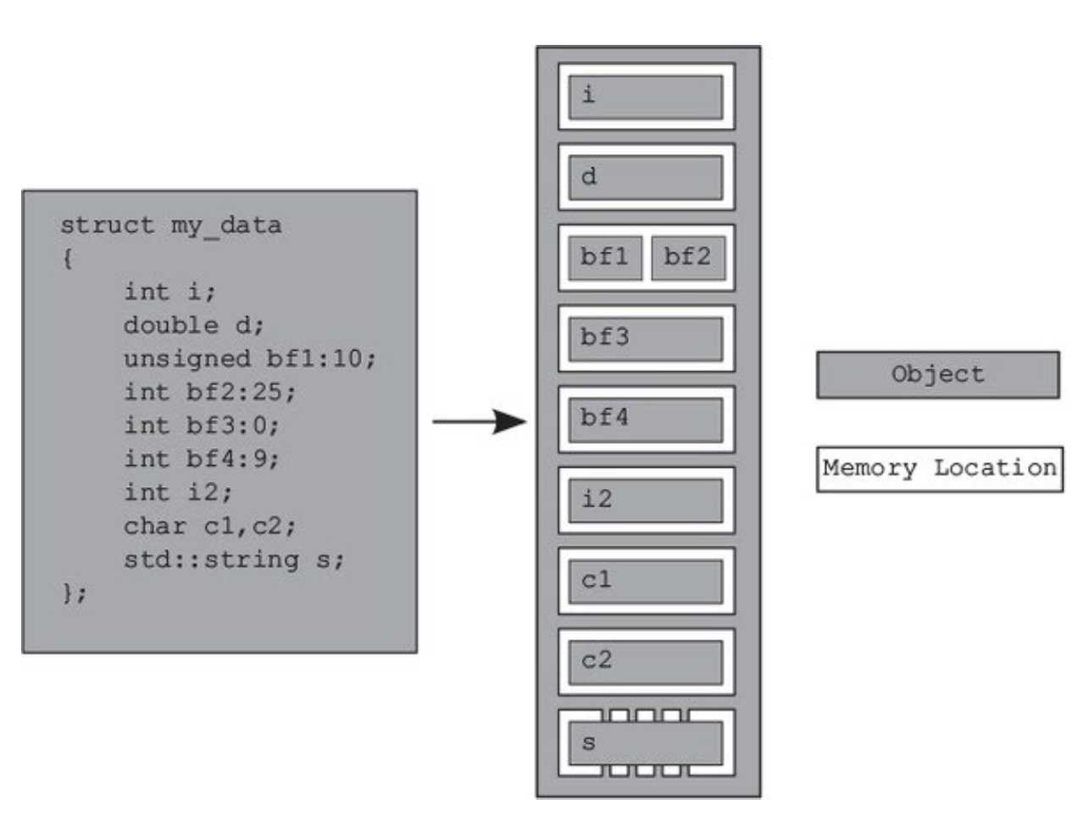

int bf2:25; // occupy 25 bits

Note: bf3 should not occupy any memory, it should appear just before bf4

Concurrency

* 2 threads access same memory location
  + Read-only data doesn’t need protection/synchronization
* **Data Race - undefined behavior**
  + no enforced ordering between access
  + one or both of those accesses is not atomic
  + AND if one or both accesses is a write
* Use critical sections to avoid data races
  + locks
  + ordered atomics
  + transactional memory

Modification order (MO)

* Composed of all writes to an object from all threads in the program
  + MO is not consistent; varies between runs
  + For every object in the program
* If the object is not one of the atomic types
  + programmer is responsible for ensuring the threads agree on the modification order of each variable (the contract)
  + Data race and undefined behavior: different threads see distinct sequences of values for a single variable
* If atomic operations are used
  + Compiler ensure necessary synchronization but does not mean “race-free”
  + Changes might be seen at diff time depending on context switch and interleaving

MO - Requirements

* Once a thread has seen a particular entry in the modification order
  + subsequent reads from that thread must return later values
  + AND subsequent writes from that thread to that object must occur later in the MO
* A read of an object that follows a write to that object in the same thread must either return the value written or another value that occurs later in the MO of that object
* Contract: All threads must agree on the MO of each individual object
  + don’t necessarily have to agree on the relative order of operations
  + E.g. MO: x = 1 → x = x + 4→ x = 7 all threads agree with this and see changes in this order BUT
    - T1 can see x = 1→ y = 2 → x = x + 4→ x = 7
    - T2 can see x = 1→ x = x + 4→ x = 7→ y = 2

Atomic operations & types

* Enforce MO
* Atomic operations are always observed fully done from any thread in the system
* Atomic load: retrieve either the initial value of the value stored by one of the modifications
* Non-atomic operation might be seen as half-done by another thread
  + e.g. load, add, store: last store might not be seen
* atomic<>: low level synchronization operations that reduce to 1-2 CPU instructions
* is_lock_free() member function returns true if operations on a given type are done directly with atomic instructions
* x::s_always_lock_free is true iff atomic type x is lock-free for all supported hardware that the current complicated code might run on
* Might emulate atomicity by using an internal mutex → might not be as efficient as expected

Memory Order in C++ for atomics

* Every operation on atomics has an optional argument of type std::memory_order
* Specifies memory access, e.g. regular, non-atomic
* If no constraints on a multi-core system:
  + Lack of MO: diff threads see value changes in diff order
  + Can occur on uniprocessor systems due to compiler transformations allowed by the memory model

std::memory_order enumeration

* Default ordering, the strongest ordering
  + memory_order_seq_cst
* Store operations can have
  + memory_order_relaxed
  + memory_order_release
  + memory_order_seq_cst
* Load can have
  + memory_order_relaxed
  + memory_order_acquired
  + memory_order_seq_cst
* Read-modify-write
  + memory_order_relaxed
  + memory_order_release
  + memory_order_seq_cst
  + memory_order_acquire
  + memory_order_acq_rel

memory_order_seq_cst

* Default option
* All threads must see the same order of operations (cannot reorder)
* A sequentially consistent store synchronizes-with a sequentially consistent load of the same variable that reads the value stored
  + Does not apply to atomic operations with relaxed memory orderings
  + Advice: use seq_cst operations on all threads
* Noticeable performance penalty on a weakly-ordered multicore machine
  + Require extensive and expensive synchronization operations between processors

Non-sequentially consistent orderings

* No single global order of events
  + Different threads can see different views of the same operations
  + No mental model of operations of operations from different threads neatly interleaved one after another i.e. messy!!
* Only requirement is that all threads agree on the modification order of each individual variable → contract

Relaxed Ordering

* There is a shared data structure with an MO and a pointer at some modification in the MO list
* When reading an MO the pointer always point to the same value or subsequent values down the MO
* Always add a modification to the end of the MO

| Sequenced-before / after | * Within the same thread, evaluation A sequenced before B, aka program order * A will be completed before B starts |
| --- | --- |
| Synchronised-with  [acquire-release] | * Appears between atomic load and store operations * A suitably-tagged atomic write operation (release), W, in thread A on a variable, x, synchronizes with a suitably-tagged atomic read operation (acquire), R, in thread B on x * R reads the value stored by   + Either W, or   + A subsequent atomic write operation on x by the same thread that performed the initial write W (also has release), or   + A sequence (after W has completed and seen) of atomic read-modify-write operations on x (e.g. fetch_add, compare_exchange_weak) |
| Inter-thread happens-before | * Evaluation A inter-thread happens before evaluation B if   + A sync-with B   + A is dependency-ordered before B   + A sync-before some evaluation X, and X happens-before B   + A happens-before X, and X happens-before B |
| Happens-before | Intra-thread happens-before   * Sequenced-before * Note: there is no happens-before relationship between operations that occur in the same statement   Inter-thread happens-before  Transitive r/ship |

Visible Side Effects

* Side-effect A on a W is visible with respect to value computation B, an R if **both** of the following are true:
  + A happens-before B
  + There is no other side effect X where A happens-before X and X happens-before B
* Tentative explanation:
  + Anything before release will be seen by acquired read even if the modified variables does not affect the acquired read operation
  + Visible: modified var must be used later

MO

* All modifications to an atomic variable is total order
* Guaranteed for all atomic operations
  + W-W coherence: A modifies atomic M happens before B that modifies X ⇒ A appears earlier than B in the MO of M
  + R-R coherence: a read operation on a shared variable always returns the most recently written value to that variable, regardless of which thread performed the write operation.
  + R-W coherence: if a read operation A of atomic value M happens before a write operation B on M, then the value read by A is a result of a previous write operation X that appears earlier than B in the modification order of M.
  + W-R coherence: write X before read B, then B can take value written by X or a side effect Y after X

memory_order_relaxed

* Operations on atomic types performed with relaxed ordering do not participate in synchronizes-with relationships
* Operations on the same variable within a single thread still obey happens-before relationships
* Accesses to a single atomic variable from the same thread cannot be reordered

E.g.

* Line 26: assert can fire
  + Line 14 can read false even though 13 read true
  + Even though line 8 happens before (sequenced-before) 9
* No happens-before between either store and either load → loads can see the stores out of order
  + store in lines 8 and 9 are sequenced before
  + loads in lines 13 and 14 are sequenced before
  + BUT in perspective of thread b, the stores are not in any particular fixed sequence → different threads; different modification order

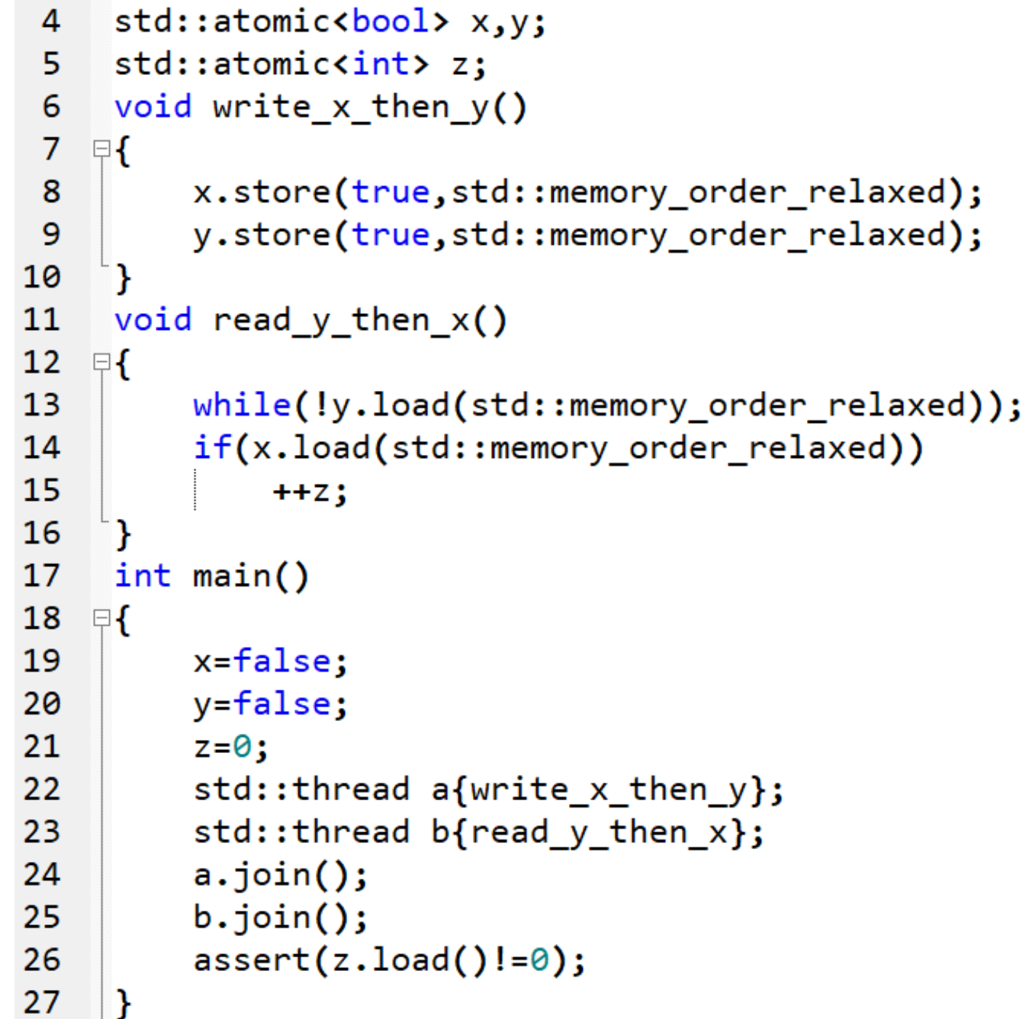

Release-acquire Ordering

* No total MO, but has some synchronisation
* Atomic store-release prevents all R&W from moving past the store-release
* Atomic loads use memory_order_acquire
* Atomic stores use memory_order_release
* Atomic read-modify-write operations (e.g. fetch_add or exchange) use either
  + acquire
  + release
  + acquire-release (memory_order_acq_rel)
* A: Atomic store with memory_order_release
* B: Atomic load with memory_order_acquire
* If load B reads a value written by store in A ⇒ store in A synchronises with load in B
* All memory writes (non-atomic and relaxed atomic) that happened-before the atomic store from A, become visible side-effects in thread B
  + once the atomic load is completed (i.e. B sees the value written by A or a value after release), B is guaranteed to see everything thread A wrote to memory.
* !! sync-with is only guaranteed if store (release) happens before load (acquire), if load happens before store, then there is no guarantee of MO
  + T2 load can happen before any of z store, so the order can be T2 if runs, then all of T1 & T3 run, and come back → can print 0, 1, 3, 5

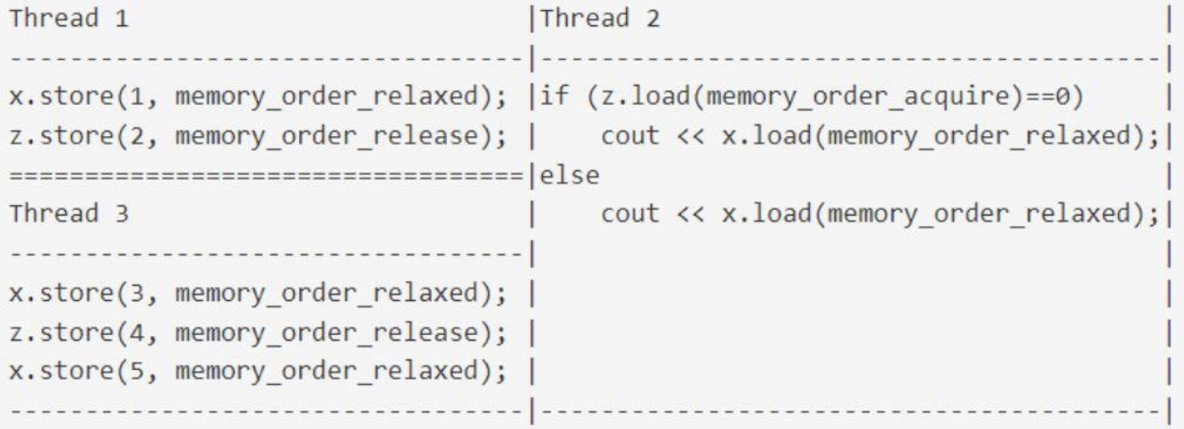

* synchronization is established only between the threads releasing and acquiring the same atomic variable.
  + Other threads can see diff order of memory accesses

E.g.

* Assert can fire:
  + Both lines 17 and 23 read false
  + x & y written by diff threads and there is no synchronization between them

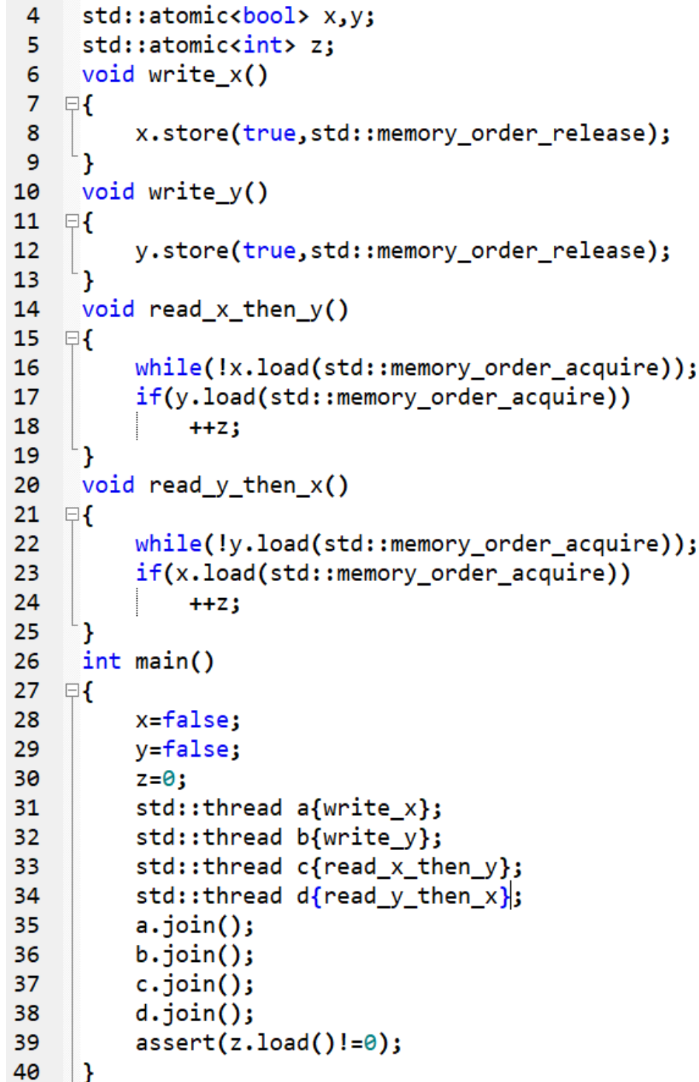

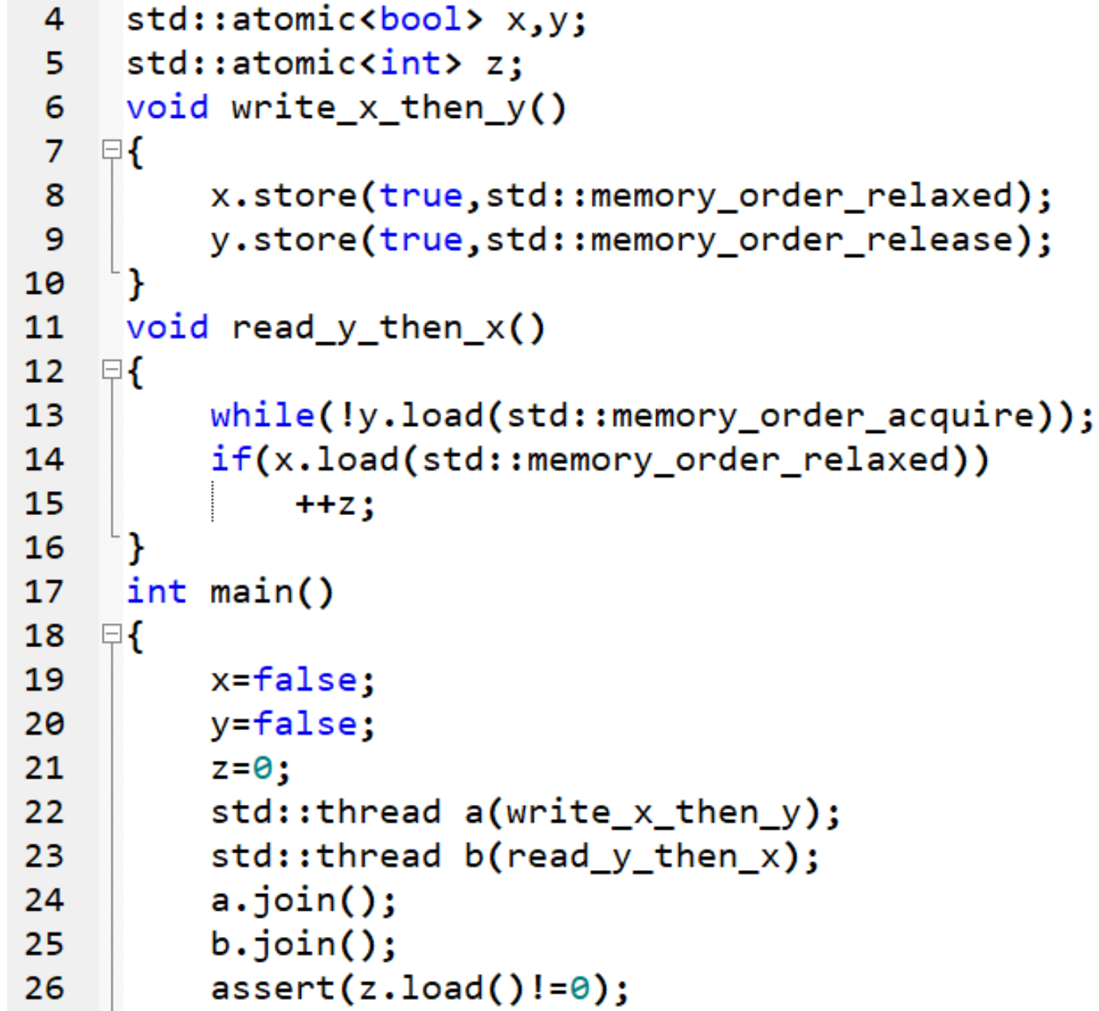

* assert never fires
* line 9 synchronizes-with 13 (true)
  + 8 happens-before 9
  + 13 happens-before 14

Language level memory models

* Modern (C++11) and not-so-modern (Java 5) languages guarantee sequential consistency for data-race-free programs (“SC for DRF”)
  + Compilers will insert the necessary synchronization to cope with the hardware memory model
  + SC for DRF is guaranteed only if every atomic only uses seq_cst
  + No guarantees for other types of orderings, even if the program is DRF
  + No guarantees if the program contains data races
  + Code with language-level specific memory models is eventually translated into assembly for each specific architecture
    - Compiler transforms first → machine code executes + hardware does more transformations

Fences (aka barriers)

* Atomic_thread_fence with memory_order_release ordering prevents all preceding R&W from moving past all subsequent stores

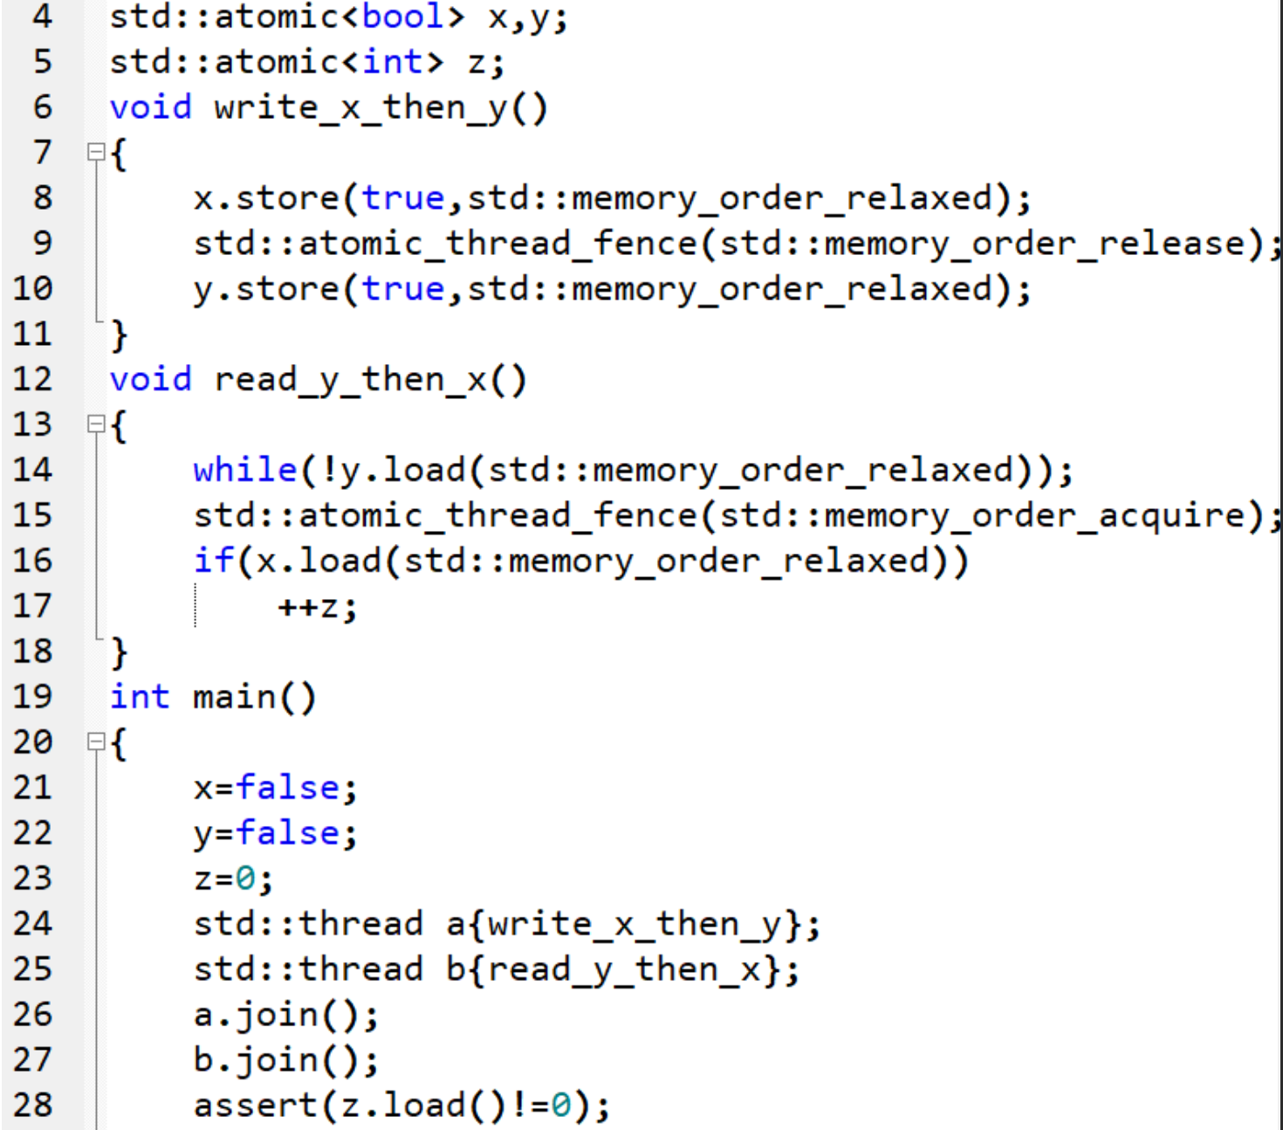

* Assert never fires
* Line 9 synchronizes-with 15
* Line 8 happens-before 16

Core Principle: For all memory models, all threads must agree on the same modification order for each atomic variable.

E.g. A program that has threads 1 and 2 incrementing the value of a and threads 3 and 4 observing the output concurrently.

# Values of ‘a’ seen by T3: 1 2 4 6 8 8 8 8 8 8

Values of ‘a’ seen by T4: 1 3 5 6 8 8 8 8 8 8

* Valid orders; consistent and do not contradict each other. At the time of observation, as long as values are increasing, they are consistent. Just different values at different points of observation.

# **Lecture 4: Testing and Debugging**

| **Race conditions** | |
| --- | --- |
| Data races | Undefined behaviour due to unsynchronised concurrent access to a shared memory location |
| Broken invariant | * Dangling pointers: another thread deleted the data being accessed * Random memory corruption: a thread reading inconsistent values resulting from partial updates * Double-free: 2 threads pop the same value from a queue, so both delete some associated data |
| Lifetime issues | * Thread outlives the data it accesses   + Accessing data that has been deleted   + Potentially the storage is even reused for another object * Ensure that call to join() is not skipped if exception thrown * E.g. thread references local variables that go out of scope before the thread function has completed |

**Techniques for multithreaded testing**

Stress testing (brute-force testing)

* Run multiple times with multiple threads
* max problematic circumstances
* Cover code paths
* Platforms to run tests
  + Uise multicore hardware
  + If available, multiple architectures, e.g. on x86, load is indep of the mem ordering used

Use special implementation of the library for synchronisation primitives

* Mark shared data in some way and allow the library to check operations on a particular shared data are done with a particular mutex locked
* Record the sequence of locks if more than 1 mutex is held by a particular thread at once
* Give priorities to threads to acquire a resource

Structuring multithreaded code

* provide suitable scheduling for threads to execute a particular part of the code

Testing performance

* Scalability: speedup when running w increasing num of threads on increasing num of cores
* Content when accessing shared data from increasing num of threads

**Debugging Tools**

* Compute happens-before to find data races

Valgrind

* Heavy-weight binary instrumentation: ~20x overhead
* Designed to shadow all program values: registers and memory: shadowing requires serializing threads
  + A-bit (Valid-address): corresponding byte accessible
  + V-bit (Valid-value): corresponding bit initialized

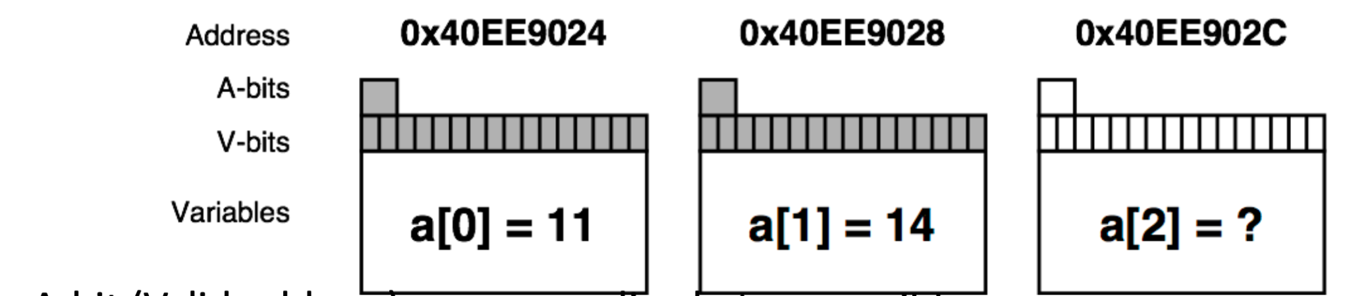

* Validates memory operations in a program
  + Each allocation is freed only once
  + Each access is to a currently allocated space
  + All reads are to locations already written
  + valgrind --tool=memcheck <prog>
* Thread error detectors: Helgrind, DRD

Helgrind in Valgrind

* Dynamic instrumentation
  + Intercepts calls to functions & instruments them
  + 100x slowdown
* Detects misuses of the POSIX pthreads API
  + by intercepting calls to many POSIX pthreads functions
* Detects potential deadlocks arising from lock ordering problems
  + Builds a directed graph indicating the order in which locals have been acquired
  + When a thread acquires a new lock
    - Update graph
    - Check if it contains a cycle → potential deadlock
  + For >= 2 locks
* Detects data races - accessing memory without adequate locking or synchronisation
  + Check the order of memory accesses - happens-before relationship
  + Builds a directed acyclic graph representing the collective happens-before dependencies
  + Monitors all memory accesses
  + (some v long explanation on slide 26)

Sanitizers

* Compilation-based approach
  + Clang and gcc support
  + ~5-10x overhead
  + Add -fsanitize=address, or -fsanitize=thread, etc for different sanitizers

E.g.

* AddressSanitizer (detects addressability issues) and LeakSanitizer (detects memory leaks)
* Thread sanitizers (TSan)
* MemorySanitizer (detects use of uninitialized memory)
* HWASAN, or Hardware-assisted AddressSanitizer, a newer variant of AddressSanitizer that consumes much less memory
* UBSan, or UndefinedBehaviorSanitizer

Address Sanitizer (Asan)

* 2x slowdown
* 1.5-3x memory overhead

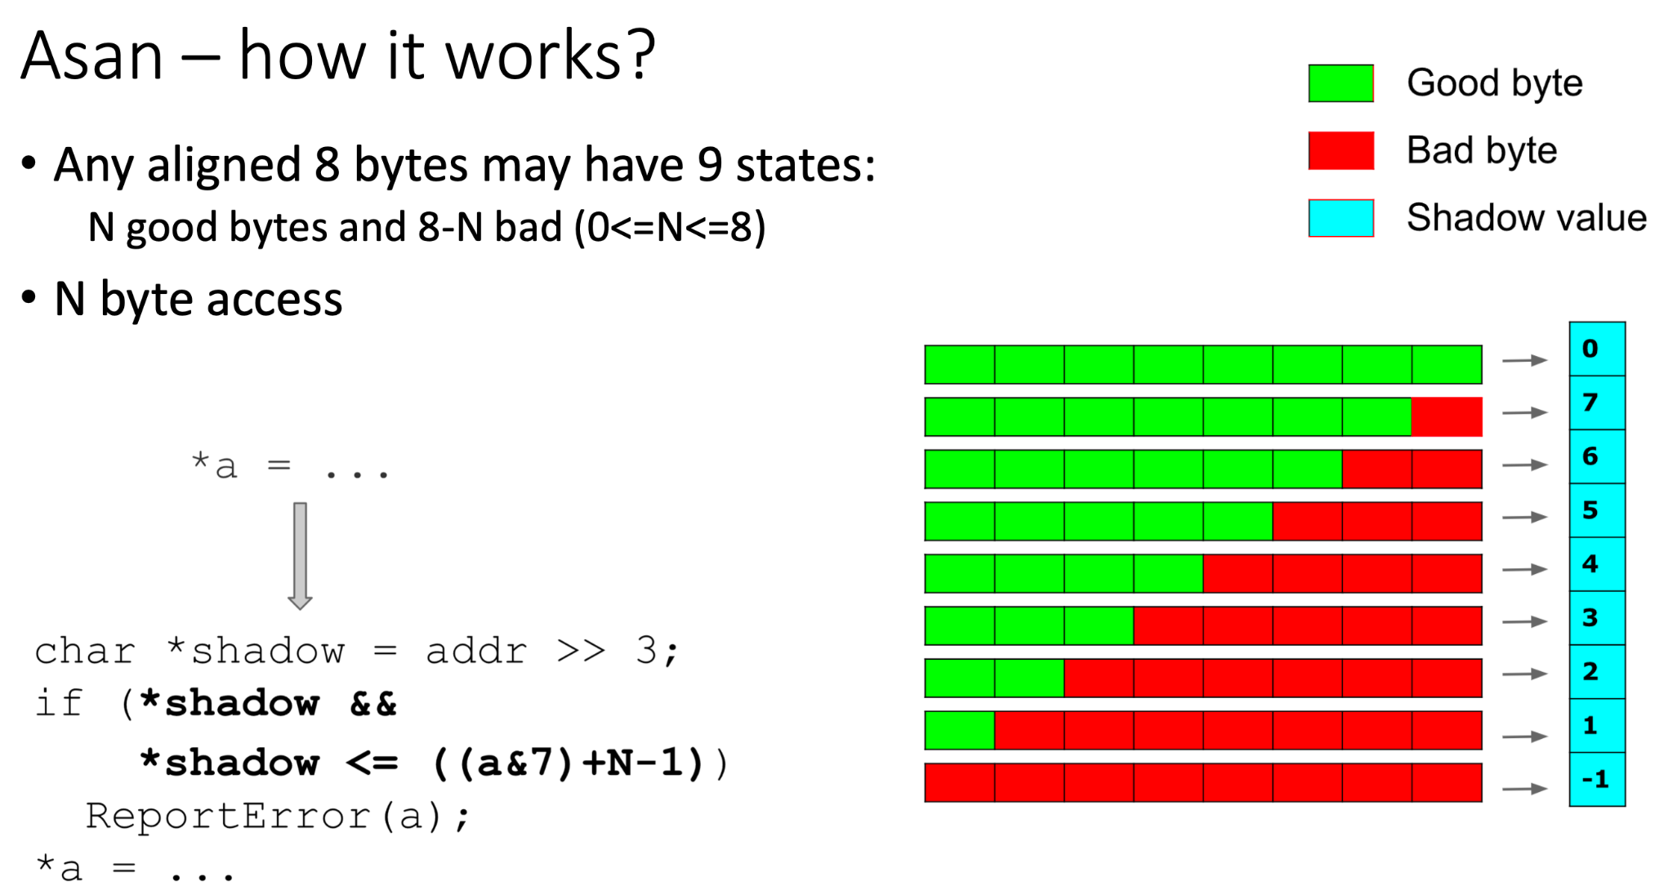

Thread Sanitizer (Tsan)

* Instrument a running program
* Engineered for speedup - 5-15x slowdown and about 5-10x memory overhead
* Scalable
* Runtime library
  + Malloc replacement
  + Fully parallel
  + No expensive atomics/locks
* Compile and link with -fsanitize=thread, -fPIE, -pie
  + Add -O2 for reasonable performance
* Run the executable (using options)
* TSAN_OPTIONS="history_size=7 force_seq_cst_atomics=1" ./myprogram
* Detects
  + Normal data races
  + Races on C++ object vptr
  + Use after free races
  + Races on mutexes
  + Races on file descriptors
  + Races on pthread_barrier_t
  + Destruction of a locked mutex
  + Leaked threads
  + Signal-unsafe malloc/free calls in signal handlers
  + Signal handler spoils errno
  + Potential deadlocks (lock order inversions)
  + [ThreadSanitizerPopularDataRac...](https://github.com/google/sanitizers/wiki/ThreadSanitizerPopularDataRaces)

Compiler-instrumentation with TSan

* Function entry/exit
* Memory access

Shadow Cell (8 bytes = 64 bits)

* Represents 1 mem access
* ~16 bits: Thread ID (TID)
* ~42 bits: Epoch (scalar clock)
* 5 bits: position/size in 8-byte word
* 1 bit: IsWrite
* 4 shadow cells per 8 application bytes

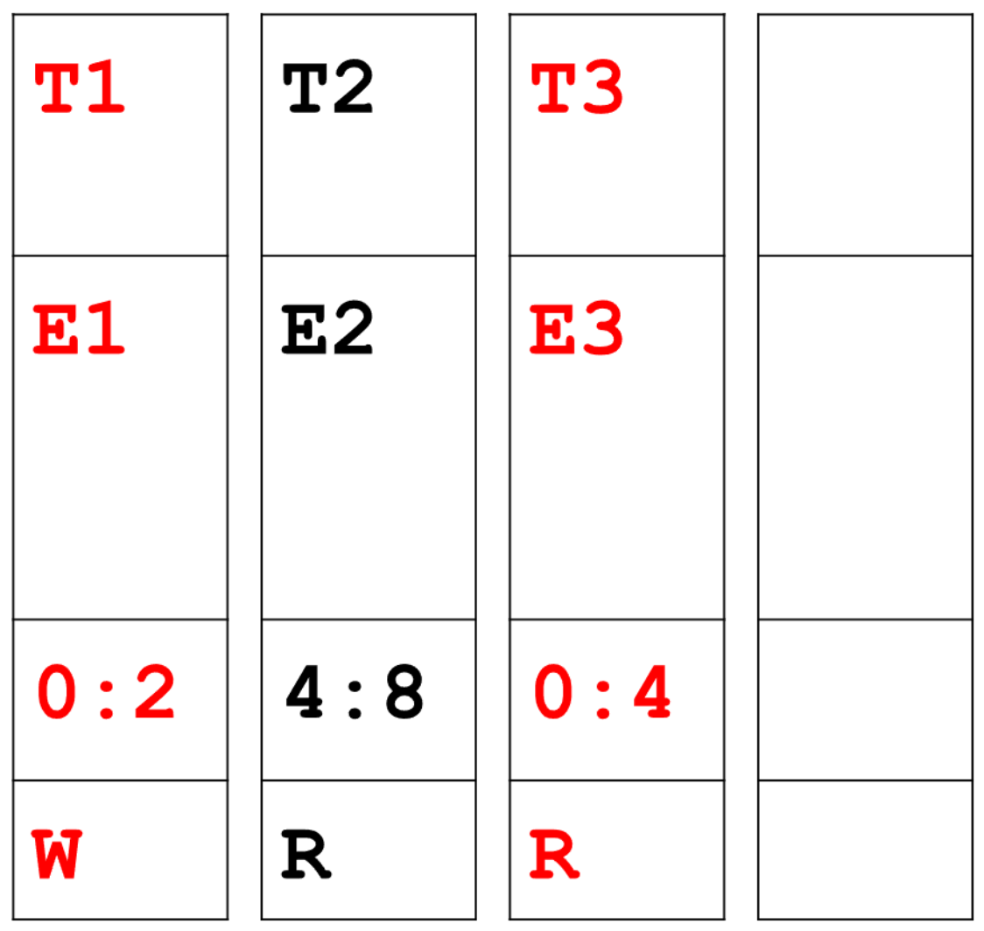

* Race if E1 does not happen-before E3
* Constant time operation
  + Get TID and Epoch
  + 1 load from thread-local storage
  + 1 comparison

Stack trace for previous access

* Shown in the report from Tsan
* Per-thread cyclic buffer of events
  + 64 bits per event (type + PC)
  + Events: memory access, function entry/exit
  + Information will be lost after some time
  + Buffer size is configurable
* Replay the event buffer on report
  + Unlimited number of frames

**Action plan for debugging**

1. Run Valgrind memcheck (and fix the errors)
2. Run Tsan (and fix the errors)
3. Run Asan (and fix the errors)
4. Run Helgrind (and fix the errors)

PYP example action plan

1. Run both sequential and concurrent implementations, compare results for correctness
2. Incrementally remove concurrency
3. Reduce problem size to ease debugging
4. Run single-threaded first
5. Use Valgrind/TSan/Asan, gdb
6. Use a "possible bug"-centric methodology

# **Lecture 5: Concurrent Data Structures in C++**

Goal:

* Multiple threads can access the data structure (DS) concurrently (performing same or distinct operations)
  + Using mutex prevents true concurrency
  + Serialization: threads take turns to access protected data
* Each thread sees a self-consistent view of the DS

Designing thread-safe DS:

* No data lost/corrupted
* All invariants are upheld (but may be broken during updates of DS)
* No race cond

Delete a node from a doubly linked list

*Invariant is broken during the delete

1. Identify the node to delete: N.
2. Update the link from the node prior to N to point to the node after N
3. Update the link from the node after N to point to the node prior to N.
4. Delete node N.

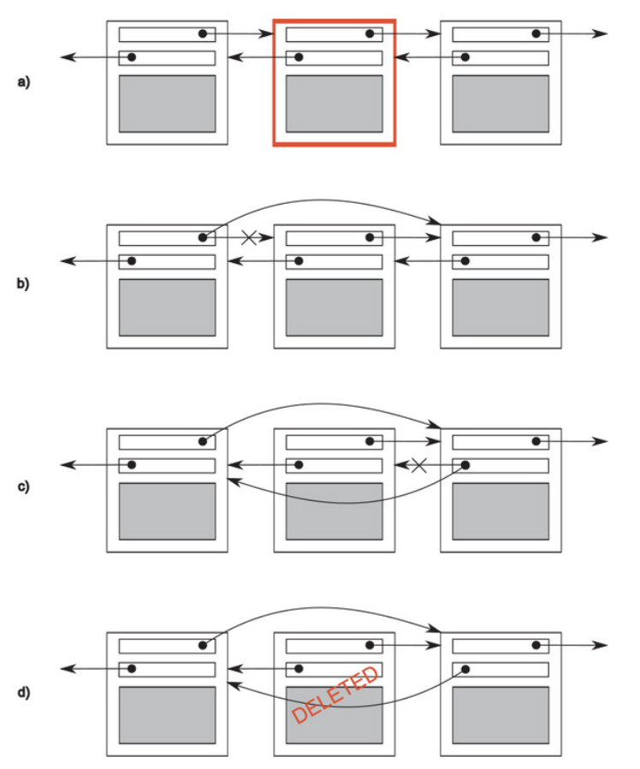

Building a thread-safe DS

* No thread can see a state where the invariants of the DS have been broken by actions of another thread
  + e.g. b & c of delete should not be seen by another thread
* Take care to avoid race conditions inherent in the interface to the DS by providing functions for complete operations rather than for operation steps (abstraction?)
* Note how DS behaves in the presence of exceptions to ensure that the invariants are not broken
* Restrict scope of locks and avoid nested locks where possible → avoid deadlock

Concurrency while calling functions

* Constructors and destructors require exclusive access to the DS
  + Programmer’s responsibility to ensure that DS are not accessed before construction is complete or after destruction has started
* DS that supports assignment, swap, or copy construction
  + Decide if they need exclusive access

Thread-safe DS

* Minimise the amount of serialization
* Granularity: minimise time for holding a lock
* Alternatives:
  + Reader-Writer: multiple threads might perform one type of operation on the DS concurrently, whereas another operation requires exclusive access by a single thread → std::shared_mutex
* Safe for multiple threads to access a DS concurrently if they’re performing different actions, whereas multiple threads performing the same action would be problematic
* Consider diff levels of protection
  + E.g. const, mutable keyword

Lock-based concurrent DS

* Ensure that the right mutex is locked and locked for min time
* Use multiple mutexes to protect separate parts of the structure → possible deadlocks

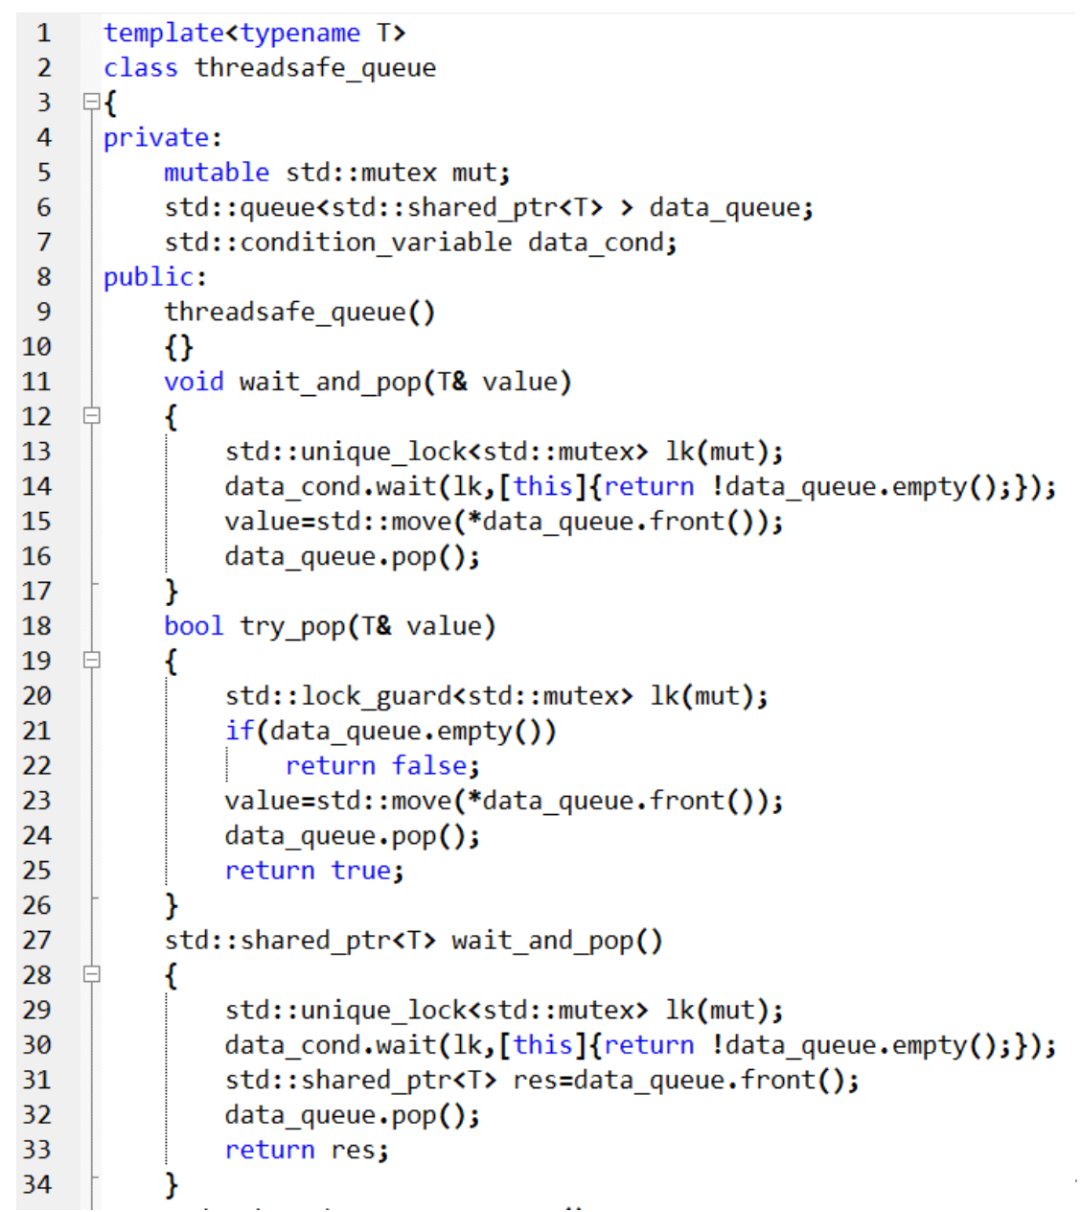

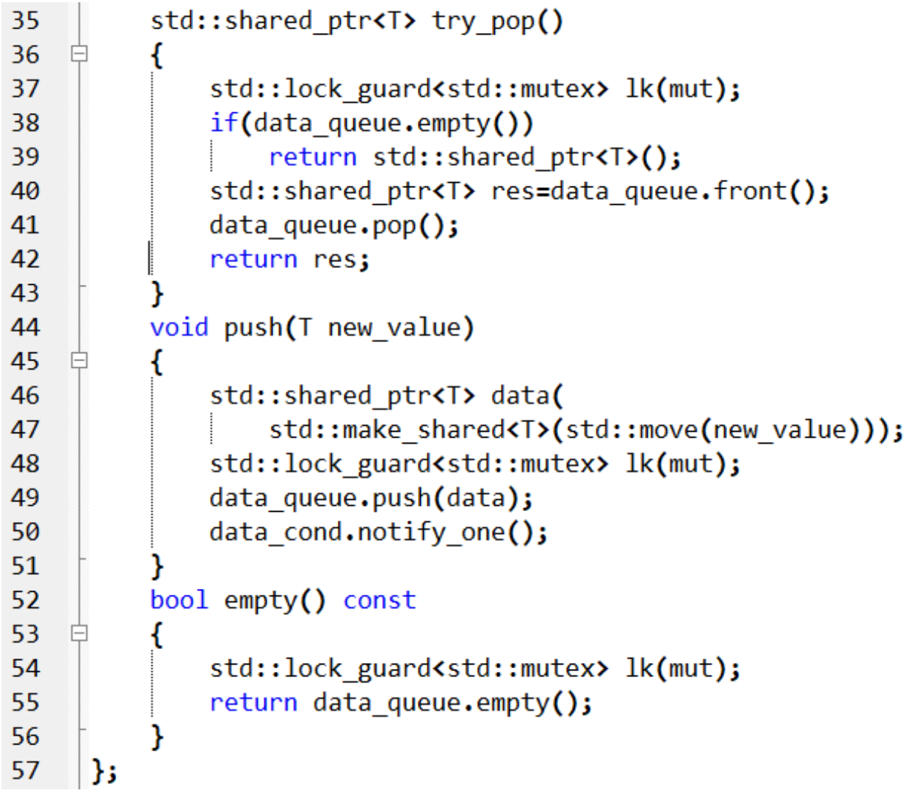

* Exception safe
* Allocation of new instance can be done outside the lock scope in push()
* Usage of 1 mutex limits the concurrency supported by this queue
  + Using standard container std::queue<>, now have 1 data item that is either protected or not
  + Fine-grained locking → need to take control of implementation details

Thread-safe queue using fine-grained locks

* Associate one mutex with each distinct item → insert mutex to the DS itself, cannot use STL
* std::unique_ptr<node> to ensure that the nodes (and data they point to) get deleted when they’re no longer needed, without having to write an explicit delete
* Dummy node
  + Ensure that there is always ≥ 1 node in the queue to separate the node being accessed at the front from that being accessed at the back
  + Empty queue: front and back points to dummy node
  + No race cond on front->next and back->next
  + Add an extra level of indirection to store the data by pointer in order to allow the dummy nodes
* Invariants:
  + back->next == nullptr
  + back->data == nulllptr
  + front == back implies an empty list
  + Single element list: front->next == back
  + For each node x in list, if x != back, x->data points to an instance of T and x->next points to the next node in the list;
  + x->next == back implies x is the last node in the list
  + Following the next nodes from front will eventually yield back

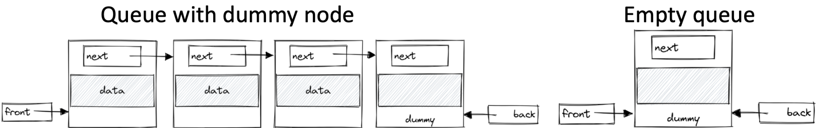



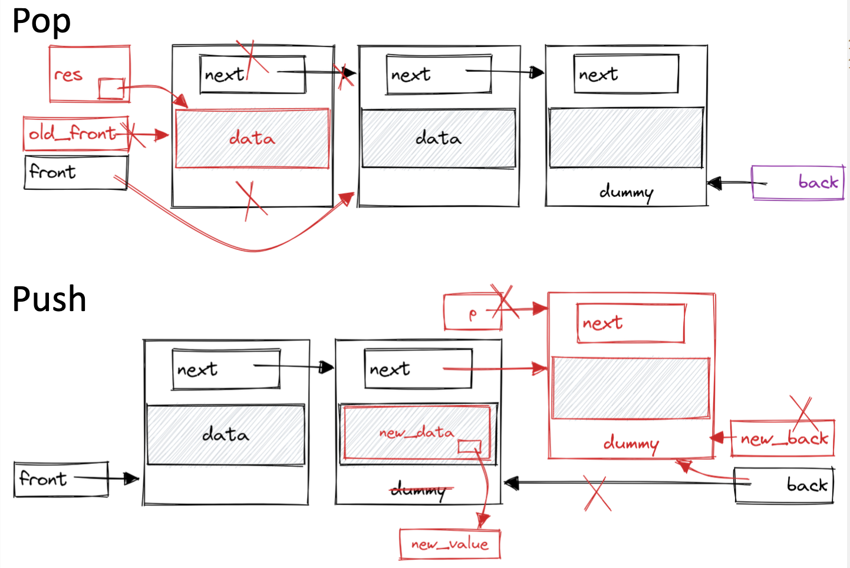

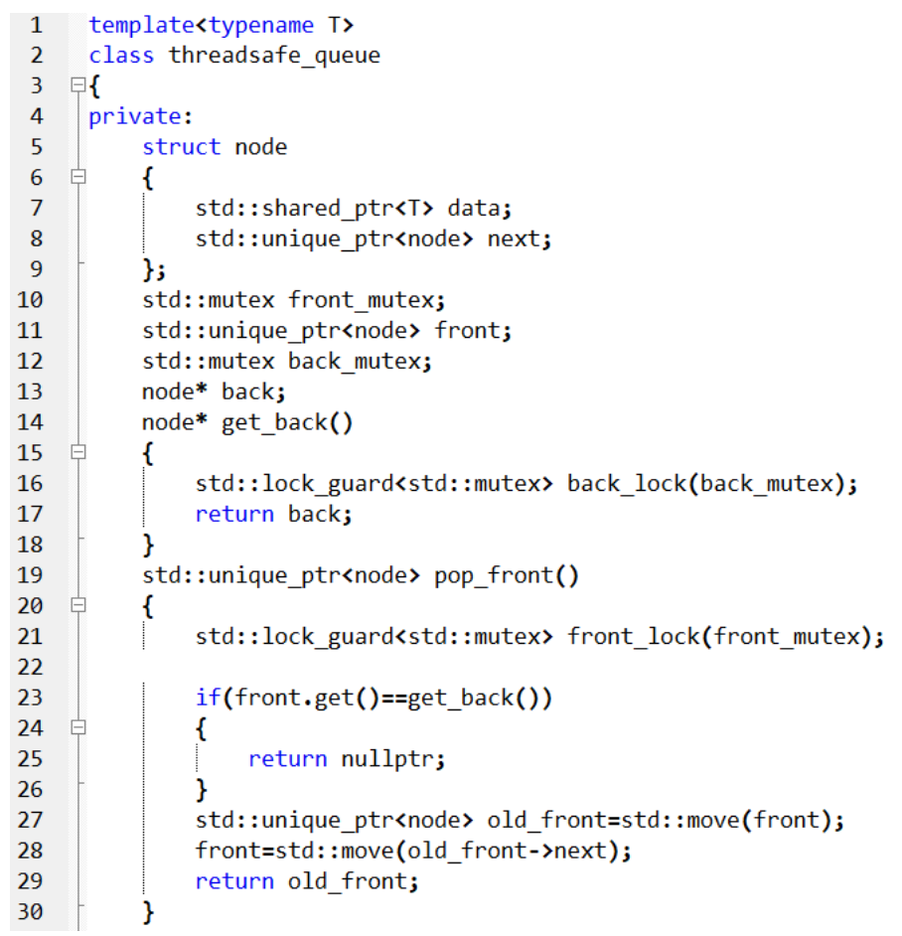

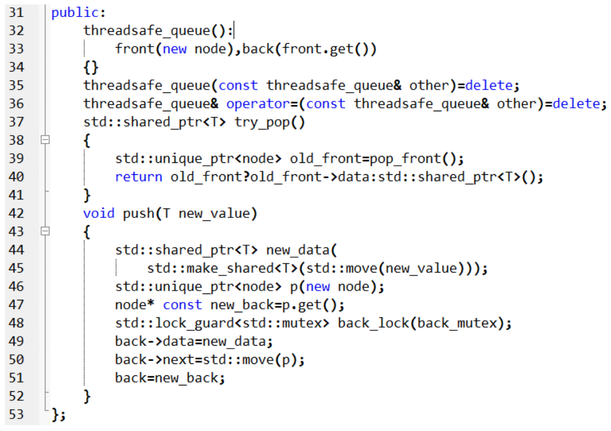

More fine-grained lock-based queue

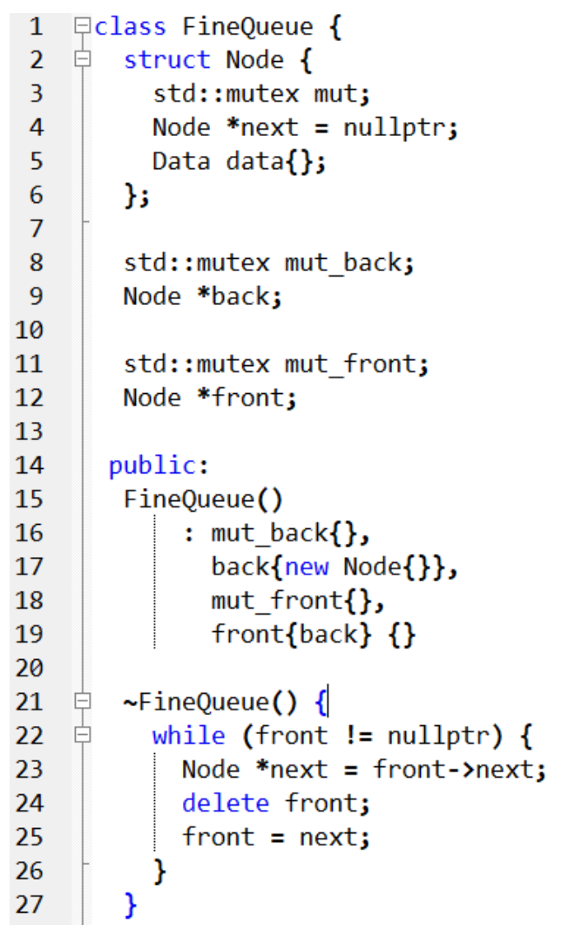

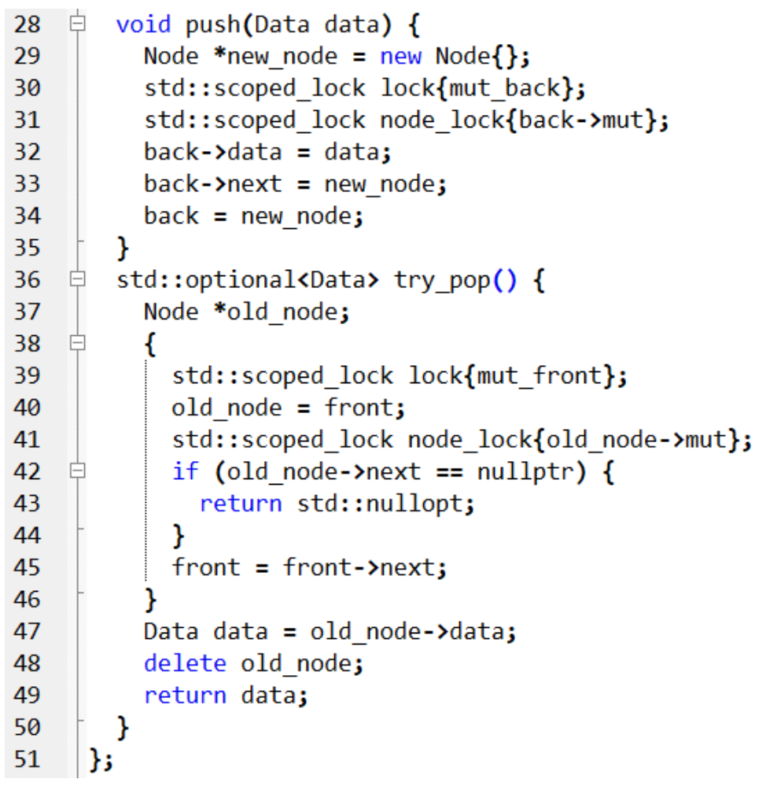

* Line 3: per-node mutex
  + Synchronises-with relationship between push and poop threads
* Line 38: additional scope introduced in try_pop()
  + Avoid Use-After-Free (UAF): node_lock unlocks early, BEFORE we proceed to call delete old_node
  + Delete is expensive → release mut_front early

Blocking DS

* Blocking calls: calls that will suspend the execution of a thread until another thread performs an action
* Thread cannot progress pass this point until the block is removed
* OS will suspend a blocked thread completely and allocate its time slices to another thread until it is unblocked by the appropriate action of another thread (unlock, notify)
* E.g. mutexes, cond var and futures

Non-blocking DS

* **Obstruction-free:** if all other threads are paused, then any given thread will complete its operation in a bounded number of steps.
* **Lock-free:** if multiple threads are operating on a data structure, then after a bounded number of steps one of them will complete its operation.
* **Wait-free:** every thread operating on a data structure will complete its operation in a bounded number of steps, even if other threads are also operating on the data structure.
* E.g. Spin lock
* > 1 thread must be able to access the data structure concurrently
  + do not need to do the same operations
* If one of the threads accessing the data structure is suspended, the other threads must still be able to complete their operations without waiting for the suspended thread
* E.g. a lock-free queue might allow one thread to push and one to pop but break if two threads try to push new items at the same time

Wait-free DS

* No starvation (unbounded num of retries)
* Spin locks are not wait-free

Lock-free DS

* Max concurrency: some thread makes progress every step
* Robustness:
  + other threads can proceed if one thread breaks
  + Cannot exclude threads from accessing the DS
  + Ensure invariants (or alternative invariants) are upheld
  + Note the ordering constraints imposed
  + Ensure the changes become visible to other threads in the correct order
* Possible livelocks
  + 2 threads each try to change the DS but each change requires the operation to be restarted → both loop and retry
* Decrease overall performance (tho they reduce time spent waiting)
  + Atomic operations used for lock-free code can be much more slower than non-atomic operations
  + Hardware must synchronise data between threads (cores) that access the same atomic variables
    - Mem contention and write propagations
    - Cache ping-pong with multiple threads accessing the same atomic variables
    - E.g. a mutex used by many threads
    - False-sharing can produce cache ping-pong as well

Guidelines for writing lock-free code

* Use std::memory_order_seq_cst for prototyping
* Use a lock-free memory reclamation scheme
  + Use some method to keep track of how many threads are accessing a particular object and delete each object when it is no logner referenced anywhere
  + Recycle nodes instead of deleting and re-creating new nodes
* Note ABA problem
  + Include ABA counter alongside the variable
  + Prevalent when using free lists
* Identity busy-wait loops and help the other thread

Lock-free Queue Implementation

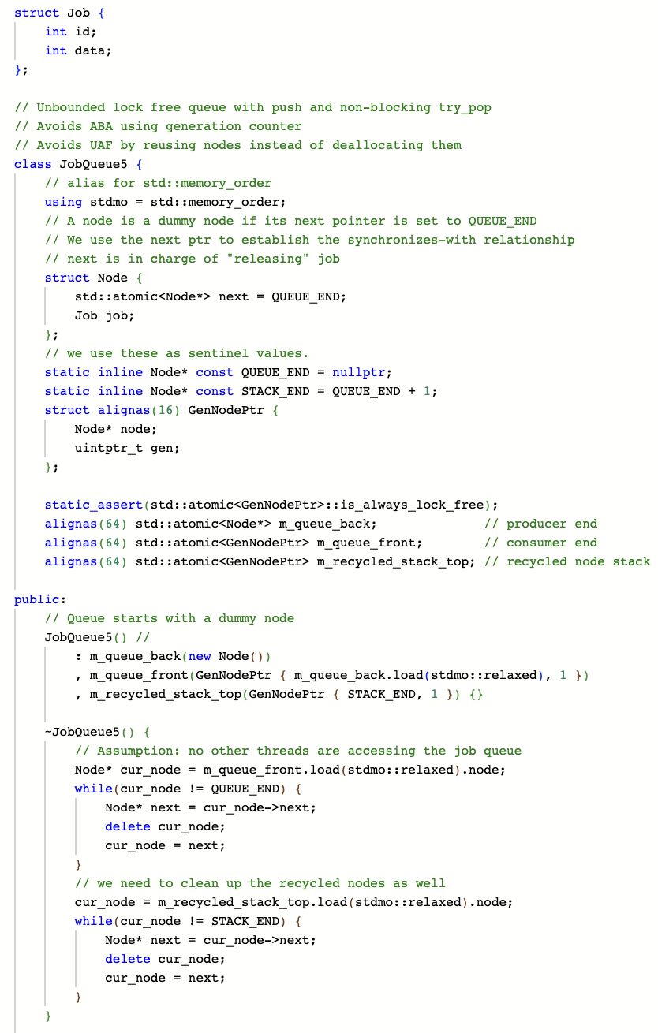

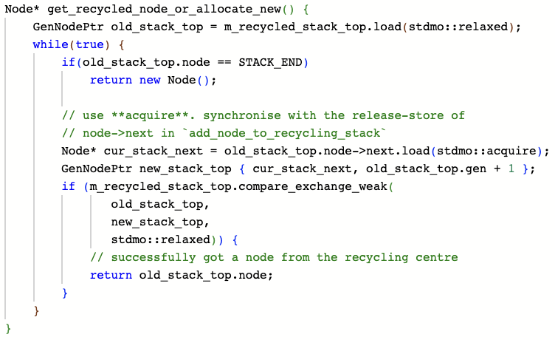

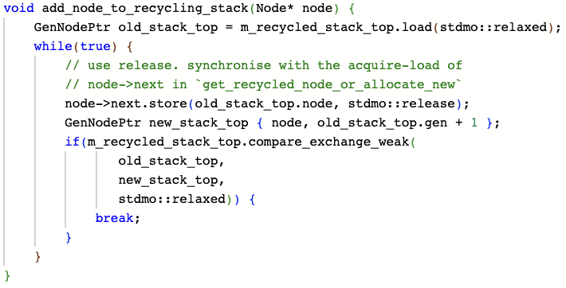

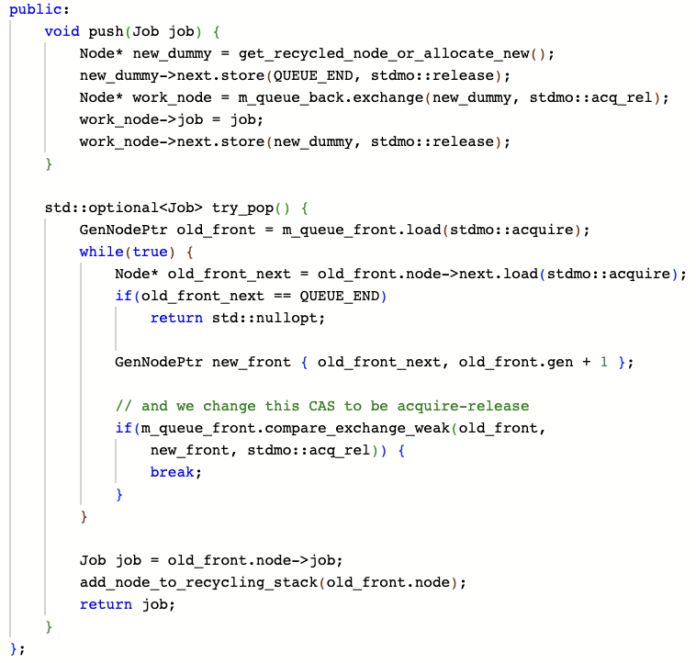

# **Lecture 6: Concurrency in Go**

Task Dependency Graph (DAG)

* Node: Represent each task, node value is the expected execution time
* Edge: Represent control dependency between task
* Critical path length: maximum (slowest) completion time
* Degree of concurrency = Total Work / Critical Path Length
  + An indication of amount of work that can be done concurrently

Parallel Programming: Speedup

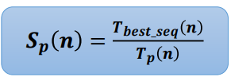

Amdahl’s Law

* Speedup of parallel execution is limited by the fraction of the algorithm that cannot be parallelized (f).
* f (0 ≤ f ≤ 1): sequential fraction, i.e. fixed-workload performance

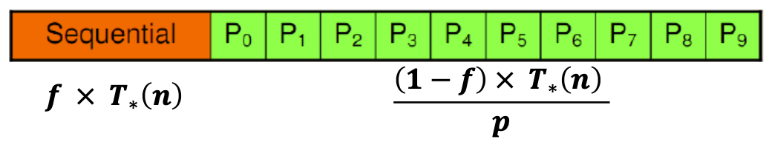

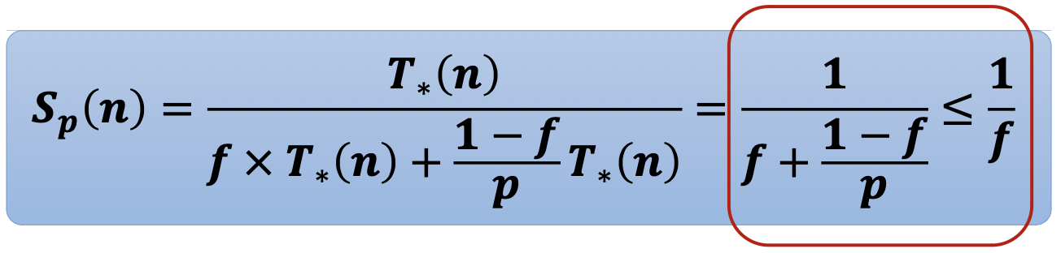

Abstractions in Go:

Concurrency with goroutine & communication with channel

Goroutines

* Function running independently
  + In the same address space as other goroutines
  + the following code can print both “” and “CS3211”

var c = make(chan int, 1)

var text string

func f() {

text = "CS3211"

<-c }

func main() {

go f()

c <- 0

fmt.Println(text) }

* Run OS threads (green threads) but cheaper than threads
* Goroutines follow the fork-join model
* Lightweight: a few kb, 3 cheap instructions per function call
* Goroutines are not garbage collected (cus not objects?), memory is garbage collected

Running Goroutines

* Runtime multiplexes groutines onto OS threads
  + Automatic scheduling - mapping M:N
  + Decouples concurrency from parallelism
* Goroutine is special class of coroutine (concurrent subroutine)
  + When a goroutine blocks, that thread blocks
    - but no other goroutine blocks
    - Thread blocks with goroutine, but thread can be preempted by the runtime
  + Preemptable: Go’s runtime can suspend goroutine that will block

Channels (FIFO)

* Similar to pipe in shell
* Values may be passed along the channel, and then read out downstream
* A channel is a reference to a place in memory where the channel resides
* Typed
* Bi-/uni- directional
  + channel<- input
  + <-channel output
* select statements (switch in other languages)
* Blocking
  + Write to channel that is full; waits until the channel has been emptied
  + read from channel that is empty until at least one item is placed on it
* good practice to have the same goroutine opening and closing a channel (when possible), but not a requirement.
* Main cause of deadlock in go
* Allows for easy distributed systems
* Data is simply protected by confinement (rather than requiring manual synchro)
* Channels are easier to reason about than shared memory / higher level / CSP
* Channels result in clear ownership / separation of concerns
* No data races / safe(r)
* No RAII i.e. need to explicitly send message to unlock something etc
* Some operations are more tedious (e.g. update complex DS)
* Lower performance / lose locality
* No way for multiple goroutines / threads to concurrently access data over a channel (serialized by channel / owner goroutine)

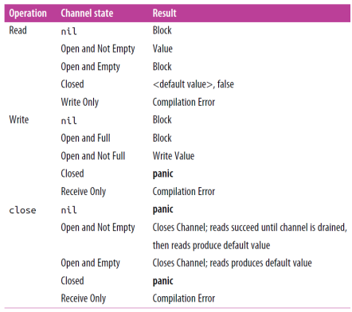

Ownership of channel

* Owner is the goroutine that instantiates, writes, and closes a channel
* Useful when reasoning about program correctness
* Unidirectional channels
  + Owners have a write-access view into the channel (chan or chan<-)
  + Utilizers only have a read-only view into the channel (<-chan)

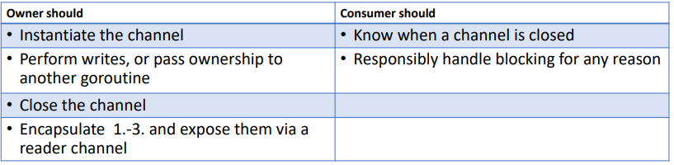

Ownership prevents:

* Deadlocking by writing to a nil channel
* Panicking by closing a nil channel
* Panicking by writing to a closed channel
* Panicking by closing a channel more than once
* Improper writes to our channel

select statement

* Compose channels together in a program to form a larger abstractions
* Bind together channels
  + Locally, within a single function or type
  + globally, at the intersection of 2 or more components in a system, e.g. component A sends to B and C, B receives from A and send to C, C receives from both A and B, select allows all three components to communicate
* Similar to syntax with a switch block
  + BUT case statements aren’t tested sequentially, and execution won’t automatically fall through if none of the criteria are met (block)

Behavior of select

* All channel reads and writes (case statements) are considered simultaneously to see if any of them are ready
  + populated or closed channels in the case of reads
  + channels that are not at capacity in the case of writes
  + Only 1 successful case is chosen (?) and then goes to the next iteration
* Entire statement blocks if none of the channels are ready
* Go runtime will perform a pseudorandom uniform selection over the set of case statements

For-select loop (while true: select…)

* allows a goroutine to make progress on work while waiting for another goroutine to report a result

Sync package

* Sync package implements mutexes
* BUT don’t use!!!
  + Only one goroutine at a time is ever responsible for a particular piece of data
* Used mostly in small scopes such as a struct
* Contains
  + WaitGroup: wait for a set of concurrent operations to complete
  + Synchronization primitives
    - Mutex and RWMutex (Reader/Writer)
    - Cond
    - Once
  + Basic constructs
    - Pool

**Go memory**

Happens Before

* Within a single goroutine, reads and writes behave as if they are executed in the order specified by the program (sequenced before)
* The execution order observed by one goroutine may differ from the order perceived by another
* To guarantee that a read r of a variable v observes a particular write w to v, ensure that w is the only write r is allowed to observe.
* r is guaranteed to observe w if both of the following hold:
  + w happens before r.
  + Any other write to the shared variable v either happens before w or after r.
* Happens before = transitive closure of the union of the sequenced before and synchronized before relations

Synchronised Before (i.e., sync-with)

* Starting of a goroutine is sync before execution of the goroutine
* Exit of goroutine is NOT guaranteed to be sync before any event in the program → independent
* A *send* on a channel is synchronized before the completion of the corresponding *receive* from that channel.
* The *closing* of a channel is synchronized before a *receive* that returns a zero value because the channel is closed
* A *receive* from an unbuffered channel is synchronized before the *send* on that channel completes
* The kth receive on a channel with capacity C is synchronized before the (k+C)th send from that channel completes.
* send 1 → recv 1 → send 2 → recv 2 → close → recv default (zero)

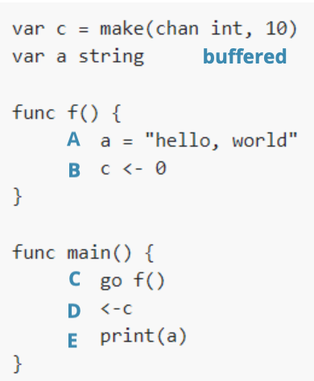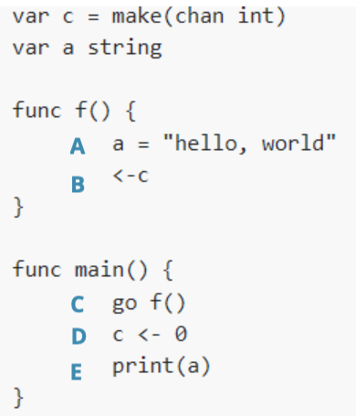

C - SB -> A - seq before -> B - SB -> D - seq before -> E

# **Lecture 7: Concurrency Patterns in Go**

Patterns

* Separation of concerns
  + Data chunks (confinement)
  + Error handling
  + Data processing (pipeline)

Confinement (data chunks)

* Achieve safe operation
  + Synchronization via communicating (e.g. channels)
* Safe concurrency with good performance
  + Immutable data
  + Data protected by confinement
    - Restricts access to shared resources to a single Goroutine at a time, which helps to prevent race conditions and other synchronization issues

Achieving confinement

* Ad-hoc confinement
  + Data is modified only from one goroutine, even though it is accessible from multiple goroutines
  + Needs some static analysis to ensure safety
  + According ChatGPT → use mutec to enforce
* Lexical confinement
  + Restrict the access to shared locations
  + E.g. expose only reading/writing side of the channel
  + E.g. expose only a slice of the array per goroutine → data parallelism

For-select loop

* Context
  + Sending iteration variables out on a channel
  + Looping and waiting to be stopped
    - Do work while channel is not closed

Preventing goroutines from leaking

* Ensure termination of goroutines
  + When it has completed its work
  + When it cannot continue its work due to an unrecoverable error
  + When it’s told to stop working
* Convention: if a goroutine is responsible for creating a goroutine, it is also responsible for ensuring it can stop the goroutine (ownership)

Leaking Goroutine

* Happens when goroutine continues to run even after its intended task is completed and is no longer needed
* Pass nil to channel in line 16 → blocks forever → goroutine accumulate in memory

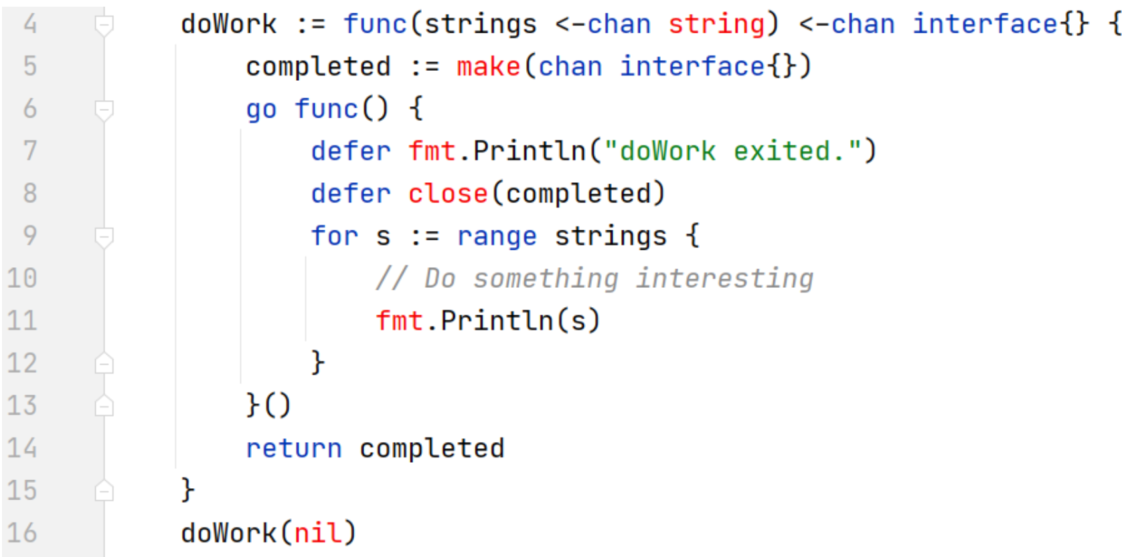

Stopping writer goroutines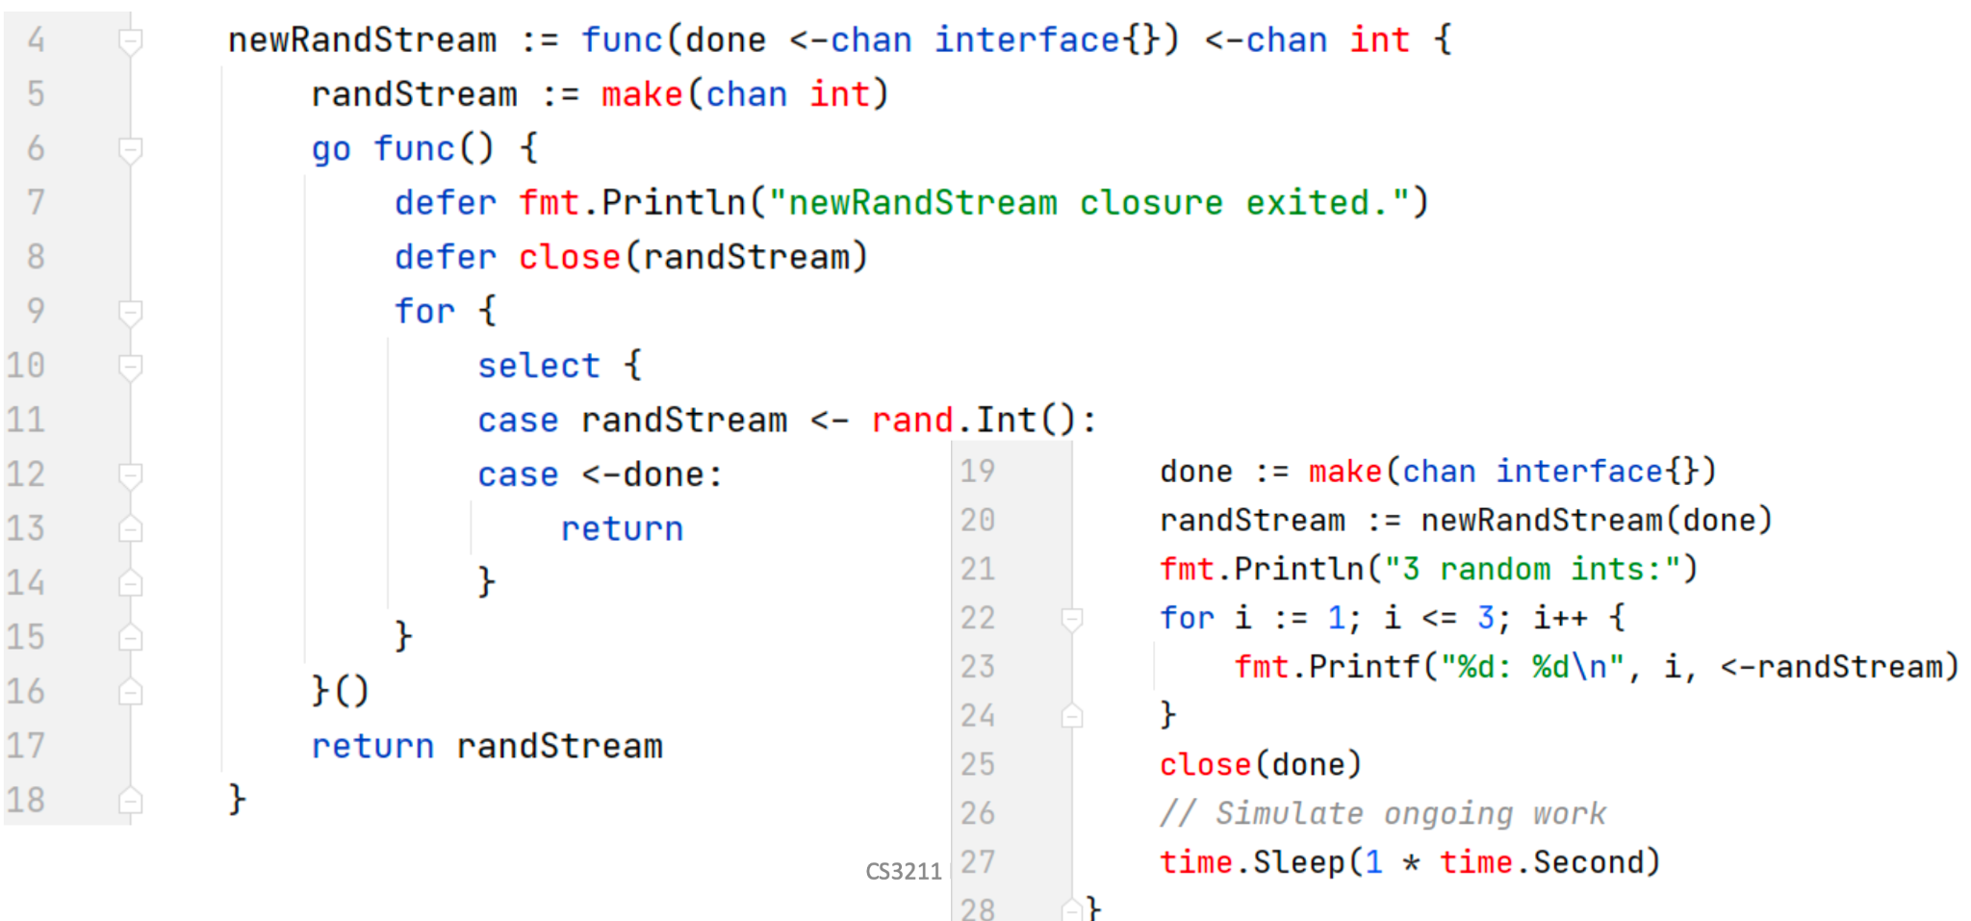

Error Handling

* A goroutine to maintain complete information about the state of the program → state goroutine
* All goroutine send their errors to the state-goroutine that can make an informed decision about what to do
* Couple the potential result with the potential error
  + Errors should be tightly coupled with your result type and passed along through the same lines of communication

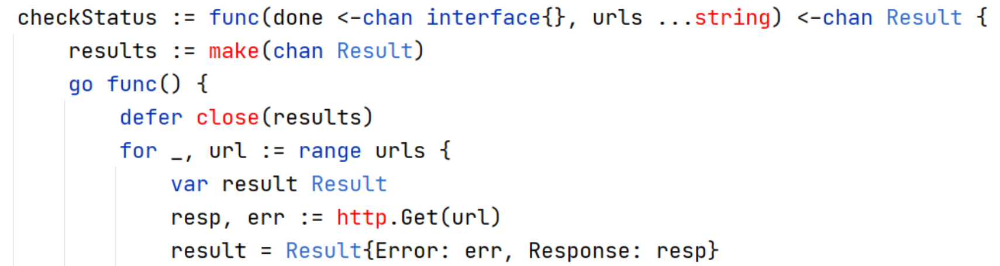

Then results <- result

Pipeline

* A set of data processing elements connected in series, where the output of one element is the input of the next one
  + Stages
  + Connect the stages

Pipelines in Go

* A series of stages connected by channels
  + Each stage is a group of goroutines running the same function
* In each stage, the goroutines
  + receive values from upstream via inbound channels
  + perform some function on that data, usually producing new values
  + send values downstream via outbound channels
* Each stage has any number of inbound and outbound channels, except first and last stages
  + The first stage: source or producer
  + The last stage: the sink or consumer

Pipeline pattern in concurrent programming

* Separate the concerns of each stage
  + Modify stages independently of one another
  + Mix and match how stages are combined independent of modifying stages
  + Process each stage concurrent to upstream or downstream stages
  + Fan-out or rate-limit portions of your pipeline

Pipelines design

* For efficient
  + Designer should divide the work and resources among the stages such that they all take the same time to complete their tasks
  + Fan-out to decrease the processing time for a stage if that is the bottleneck
  + Use of I/O and multiple CPUs for processing streams of data
* Not obviously faster than a task pool
  + Pipeline is better if there is a cap on a specific resource that is needed by all tasks in the task pool (at different times)

Fan-out, fan-in pattern

* Stages in pipeline may be slower than the other, e.g. computationally intensive work, and they might benefit from (data) parallelism
* Fan-out: start multiple goroutines to handle input from pipeline
  + Fan out if the stage
    - does not rely on value that the stage had calculated before
    - Takes a long time to run.
  + Fan-out has no guarantee on the order concurrent copies run and return
  + Use runtime.NumCPU() to find the number of OS threads that are used to run goroutines → usually is the number of fan-out
* Fan-in: combine multiple results into one channel
  + Involves multiplexing or joining together multiple streams of data into a single stream (merging)
    - Consumers read from the multiplexed channel
    - Spin up one goroutine for each incoming channel, and transfer the information from the multiple streams into the multiplexed stream

Realistic Load balancer

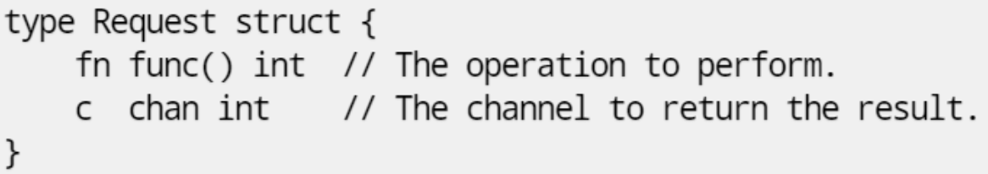

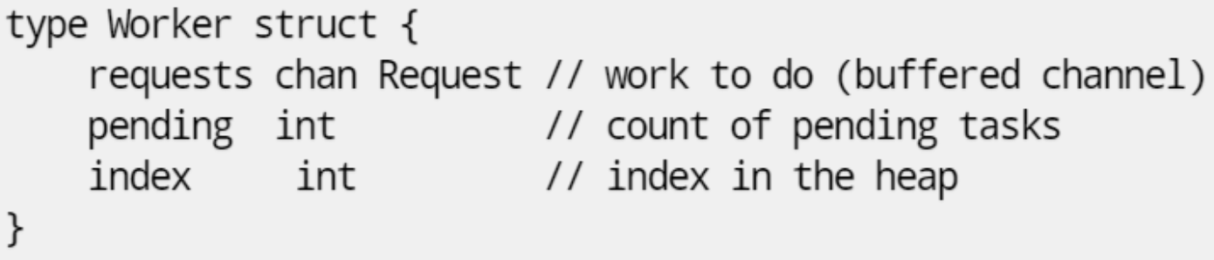

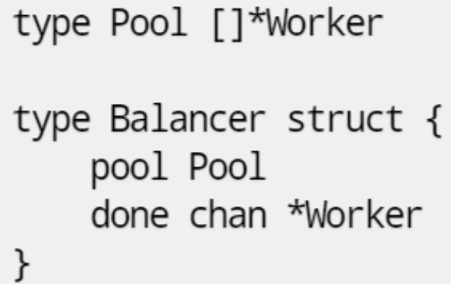

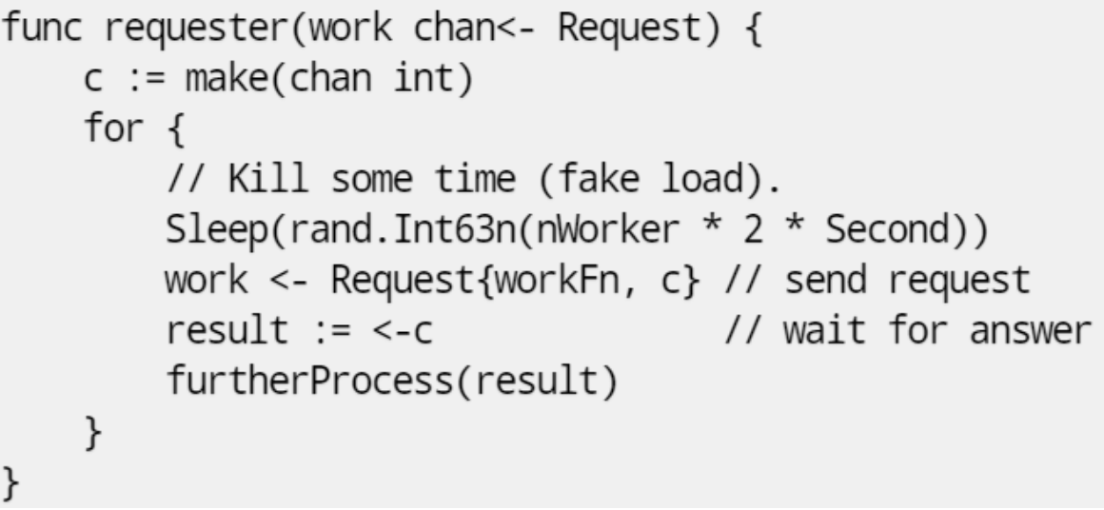

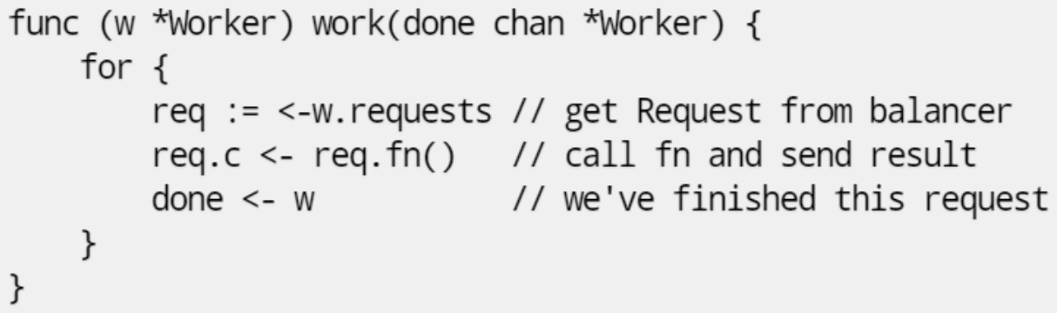

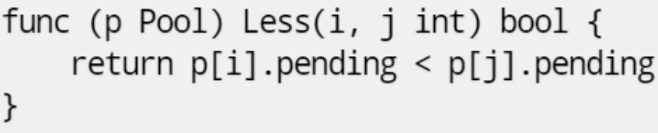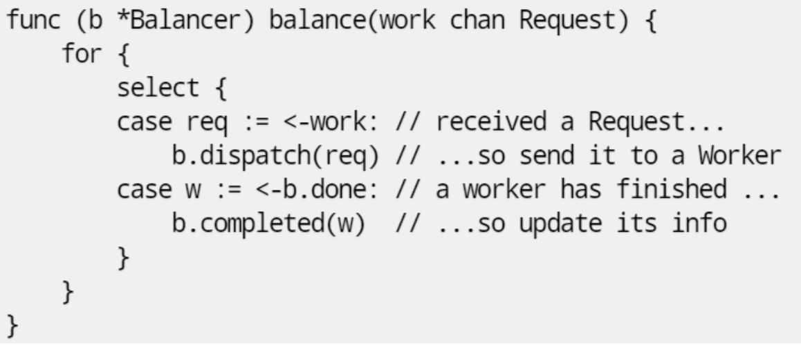

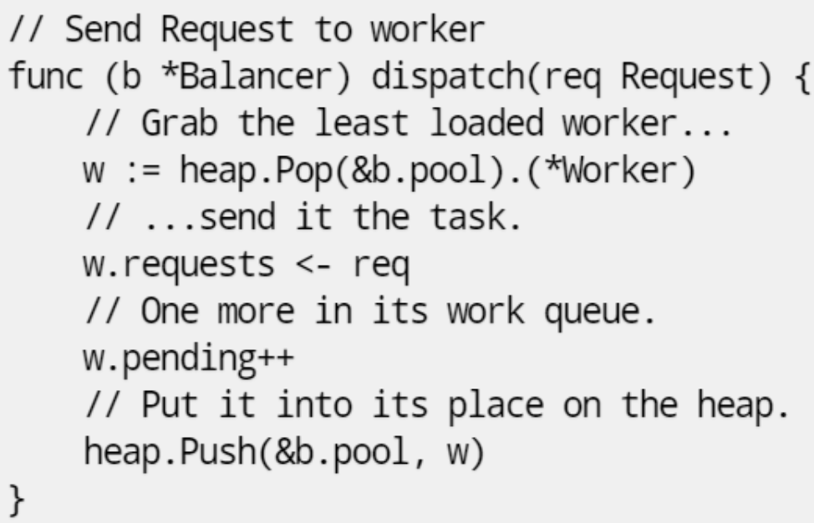

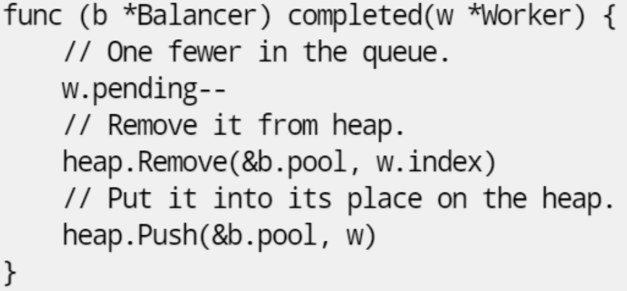

* The requesters send Requests to the balancer
  + return channel inside the request
* Worker
  + Channel of requests delivers requests (w.requests) to each worker
  + The balancer tracks the number of pending requests as a measure of load
* Each response goes directly to its requester
* Balancer needs
  + A pool of workers
  + A single channel to which requesters can report task completion
  + Dispatches and Completes
* A heap (priority queue) of channels - the Pool
  + Heap interface
  + Balance by making the Pool a heap tracked by load

Dispatch

1. Send request to worker
2. Pop the least loaded worker to send the task to
3. Increment num pending tasks of the worker
4. Push the worker back to the heap

Completed

1. Decrement num pending tasks of the worker
2. Remove from heap
3. Push the updated worker to the heap

Commonly seen behaviours in Go

* <-done calls give goroutines the chance to be stopped at any point && each blocking call is an opportunity for deadlock

func f() {

time.Sleep(time.Second)

fmt.Println(“hello world”)

}

func main() {

for i := 0; i <10; i++ {

go f()

}

}

AND

func main() {

var wg sync.WaitGroup

for i:= 0; i < 10; i++ {

go func() {

wg.Add(1)

f()

wg.Done()

} ()

}

wg.Wait()

}

* Both main functions return 0 and does not print out anything.
* For former, main thread ends before f() starts running.
* For latter, main can reach wg.Wait() before any goroutines have been added.

Context library in Go

* means of transmitting deadlines, caller cancellations, and other request-scoped values across API boundaries and between processes
  + For multiple exit conditions
* not stored but passed to each function that needs it
* Incoming requests should create context; Outgoing calls to server should accept a context. Chain of function calls between them must propagate the context
* When a context is canceled, all contexts derived from it are also canceled

# **Lecture 8: Classical Synchronization Problems**

| **Problem** | **CS Problem** |
| --- | --- |
| Barrier | Wait until threads/processes reach a specific point in the execution |
| Producer-consumer | Model interactions between a processor and devices that interact through FIFO channels |
| Reader-writer | Model access to shared memory |
| Dining philosophers | Allocation of limited resources to a group of processes in a deadlock-free and starvation-free manner |
| Barber shop | Coordinating the execution of a processor |
| FIFO semaphore | Needed to avoid starvation and increase fairness in the system |
| H2O | Allocation of specific resource to a process |
| Cigarette smokers | The agent represents an OS that allocates resources, and the smokers represent applications that need resources |

**Producer-consumer**

Processes share a buffer (bounded or unbounded)

* Producers produce items to insert in buffer only when buffer is not full (< k items)
* Consumers remove items from buffer only when the buffer is not empty (> 0 items)

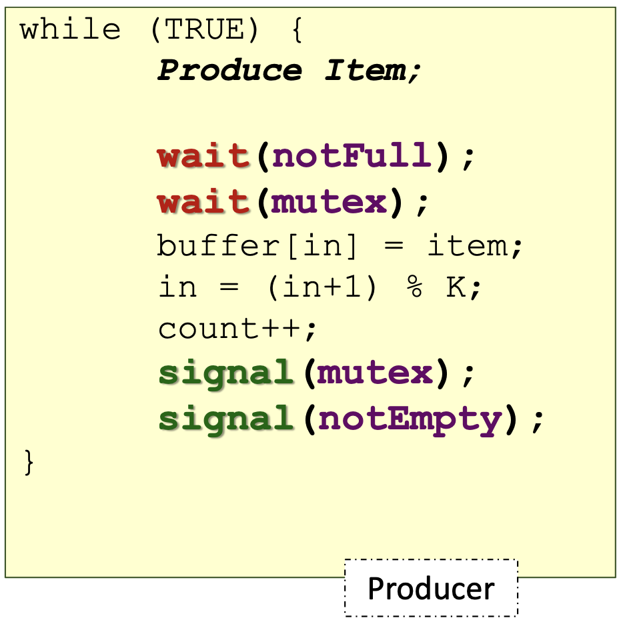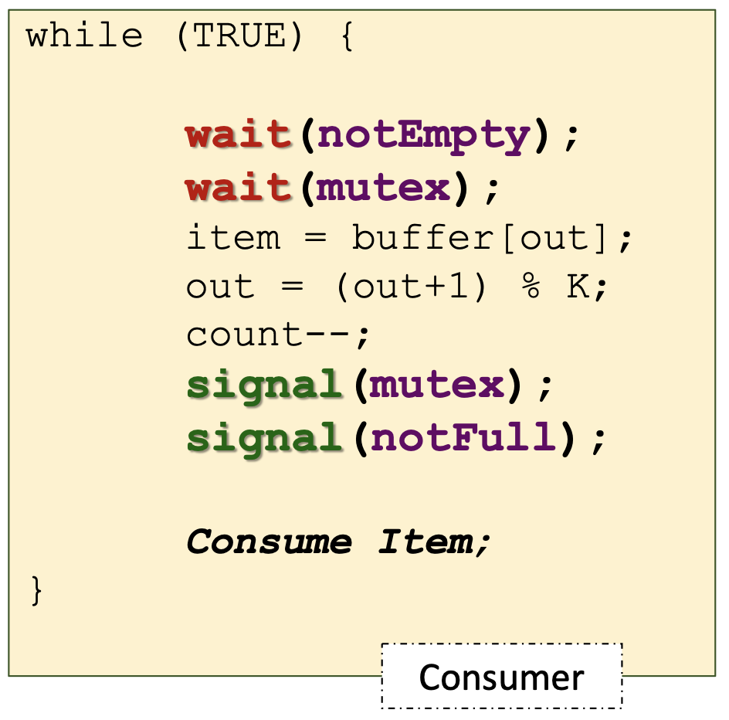

**Reader-Writer**

Processes share a data structure D

* Reader: retrieves information from D
  + Shared-access to D with other readers
* Writer: modifies information in D
  + Must have exclusive access to D

| When a reader is waiting on semaphore.wait() i.e. roomEmpty, no other reader is waiting for roomEmpty but many writers will be waiting for roomEmpty. Readers will just increment counter and go to CS. Last reader will ‘switch off the light’ i.e. signal roomEmpty so that writers can enter |  |
| --- | --- |
| Writer starvation is possible |
| turnstile ensures that when a writer starts waiting on the room, all readers must queue at turnstile.  If a writer enters and room is not empty, writer will be blocked at roomEmpty.wait() → barring readers from entering the room while a writer is queued. | No starvation |

Programming language locks for reader-writer

* C++: shared_mutex
* Go: RWLock

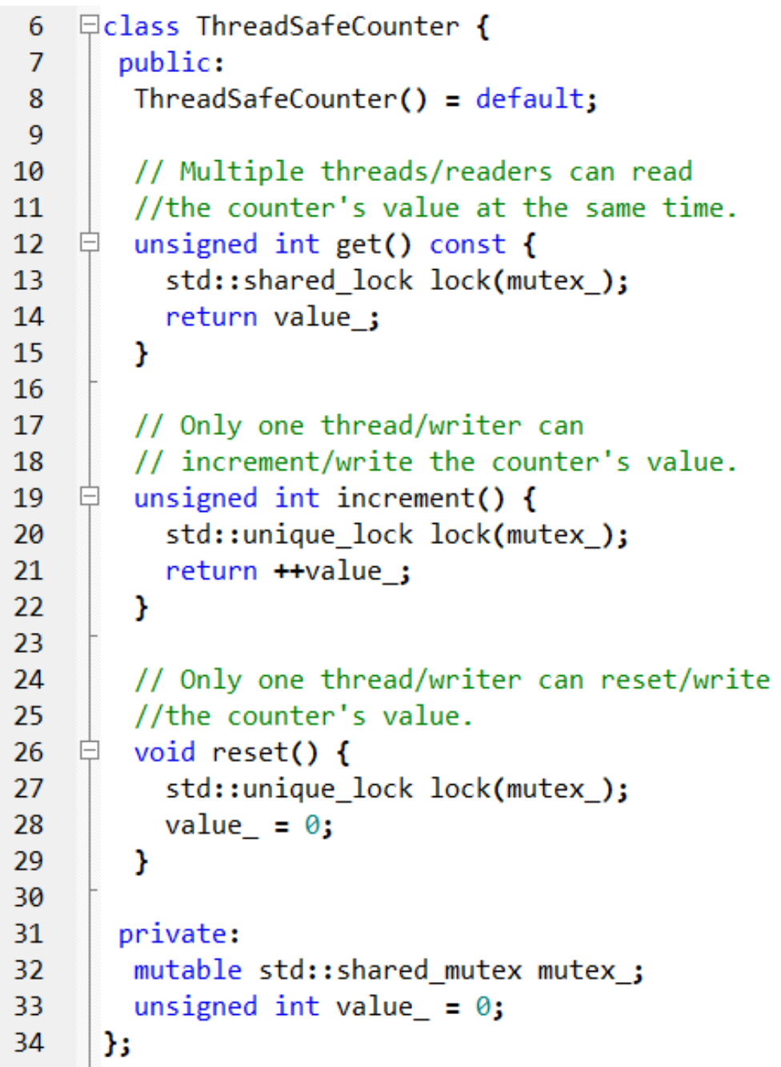

**Barrier**

* Appears in many collective routines as part of directive based parallel languages
  + parallel for loop in OpenMP
  + Collective communication in MPI
* Part of the programming language
  + std::barrier in C++ 20
  + WaitGroup wait in Go
* Single use barrier or latch (std::latch)
  + Starts in the raised state and cannot be re-raised once it is in the lowered state
* Reusable barriers (std::barrier)
  + Once the arriving threads are unblocked from a barrier phase’s synchronisation point, the same barrier can be reused
  + Combining tree barrier - hierarchical way of implementing barrier
    - Resolve the scalability by avoiding the case that all threads are spinning at the same location
    - Combine into taskgroups so that each taskgroup spin wait at different locations → fewer resources wasted

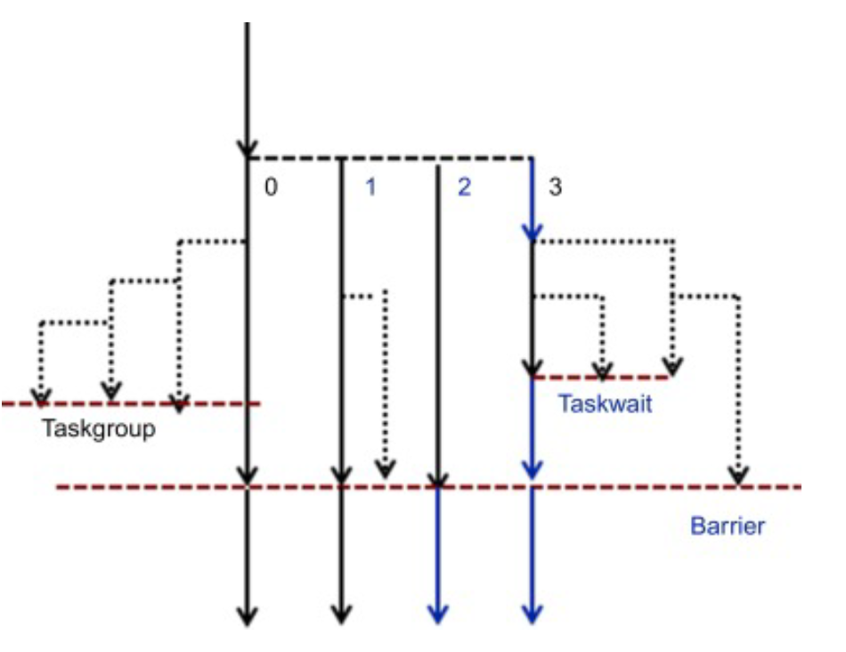

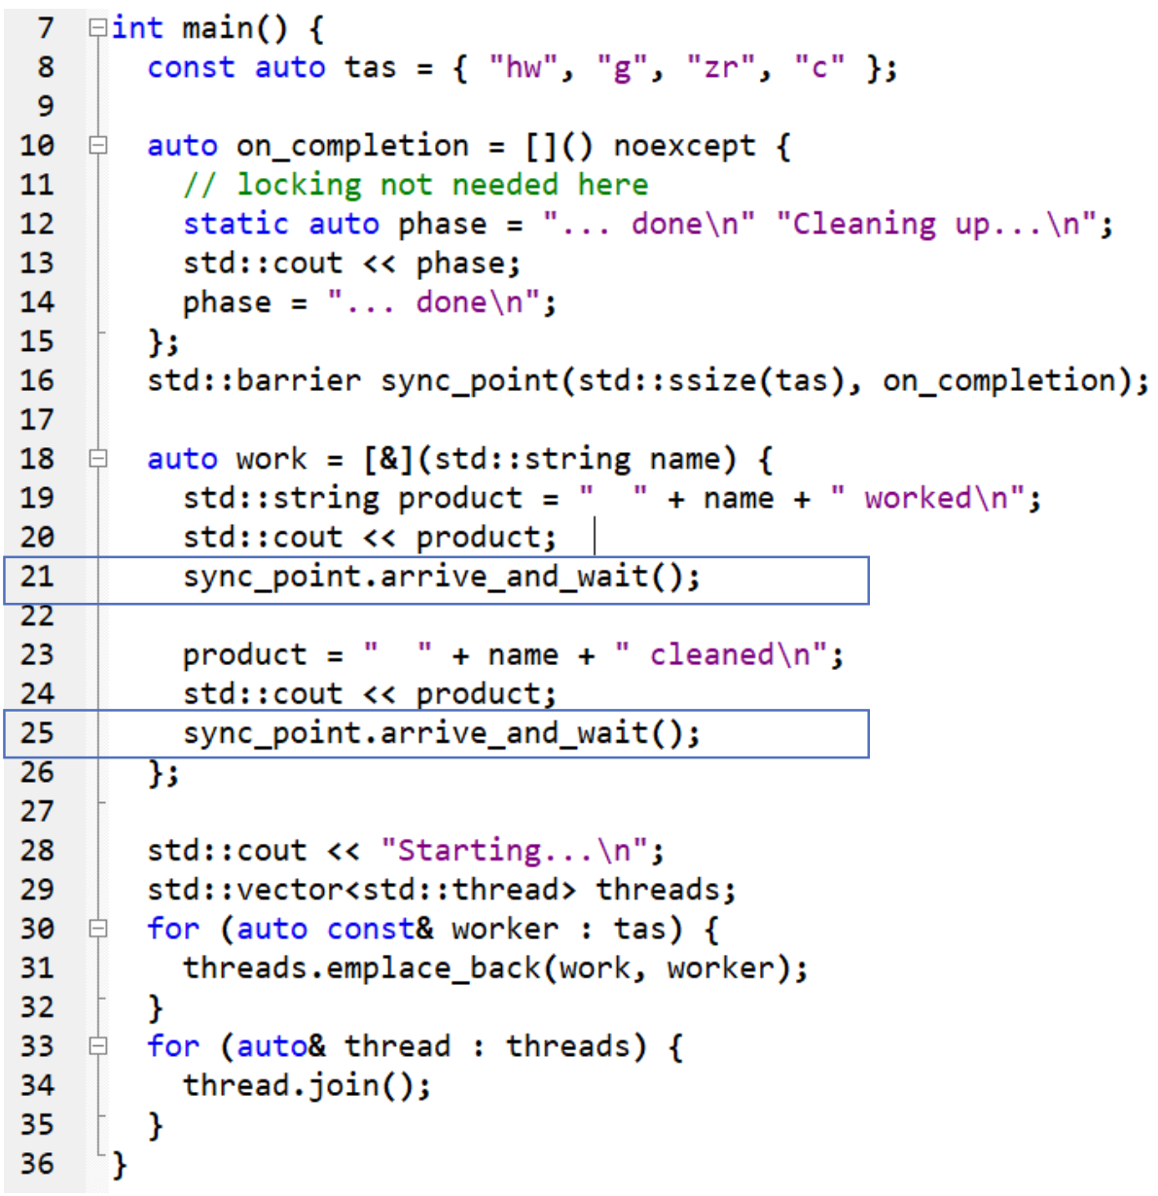

* Line 21 & 25: wait for all threads to arrive at the barrier

Barrier Implementation in C++

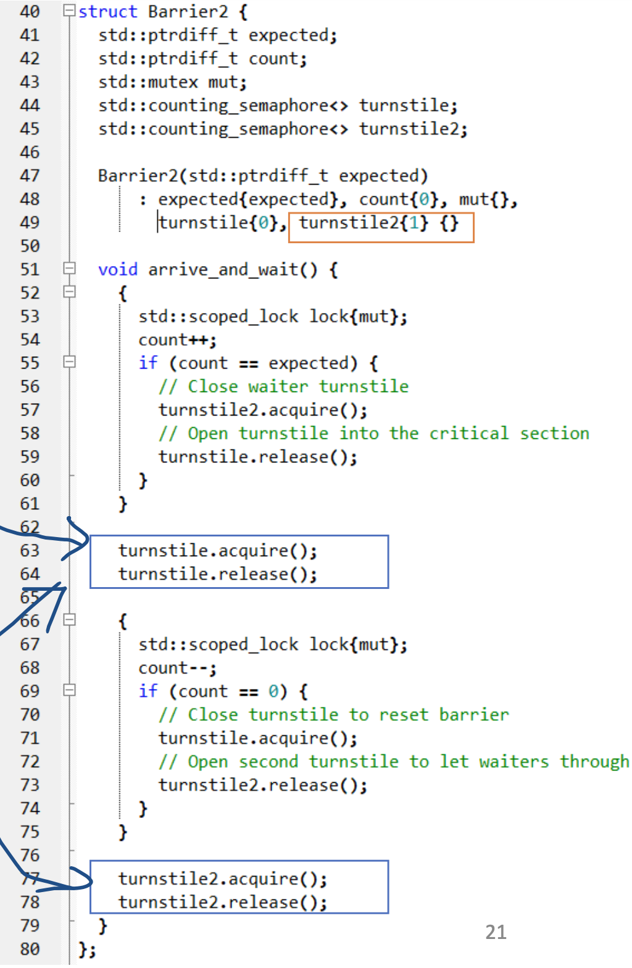

* Use turnstiles to avoid threads going ahead of other threads by one lap
* Lines 102 and 115: counting semaphore can be increased by expected to allow threads to pass
  + But counting semaphores may block if there were high contention

Barrier Implementation in Go

* Use 2 WaitGropus for a reusable barrier for a group of goroutines

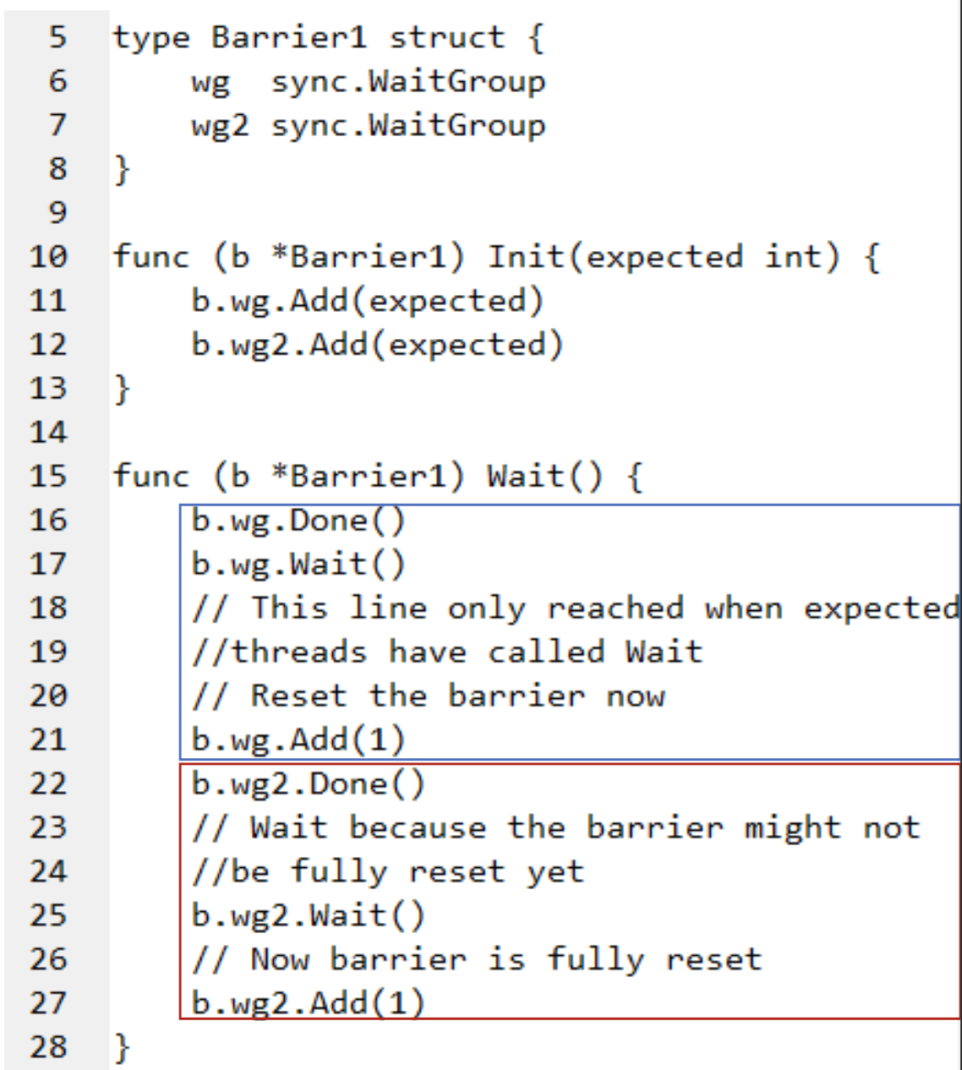

**Dining Philosophers**

* Appeared when computers were competing for access to tape drive peripherals
* Models the problem of allocating limited resources to a group of processes in a deadlock-free and starvation-free manner
* An algo that solves this problem without deadlock
  + Low contention: good performance when the philosophers spend any appreciable amount of time thinking (waiting), compared to eating
  + High contention: philosophers are hungry

Dining philosophers implementation in C++

* Use some deadlock avoidance algo
  + Objects are locked by an unspecified series of calls to lock, try_lock and unlock.
  + If a call to lock or unlock results in an exception, unlock is called for any locked objects before rethrowing

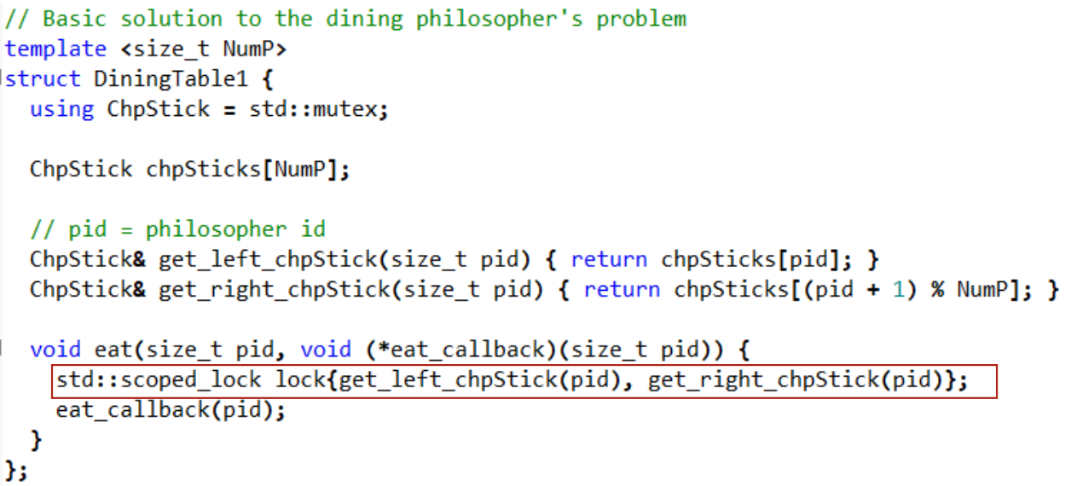

Limiting number of eaters

* Starvation is possible as mutexes and semaphores are not fair in C++
* Wakes up random process

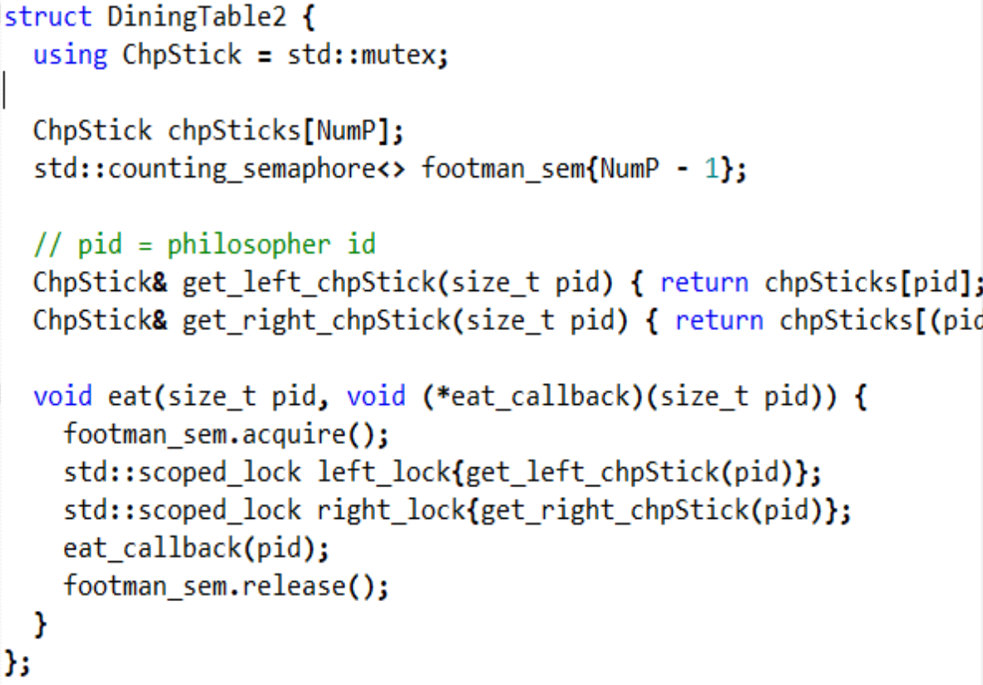

* Use a fair semaphore: FIFO sem

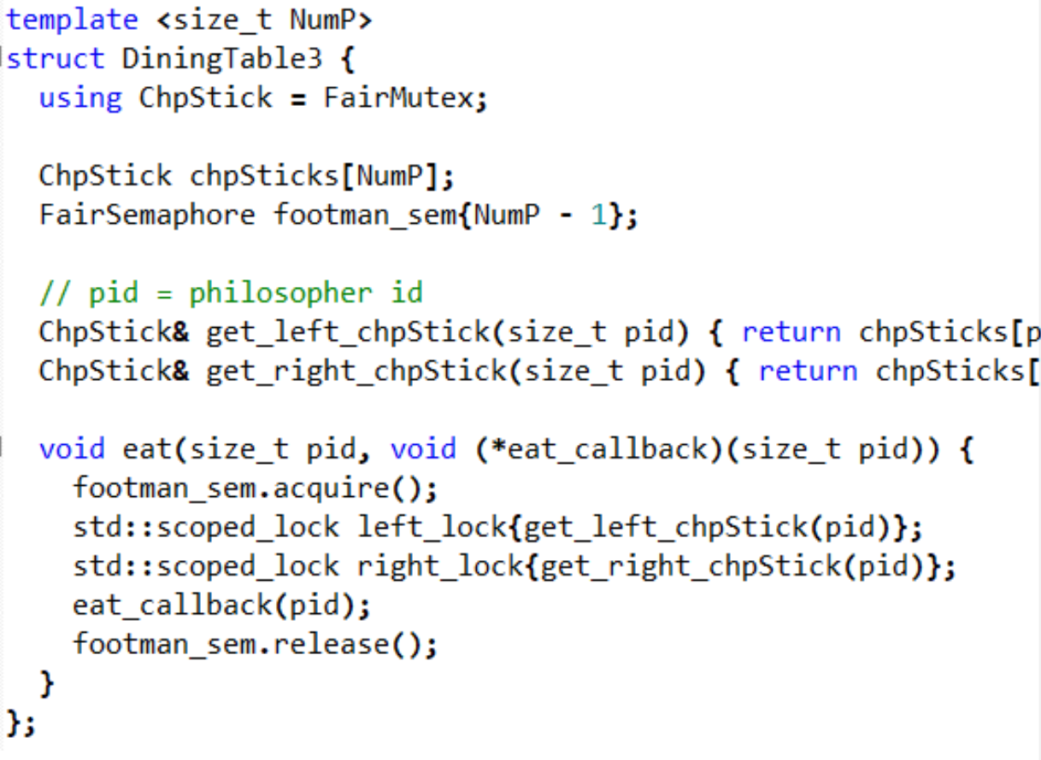

Dining philosophers implementation in Go

* Use odd-even ring communication to avoid deadlock
* Odd read, even write then swap

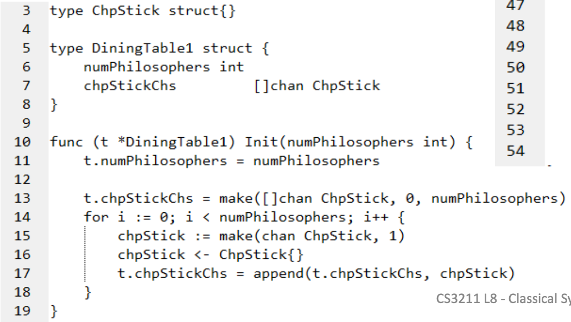

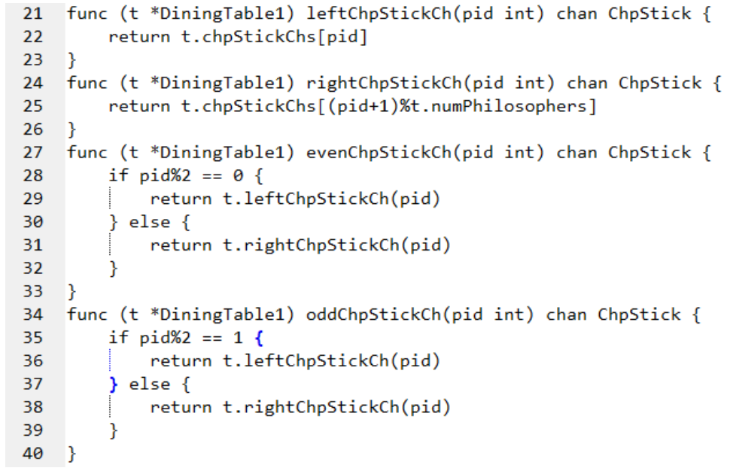

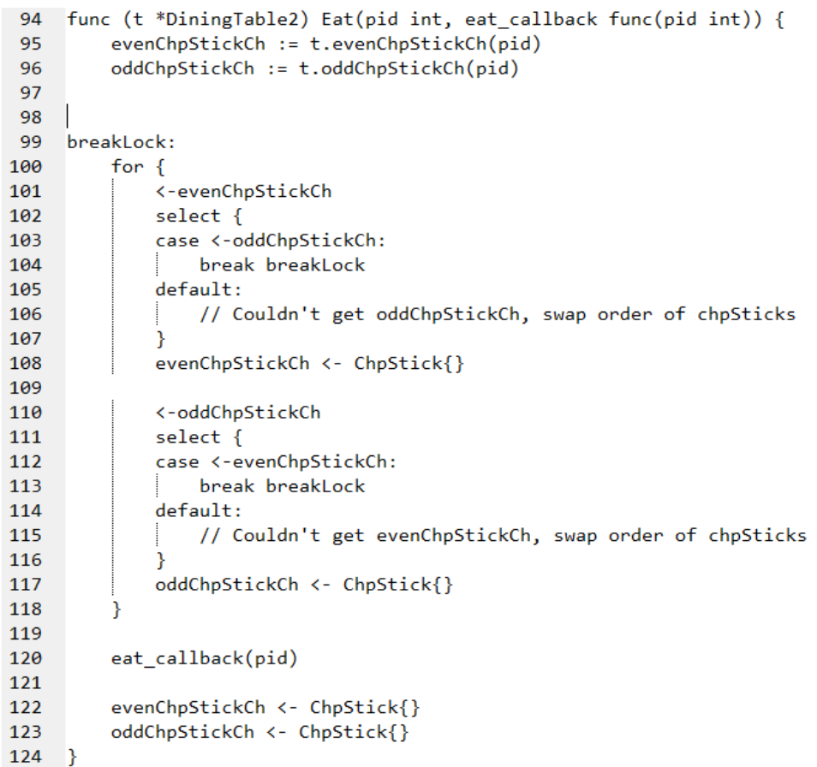

Limiting number of eaters

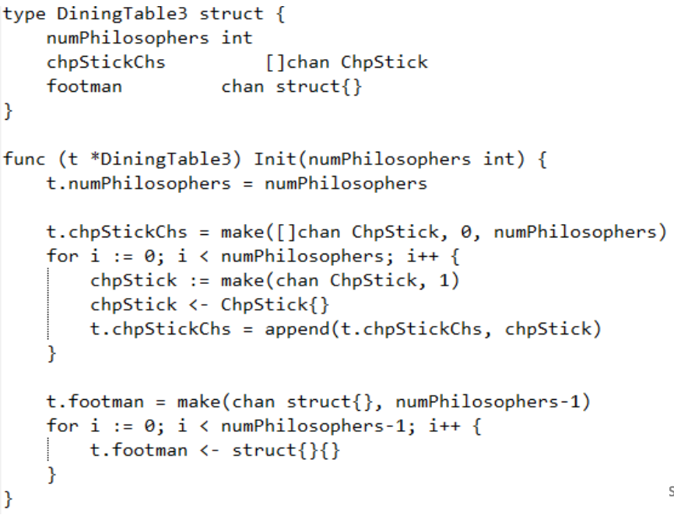

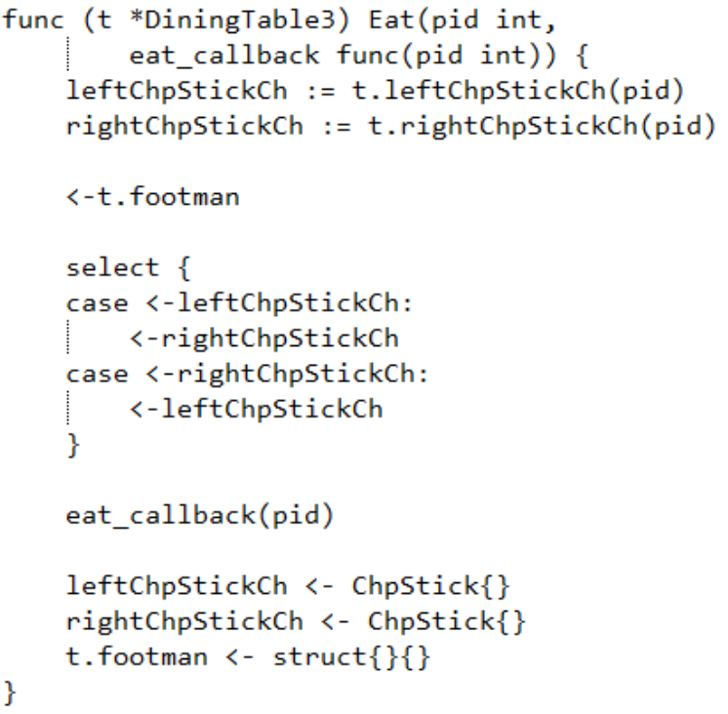

**Tanenbaum Solution**

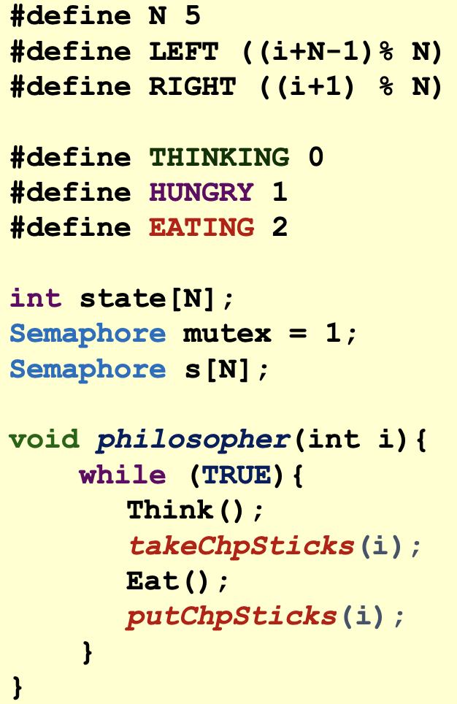

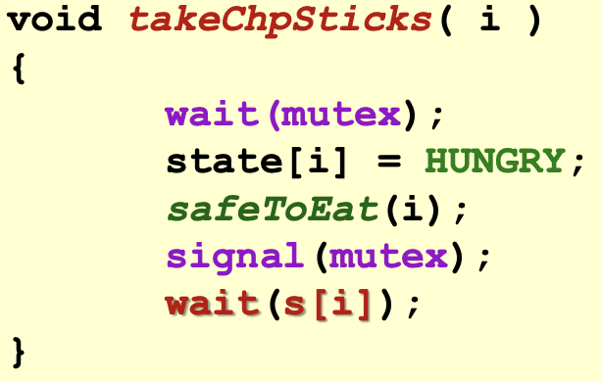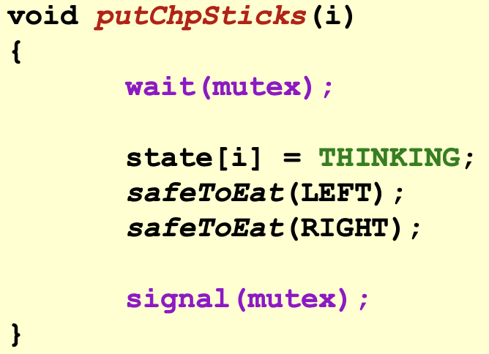

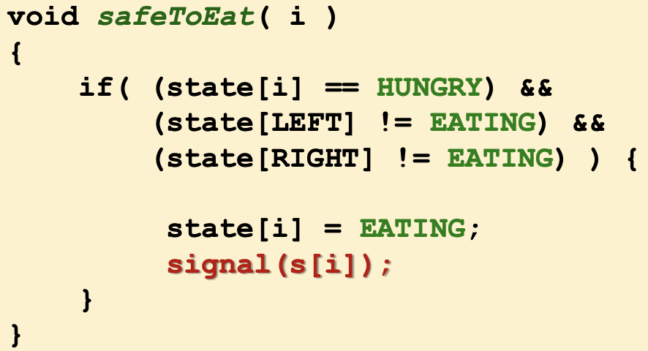

Limiting number of eaters

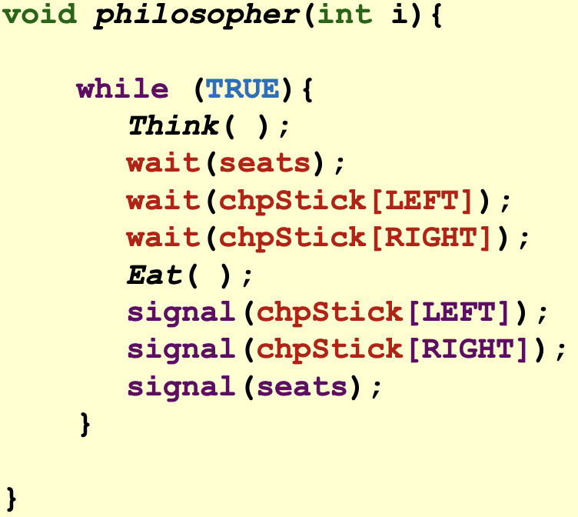

**Barbershop (Sleeping Barber)**

Pseudo-code

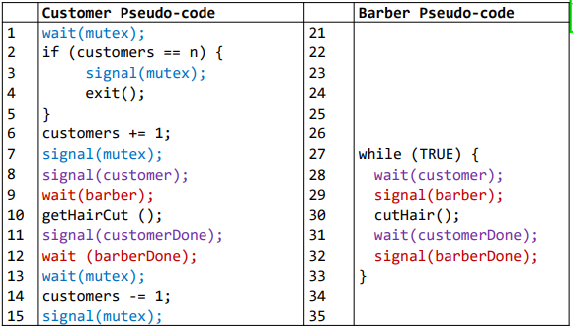

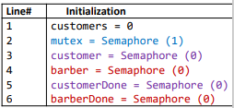

* lines 1 to 7 customers enters shop atomically and checks if there are seats available to wait for barber
* signal(customer) to let barber knows that customer has arrived
* wait(barber) waits for barber to be ready
* customerDone and barberDone ensures both parties to know that haircut has completed

Implementation in C++:

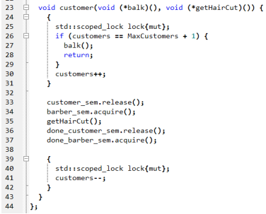

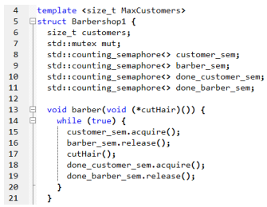

Implementation in Go:

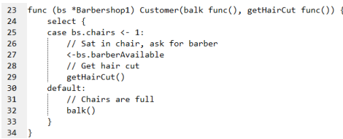

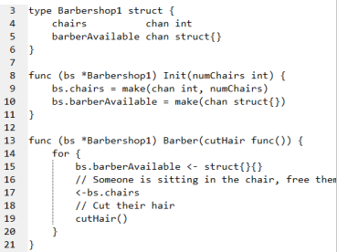

Problems with both C++ and Go solutions:

Cannot ensure customers get served based on the order they enter (FIFO)

* C++ uses counting_sem which does not guarantee that the thread releases in order
* Go uses channel although normally uses FIFO, but documentation does not guarantee FIFO

**H2O Problem**

* Allows the right number and type of atoms to enter the bonding chamber

Implementation in C++

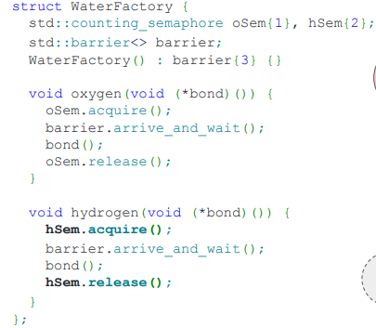

* Requires a counting semaphore for each type of atom to allow the right number of that type to enter the bonding chamber
* Requires a barrier to wait for all 3 atoms to arrive

# Implementation in Go:

Requirements:

1. Wait for 2H, 1O before bond()
2. Wait for 2H, 1O to bond(), before releasing

Idea: Let O atom be the “leader” to check & coord

1. O acquire mutex for H2O [O <- oCh]
2. O waits for 2H, 1O [O <- hCh, hCh]
3. O signals to bond [bond()]
4. O waits for 2H, 1O to bond [O <-postBondCh, postBondCh]
5. O release “mutex” for H2O [oCh <-]

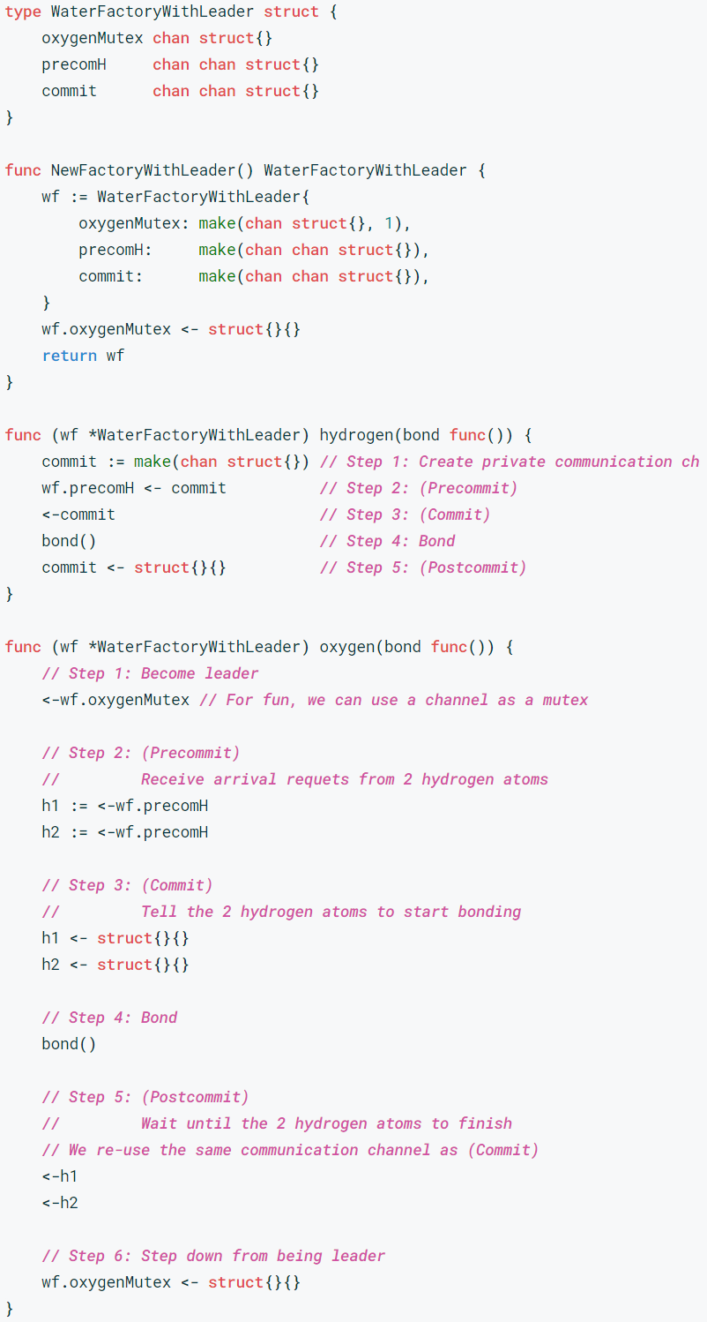

**FIFO Semaphore**

Guarantee a very strict form of fairness, where waiters are unblocked in the order they arrived.

Implementation in C++ (Using a ticket queue):

Idea: Arriving threads get a queue number and will only be released when now_serving counter = thread’s queue number

# 

# **Lecture 9: Safety in Rust**

* Ownership and borrowing
  + Prevents simultaneous mutation and aliasing
  + Aliasing: more than ptr to same memory
  + No runtime like C++
  + Memory safety like in garbage collected languages
  + No data races, no seg-faults, expressive type system!!

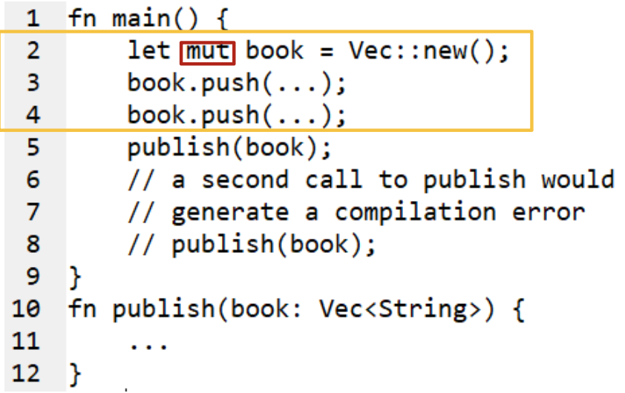

* Lines 2 - 4: book is initialised, owner is main
* Line 5: give ownership to publish
  + Pass without &
* Runtime
  + Copy over the fields from main’s stack to publish’s stack
  + Forgets about the first book in main
* Line 11: runs the destructor for book (after book reaches the end of scope of publish)
* Line 8: compilation error - use of moved value book

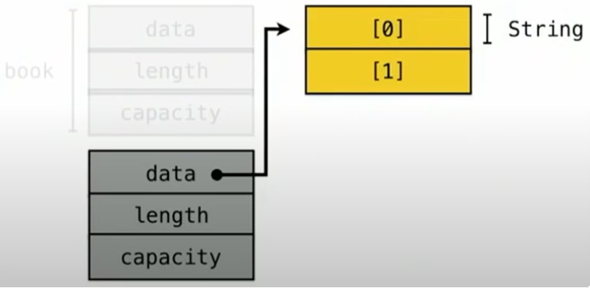

**Ownership**

* Default for Rust
* Ownership does not allow aliasing
  + Prevents double free
* ≠ copy constructor in C++
* Abit like move in C++ but enforced at compilation time and no ownership is retained
* Deep copy of data is explicit using clone()
  + In C++, copy constructor does the deep copy

**Shared borrow**

* Allows aliasing but no mutation → aliasing means more than 1 pointer pointing to the same location
* Prevents use-after-free

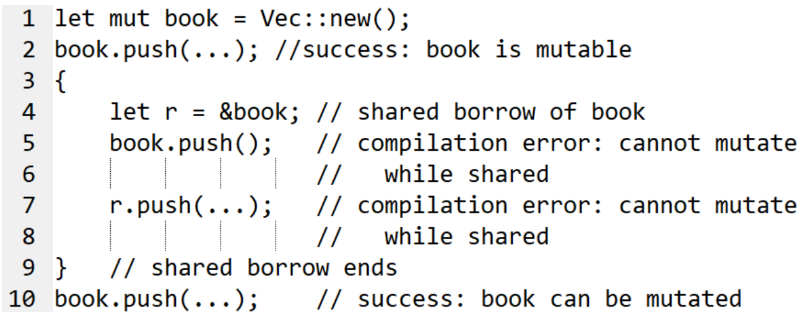

* Line 4: borrow the vector using &, creating a shared reference, cannot mutate

**Mutable Borrow**

* Allow mutation but no aliasing → only 1 pointer to the mutable object at a time
* Prevents use-after-free

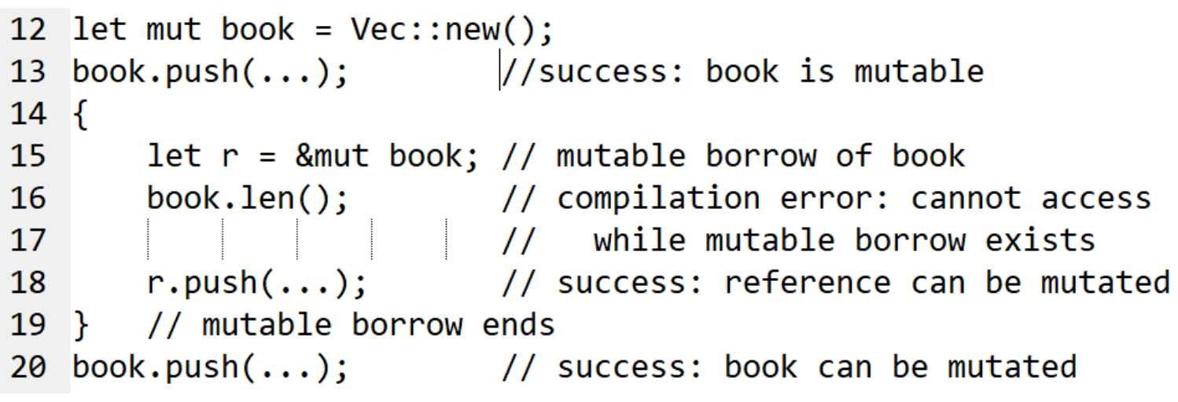

**Memory safety in Rust**

* Borrow check statically prevent aliasing + mutation
  + Compile time
* No segfaults
* Data race = sharing + mutation + no ordering
* Rust prevents sharing + mutation → no data race
  + But can still have other race conditions where the correctness dependes on ordering/timing

| **Type** | **Ownership** | **Alias** | **Mutate** |
| --- | --- | --- | --- |
| **T** | Owned | No | Yes |
| **&T** | Shared reference | Yes | No |
| **&mut T** | Mutable reference | No | Yes |

# **Threads**

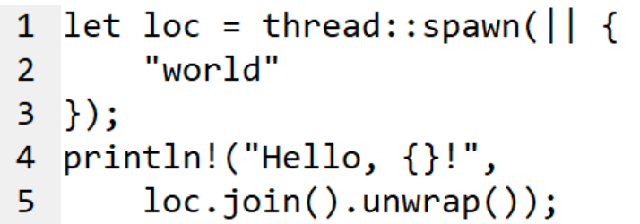

* Line 1: create a thread
  + loc is a JoinHandle
  + If loc is dropped, the spawned thread is detached
* Line 5: join a thread & unwrap to return value

Transfer vector to a thread

# 

* move converts any variables captured by reference or mutable reference to variables captured by value
  + The closure (like lambda function) will take ownership of the values it uses from the environment, thus transferring ownership of those values from one thread to another
* Line 5: error: use after move

Removing move

* Line 3: error: value does not live long enough
  + Possible memory issues: UAF → since thread will be detached and destroys value
* Spawn a thread
  + Capture everything as a borrow
  + The closure captures dst as mutable borrow (inferred by Rust)

Reference Counting (RC)

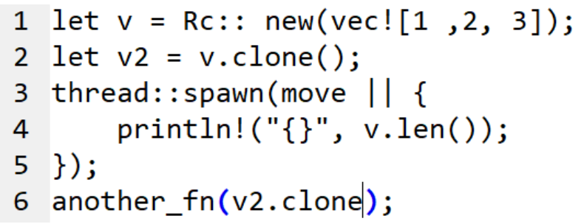

* Line 4: error: Rc<T> cannot be sent across threads
  + Rc type is not atomically managed
  + No send trait → so Rc can only belong to main thread

Traits

* Similar to interface
* Might have methods
* E.g. Clone trait
* Marker traits:
  + Send - transferred across thread boundaries
    - String, u32, Arc<String>
  + Sync - safe to share references between threads
    - Type T is Sync iff &T is Send
  + Copy - safe to memcpy (for built-in types)
    - u32, f32
    - Not for strings

Atomically Reference Counted - Arc

* Shared pointers in C++, shared borrow → allows multiple ownership in of same data
* Allows only shared references
  + can only contain immutable data as it cannot guarantee safety from data races
  + If mutable data is required, encapsulate Mutex inside Arc
* Thread-safe: Allows extension of lifetime; data will not be dropped until all references to it have ceased
* More expensive than RC → more memory + longer operations
* Line 3: move reference
* Line 4: safe to access v
* Refcount = 2: v and v2

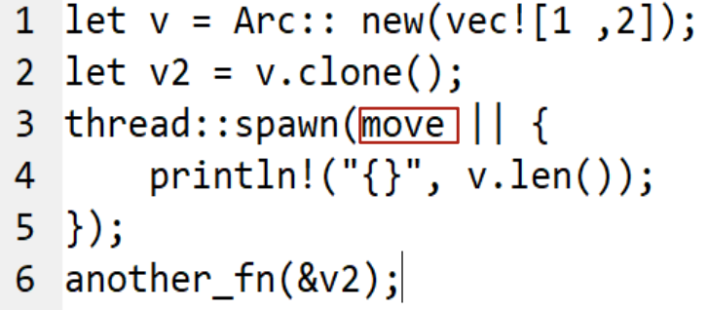

**Synchronisation in Rust**

* Shared memory: mutex & atomics
* Message-passing
  + Channels: MPSC (multi-producer, single-consumer FIFO queue)

Mutex

* Based on ownership
* Data protected by the mutex
* Lock returns a guard - a proxy through which we can access the data

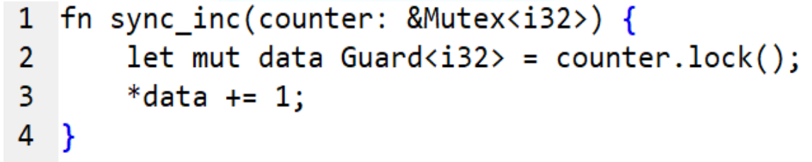

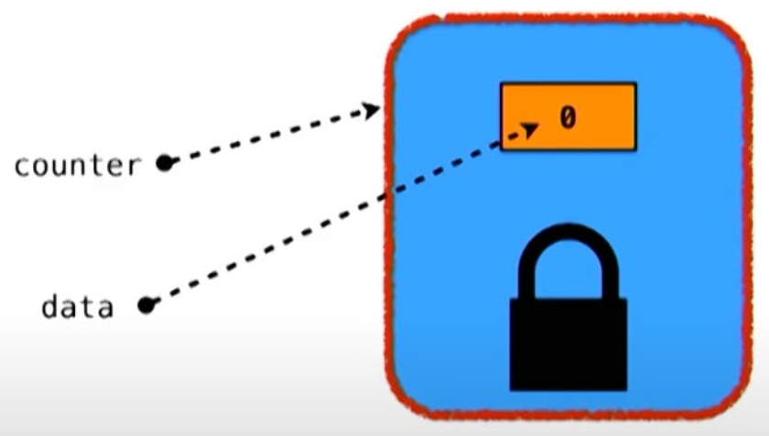

Atomics

* Similar to modern C++ (same mem model)
* Mem ordering - SeqCst

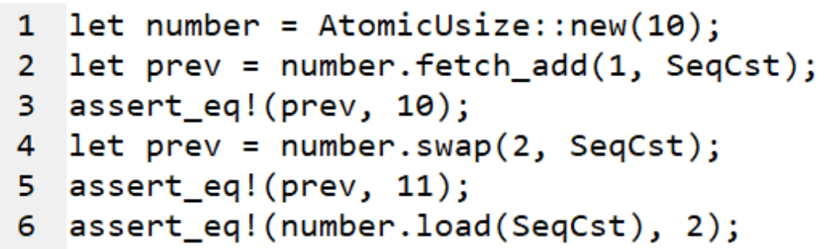

Multi-producer, single-consumer FIFO queue

* Channel with a reading and writing reference
* Accepts 1 reader and multiple writers

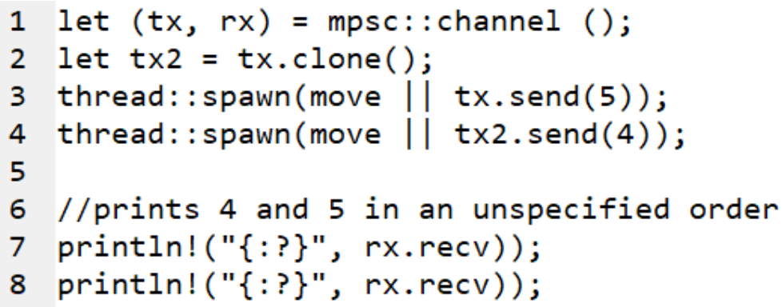

**Crossbeam**

* Ability to create scoped threads - now in std
  + Cannot borrow variables mutably into 2 threads in the same scope
  + Line 5: create the scope
  + Line 6: spawn threads

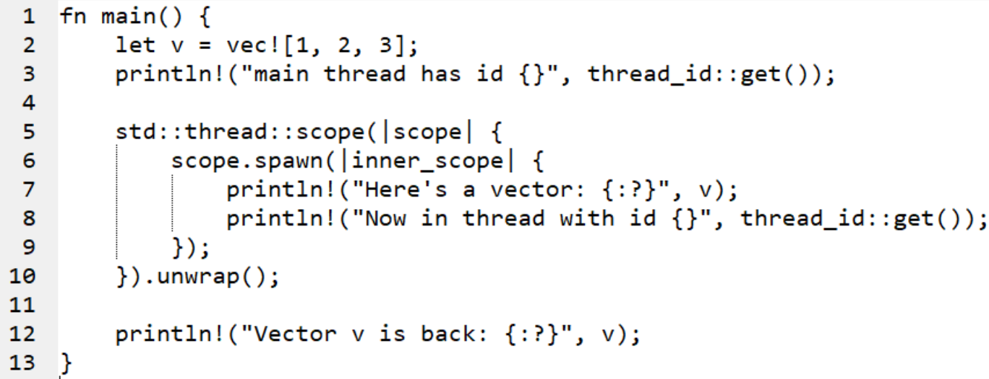

* Message passing using multiple-producer-multiple-consumer channel with exponential backoff
  + Line 12: Use a bounded channel

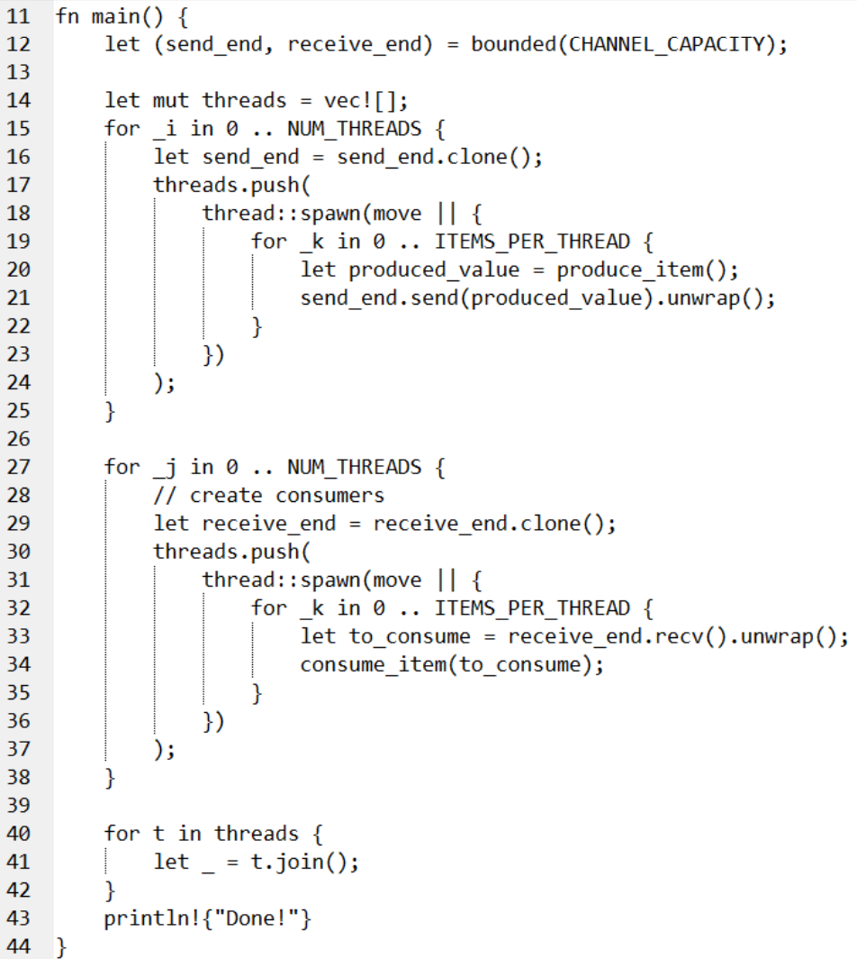

Exponential backoff

* Resources might not be available now → retry later
* Unhelpful to have a tight loop that retries ASAP
* Wait a bit and try again → if err, increase wait time
* Rationale: if the resource is overloaded now, the reaction of requesting it more will make it even more overloaded and makes the problem worse

Backoff with scoped threads

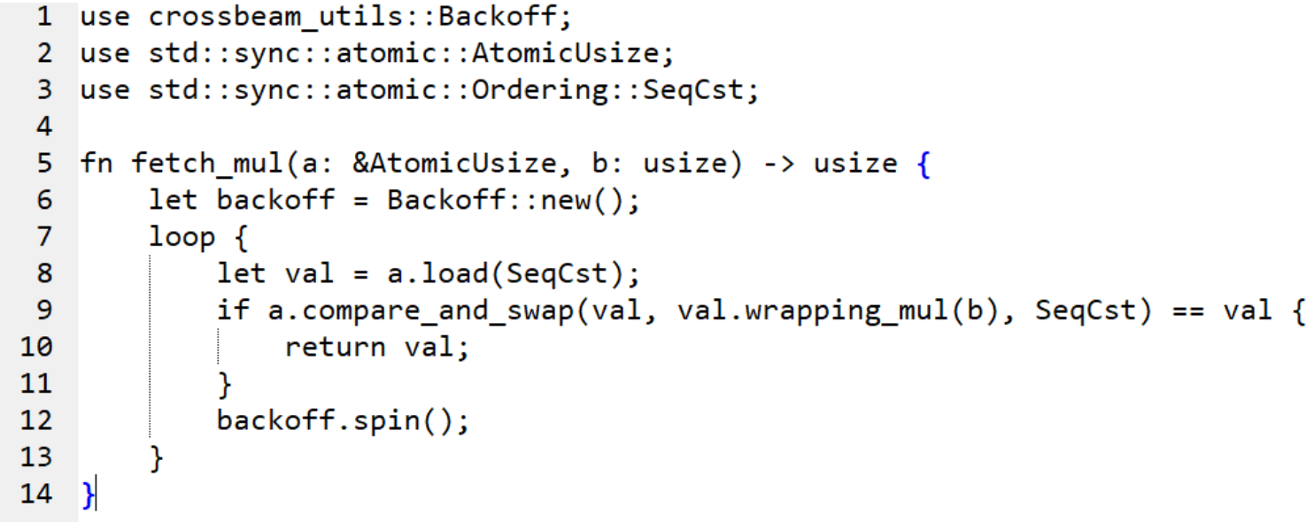

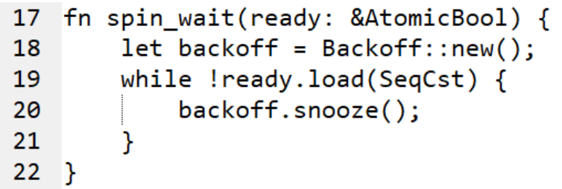

* Line 12: backoff in lock-free loop
* Line 20: snooze → wait for another thread to take its turn first

**Rayon**

* Data parallelism library: parallelise some spots without full/major rewrite
* Similar functionality with OpenMP
  + omp uses compiler directives
* Rationale: common for computationally intensive parts to happen in a loop → parallelising loops is likely to be profitable

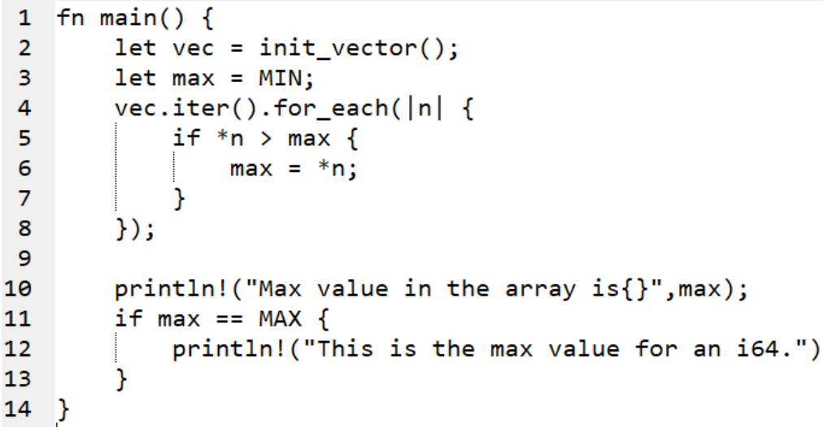

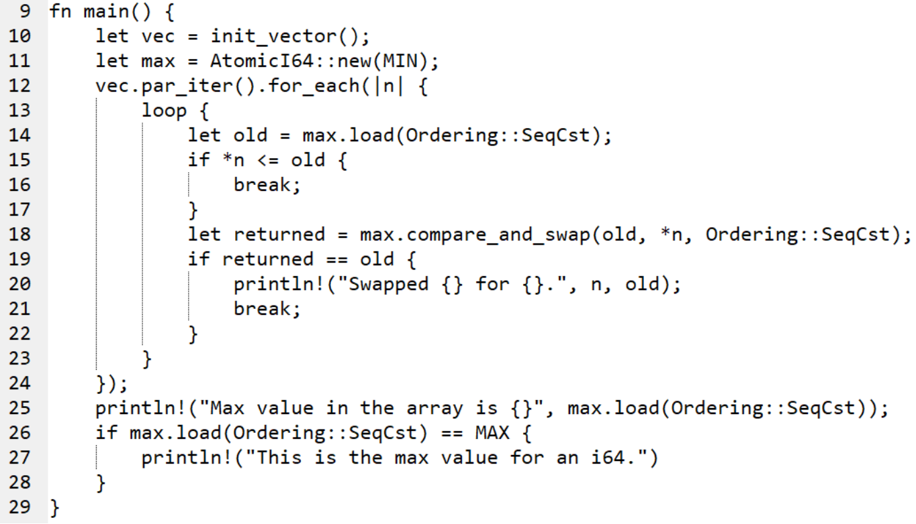

Traits of closures:

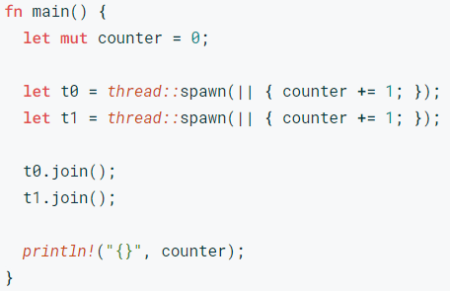

2 issues:

1. counter is mutably borrowed twice!
2. counter does not live long enough to be referenced
   1. any data captured by the closure of thread::spawn must live for at least as long as the static lifetime

Interior Mutability

let counter = *Mutex::*new(0);

* even though binding is non-mut can get mutable reference to data within mutex using lock()
* Normally unsafe code → safety ensured at runtime

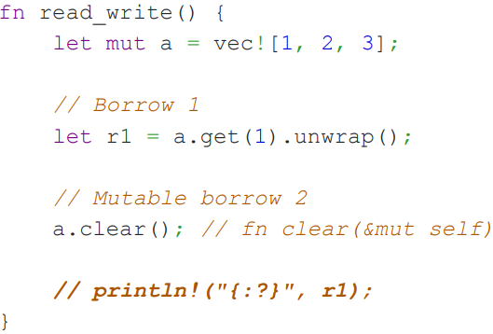

* No error since r1 is not used after initial assignment, it will be dropped before a.clear()

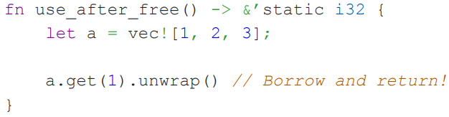

* Error: cannot return a local variable owned by fn

Explicit Lifetime Notation

* For ambiguous lifetime such as:

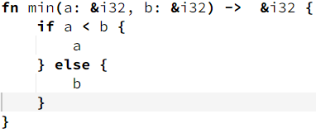

Compiler does not know which parameter the return value borrowed from

* foo<’a> means that foo has a lifetime parameter of a so foo’s lifetime cannot exceed a

# 

# **Lecture 10: Async Programming in Rust**

**Overheads of threads**

* Context switching cost: threads give up the rest of the CPU time slice when blocking functions are called, and a switch happens
  + Registers restored, virtual address space switched, cache stepped on etc
  + Big cost for high-performance situations (servers) with multiple threads, each handling a connection
* Memory overhead
  + Each thread has its own stack space taht needs to be managed by the OS → too much mem for a lot of concurrent connections
* Mitigation:
  + use lightweight threads (green threads) - usually need a runtime, e.g. Go
  + Non-blocking I/O

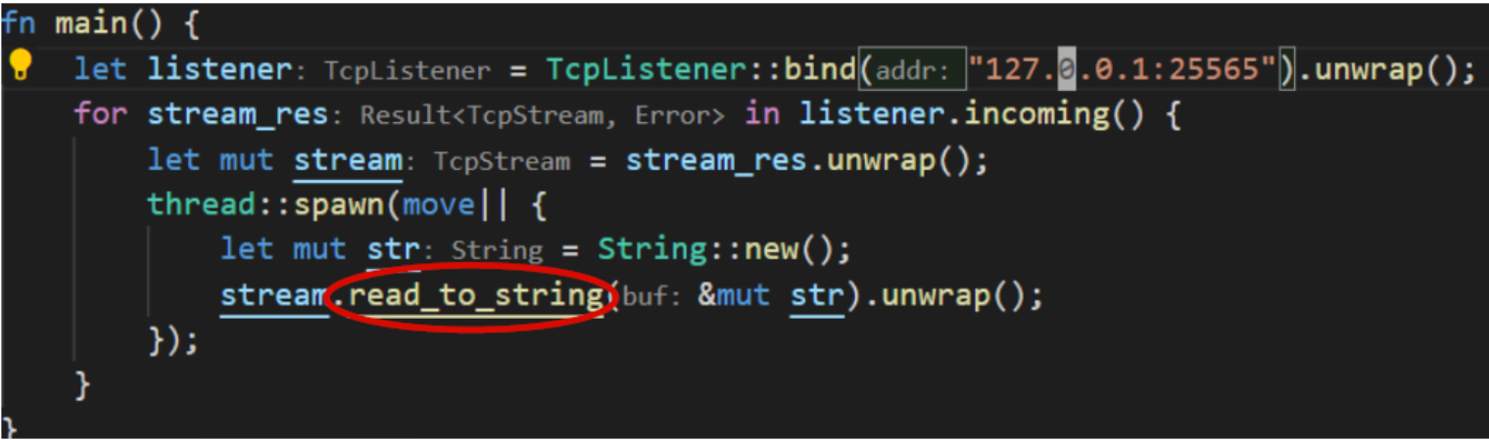

* read() system call can block (slow network connection, malicious client etc)
  + Block if there is more data to be read but unavailable
  + Thread get pulled off the CPU and it cannot do anything else in the meantime
* read() could return a special error value instead of blocking
  + If client has not sent anything, thread can do other useful work, e.g. reading from other descriptors
* Non-blocking I/O enables concurrency with 1 thread

**Non-blocking I/O**

* epoll is a kernel-provided mechanism that notifies us of what file descriptors are ready for I/O
* Scenario: server has conversation with multiple clients simultaneously (multiple fds)
* epoll notifies the thread when a client said sth
* read() from each of those fds (ready for reading), continue those conversations
* Rinse and repeat → event loop

**State management - Futures**

* Key problem: manage the state associated with each conversation
* Future allows us to keep track of in-progress operations along with associated state, in one package
* Future represents a value that will exist sometime in the future
* Calculation has not happened yet
  + Just keep asking
* Event loop: runtime for Futures
  + Keep polling Future until it is ready
  + Runs your code whenever it can be run
  + User-space scheduler for futures
* Futures.rs: zero-cost abstraction for futures
  + The code in binary has no allocation and no runtime overhead in comparison to writing it by hand (non-assembly code)
  + Cannot optimize further by hand
  + Building async state machines
  + Future Trait
  + Event reactor

**Future trait**

* The executor thread should call poll() on the future to start it off
* Executor thread will run code until it can no longer progress
  + If the future is complete, return Poll::Ready(T)
  + If future needs to wait for some event, return Poll::Pending, and allows the single thread to work on another future

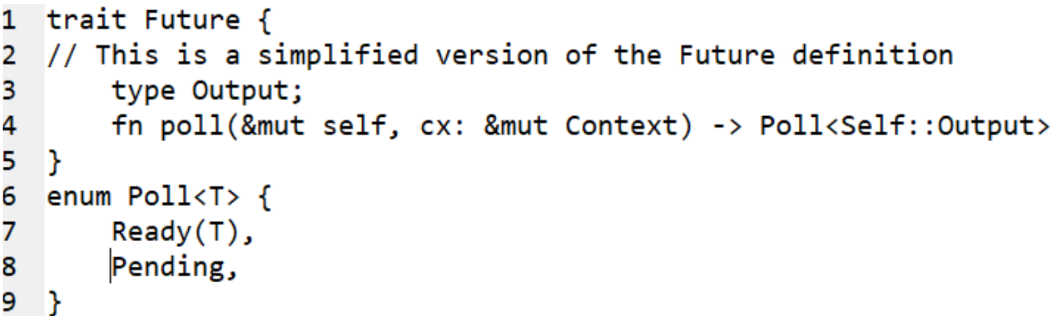

* When poll() is called, Context structure is passed in
* Context includes a wake() function
  + Called when future can make progress
  + Implemented internally using syscalls
* After wake() is called, executor can use Context to see which Future can be polled to make new progress

Executors

* An executor loops over futures that can concurrently make progress
  + Calls poll() on them to give them attention until they need to wait again
  + When no future can make progress, the executor goes to sleep until one or more futures calls wake()
* Popular executor: Tokio
  + Wraps around mio.rs and futures.rs
* Executors can be single- or multi-threaded
* Running on a multiple cores machine
  + Futures can truly run in parallel
  + Need to protect shared data using sync primitives (enforced by ownership model as well)

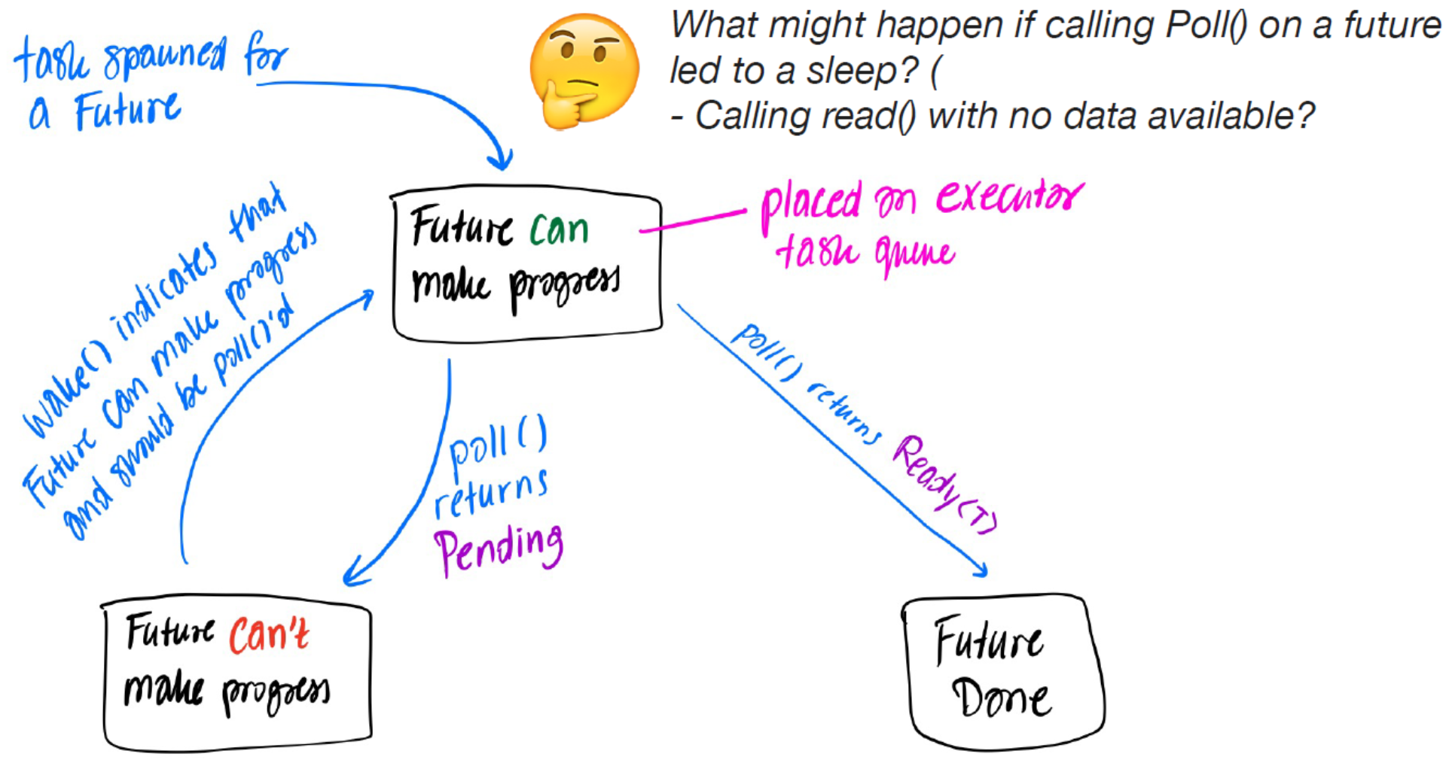

Futures should not block

* If code within a future causes the thread to sleep, the executor running that code is going to sleep
* Async code needs to use non-blocking versions, including mutexes, syscalls that would normally block
* Executor runtimes, e.g. Tokio, provides these non-blocking implemtatioons for synchronisation primitives

Composition with futures

* Futures are combined with various combinators
  + Sequential
  + Concurrently
* Code becomes messier as complexity increases

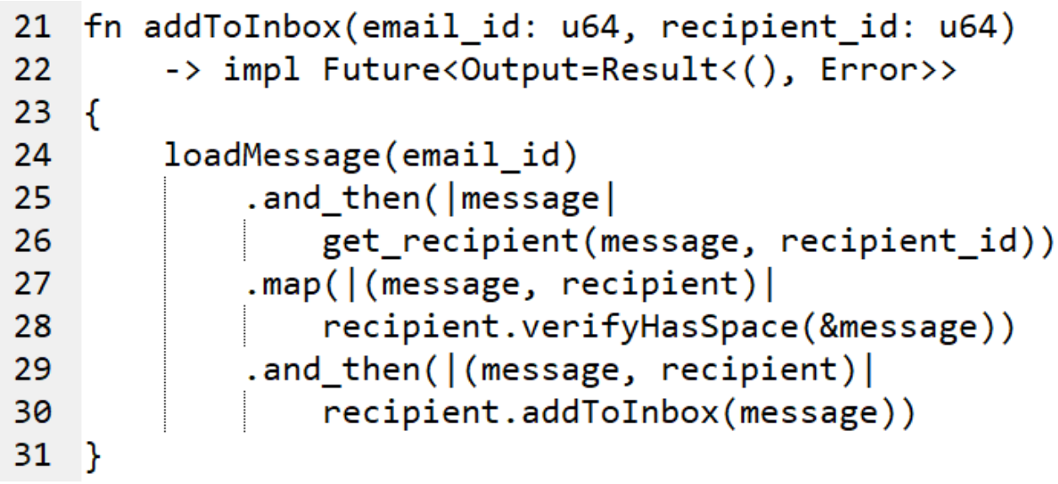

* Line 21, 24, 25, 29: async functions returning Futures
* Line 27: synchronous (normal) functions
* Line 26: get_recipient takes a message even tho it does not need it as this allows the next future to get message and recipient as input
  + Like a pipeline

**async/await**

* Syntactic sugar
* async function returns Future
  + Any futures used in the function are chained together by the compiler
* await waits for a future and gets its value
  + Can only be called in an async fn or block
* Rust compiler transforms this code into a Future with a poll() method
* Futures dont do anything unless an executor executes them

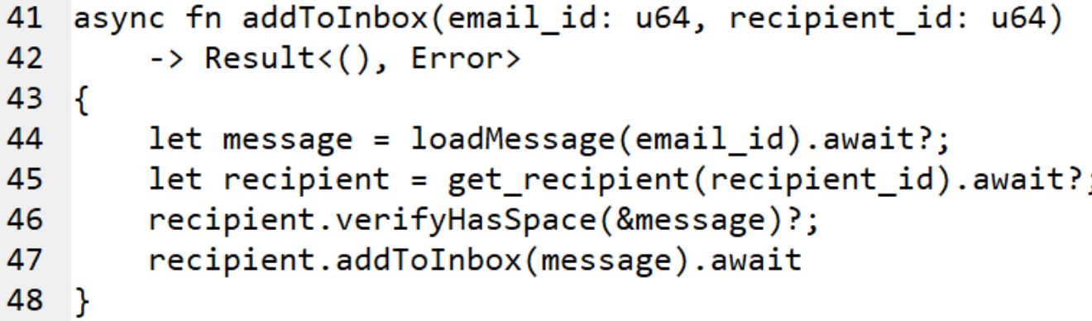

* Line 44, 45, 47: await waits for a future and gets its value
* Line 46: normal function
* 5 places where program might be paused, not actively executing
  + Before anything has happened (Future created but not polled)
  + Await-ing for loadMessage
  + Await-ing for get_recipient
  + Await-ing for addToInbox
  + Future has completed
* Use enum to store the state for these possibilities
* poll() implementation should look at the current state and execute the appropriate code from the async fn

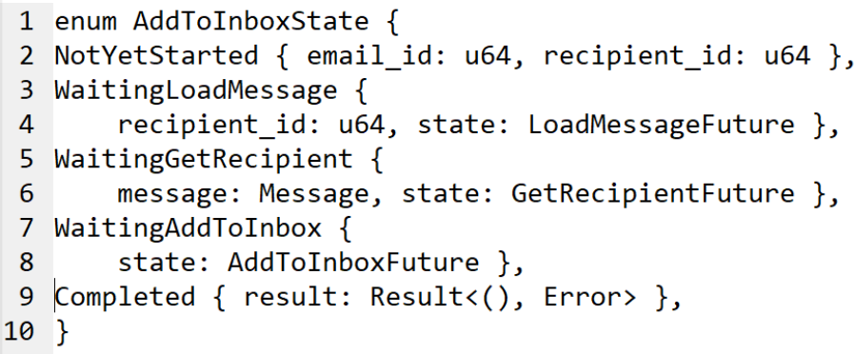

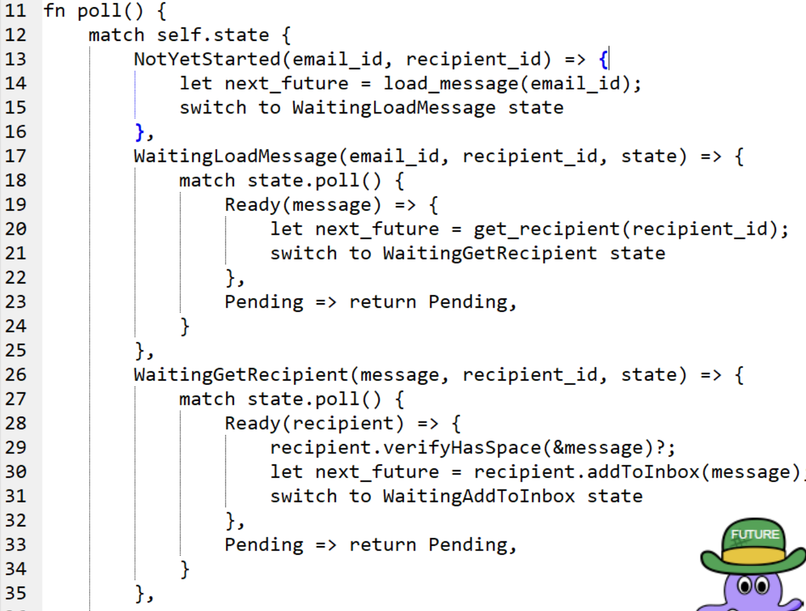

Another example of async

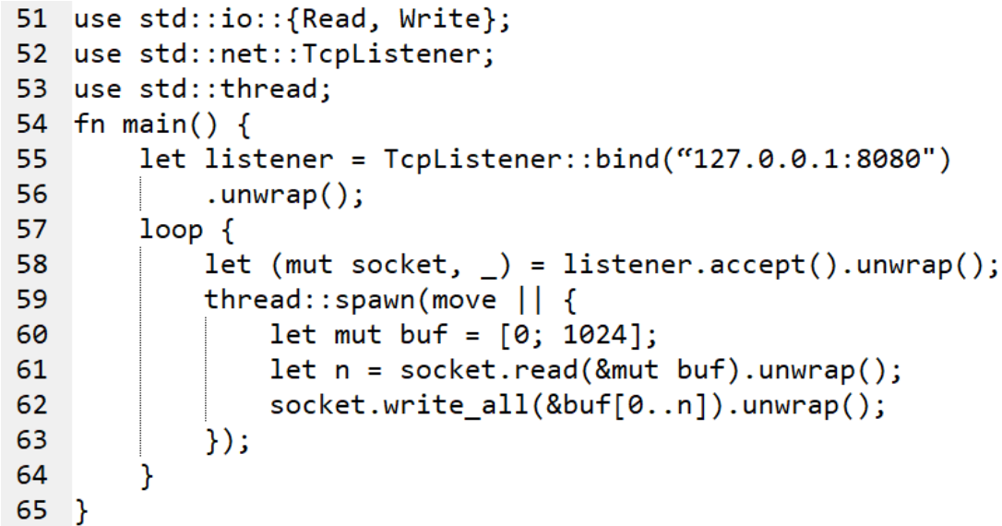

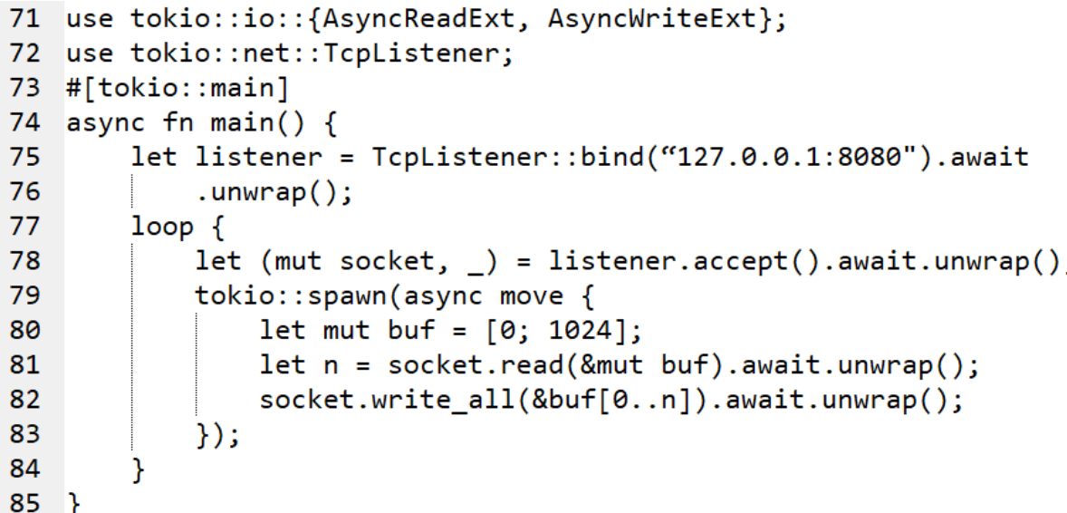

* main() returns a Future
  + Need to run main() and submit the returned Future to the executor
  + Line 73: #[tokio::main] macro submits the future to the executor

Implications

* Async functions have no stack
  + aka stackless coroutines
* The executor thread still has a stack (used to run normal/synchronous functions), but it is not used to store state when switching between async tasks
* No recursion
  + Future returned by an async function needs to have a fixed size known at compile time
* Rust async functions are nearly optimal in terms of memory usage and allocations
  + Low overhead - very optimised
* Async code makes sense when
  + Need extremely high degree of concurrency (many threads)
  + Work is primarily I/O bound
    - Context switching is expensive only if a tiny fraction of the time slice is used
    - If you are doing a lot of work on the CPU for an extended period of time, you might prevent the executor from running other tasks

Similar tools in other languages

* Javascript: Promises and async/await
  + Involves much more dynamic mem allocation, not as efficient
* Golang: goroutines are the async tasks but they are not stackless
  + Resizable stacks - possible because Go is garbage collected
  + Runtime nows where all pointers are and can reallocate memory
* C++20: stackless coroiutines
  + Not polished yet

PYP

Relaxed consistency models at the programming language level address the concern that software complexity is increased by the need for unnecessary synchronization.

* False, relaxed consistency need more sync by programmer

The modern C++ memory model exhibits a different behavior when it is running on a weak-consistent architecture (e.g. ARM).

* False, C++ memory model provides the same guarantees across architectures

Programs using C++ atomics (without other sync mechanism e.g. mutex) might suffer of deadlocks.

* True, deadlock can happen due to busywaiting / mutex / spinlock using atomics

C++17 included support for multithreaded programs as a compiler-specific extension.

* C++17 did not include support for multithreaded programs as a compiler-specific extension, but rather as a standardized part of the language

MPMC using done

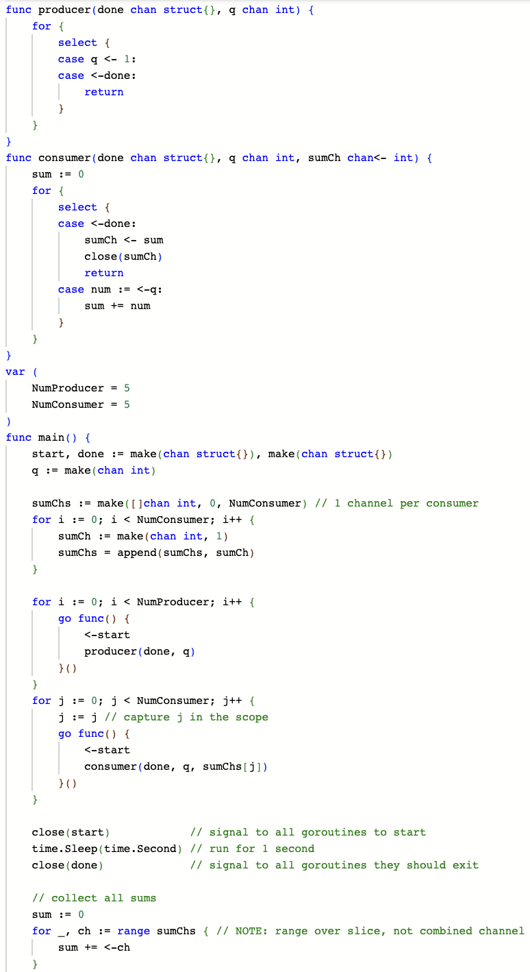



MPMC using context

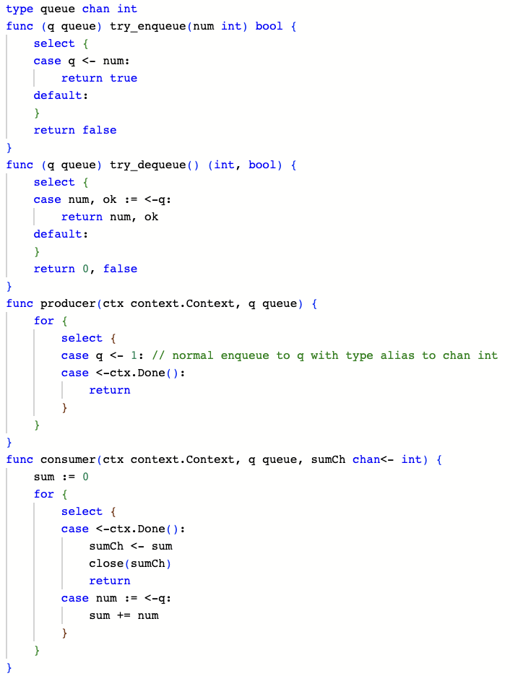



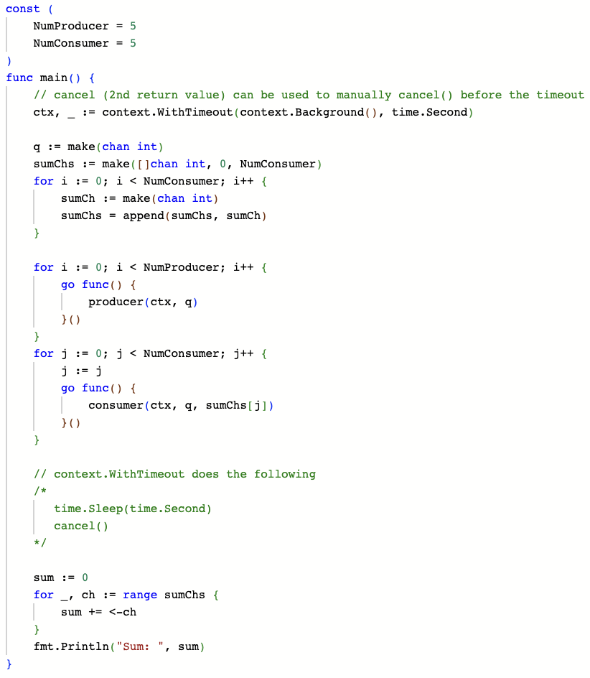

Assignment 3 Rust ideas

Async

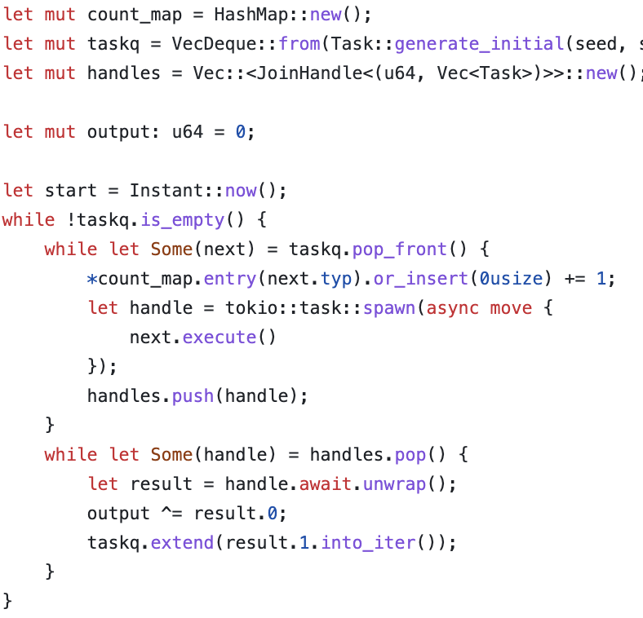

MPSC

let pool_size = num_cpus::get();

let pool = threadpool::ThreadPool::new(pool_size);

let (result_sender, result_receiver) = mpsc::channel();

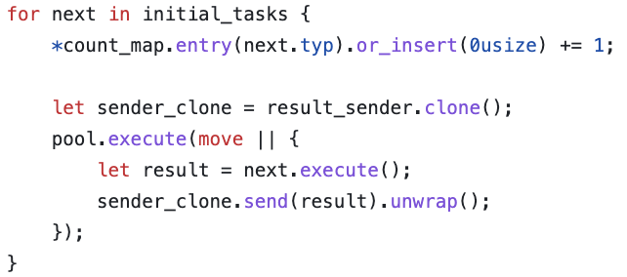

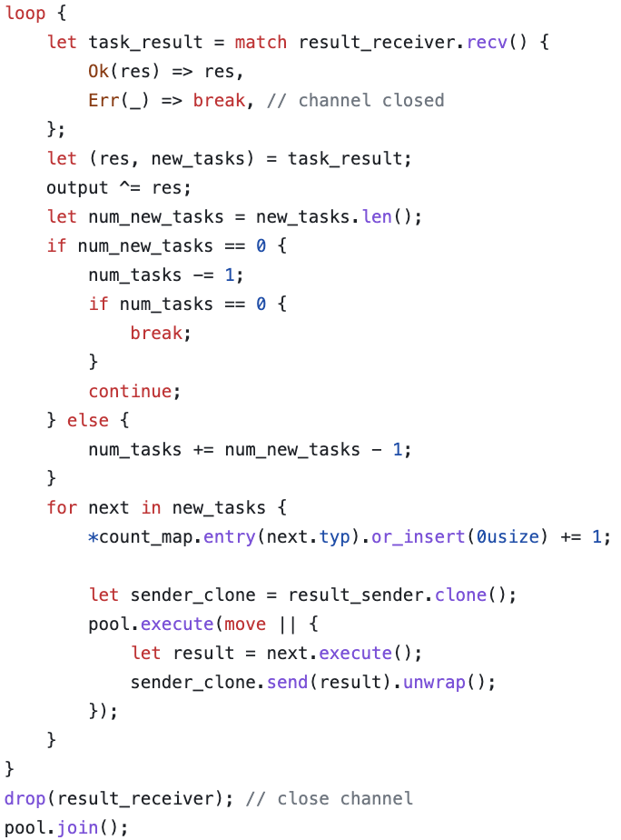

Scope Thread

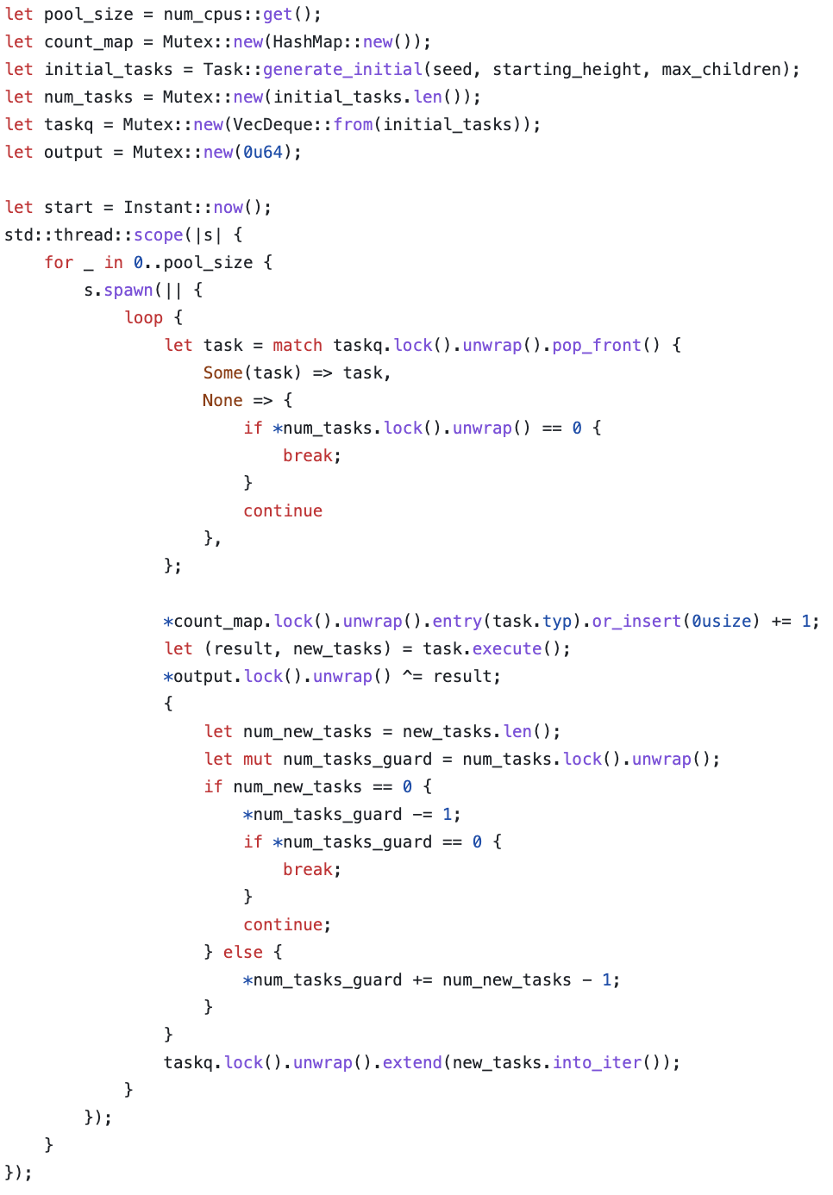





Simple Fan-in Fan-out

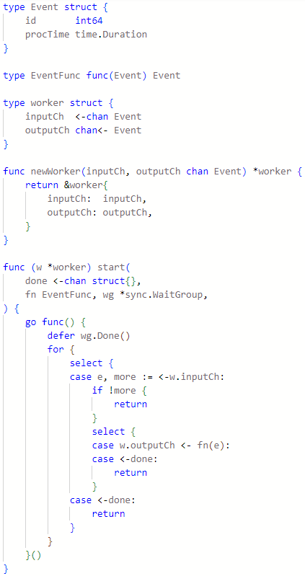



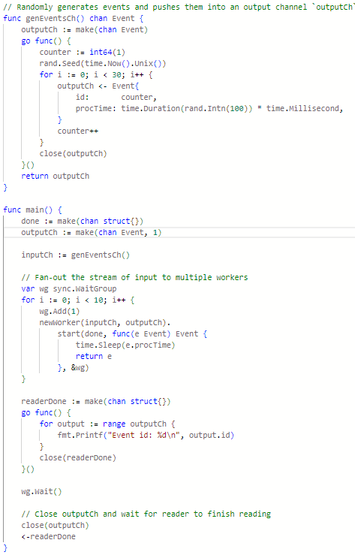

Pipeline Go

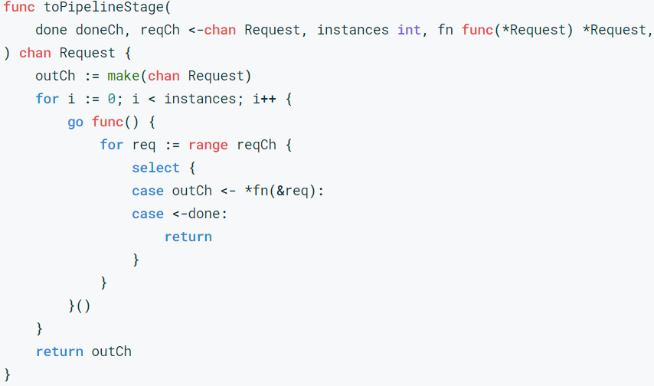

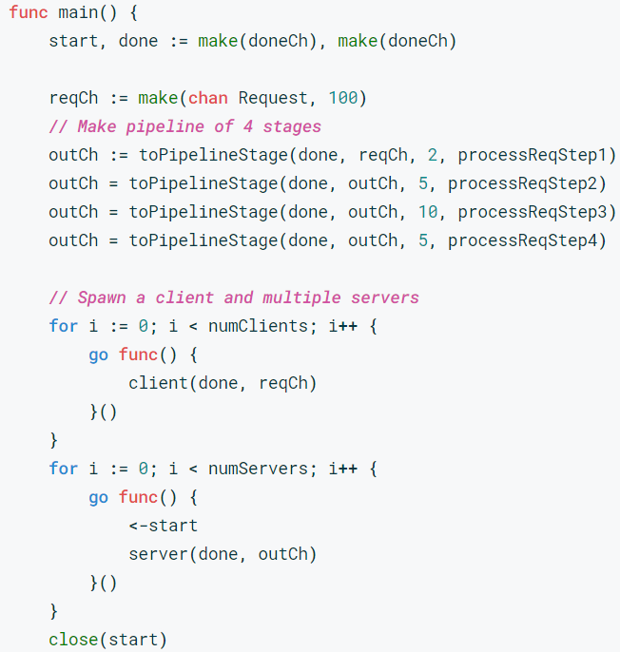

Rust Rayon - par_iter

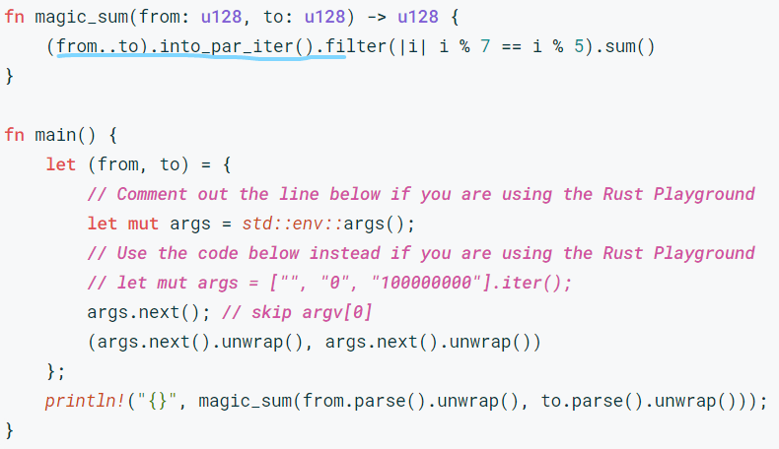

Rust Rayon - recursive example

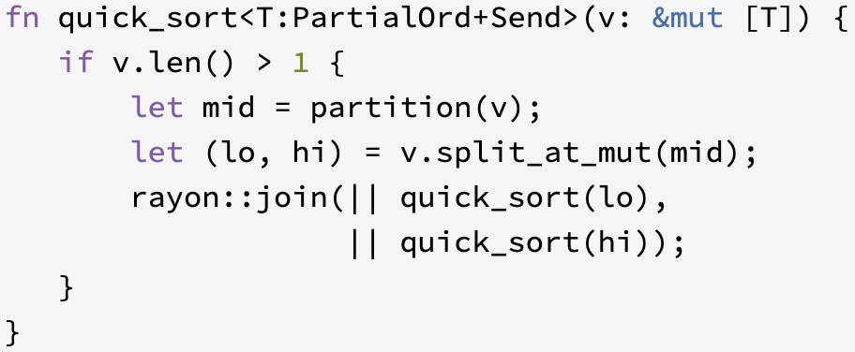

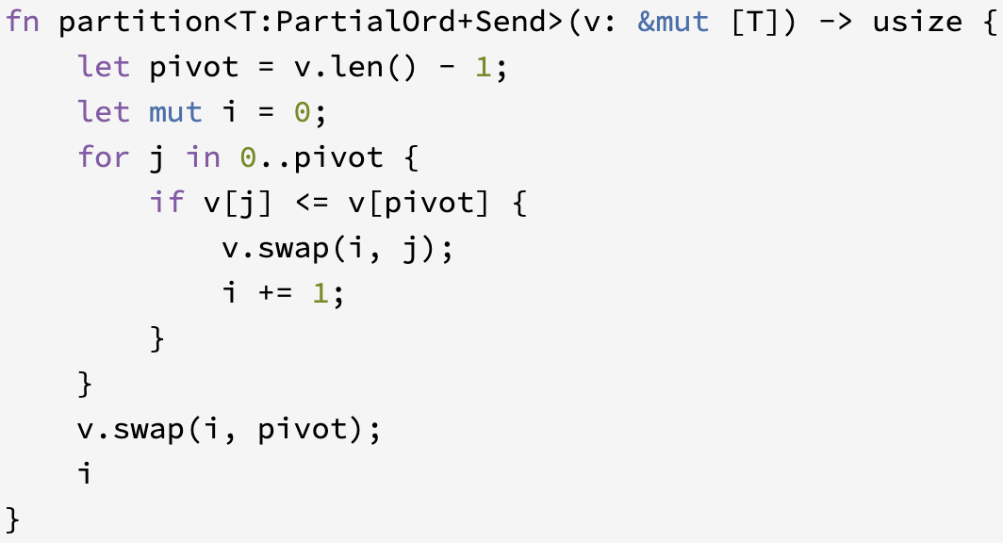

Go - recursive merge sort

